ARTIFICIAL INTELLIGENCE FOR TERRAIN RELATIVE NAVIGATION IN UNKNOWN ENVIRONMENTS

Marcos Avilés⁽¹⁾, Maciej Quoos⁽²⁾, Julia Wajoras⁽³⁾, Jesús Gil⁽⁴⁾

- GMV Aerospace & Defence SAU, Spain, maaviles@gmv.com
- GMV Innovating Solutions Sp. z o.o., Poland, mquoos@gmv.com
- GMV Innovating Solutions Sp. z o.o., Poland, jwajoras@gmv.com
- ESA/ESTEC, Netherlands, jesus.gil.fernandez@esa.int

ABSTRACT

We present a navigation architecture with the capability to fly over an unknown terrain and achieve better navigation performances than current vision-based techniques based on unknown feature tracking. Limited a priori knowledge of the terrain was assumed, a coarse shape model of the target and unknown surface characteristics, to demonstrate the generalization of performances.
The architecture relies on Artificial Intelligence techniques based on Convolution Neural Networks, but it is designed in such a way that the core IP functions can be switched for higher flexibility.
The reference scenario was the Very Close Fly-By phase of the Hera mission, and the performances of the new proposed navigation were compared against the nominal navigation of Hera also exploring contingency cases where no altimeter is present.
The validation of the performances of the autonomous navigation system was performed in a high-fidelity MIL testbench considering the representative proximity operations of Hera during very low altitude fly-bys, but also in a reduced-scale mock-up using real images acquired at a HW facility.

INTRODUCTION
Space missions benefit greatly by the capability of the on-board GNC system to adapt rapidly to an unknown environment. Autonomous vision-based navigation is a particular technology under implementation in several ESA missions. One of the most interesting applications in that field is the proximity operations around a small asteroid, like those in Hera.
The goal of this work was to develop a navigation algorithm with the capability to fly over an unknown terrain and achieve better navigation performances than current vision-based techniques based on unknown feature tracking.
From a vision point of view, the objective is to estimate the pose of the spacecraft with respect to a target body. Traditional methods have shown that pose estimation can be achieved by establishing the correspondences between an object image and the object model. They rely on hand-crafted features, which might be not robust to image variations and background clutters. Deep learning-based methods train end-to-end neural networks that take an image as input and output its corresponding pose. However, generalization remains as an issue, as it is unclear that such end-to-end methods learn sufficient feature representations for pose estimation. Moreover, the uncertainty on the target body, whose exact shape or appearance can be unknown does not allow to defining specific features or properly training the neural network.
Other recent methods use Convolutional Neural Networks (CNNs) to first regress 2D features and then compute 6D pose parameters using the Perspective-n-Point (PnP) algorithm. In other words, the detected features serve as an intermediate representation for pose estimation. Such two-stage approaches achieve state-of-the-art performance, thanks to robust detection of these keypoints.

PROPOSED APPROACH
We thus focus on solving the problem pose estimation using this two-stage approach, which also fits better from a mission perspective. During initial commissioning passes around the asteroid, features are detected and stored on-board. Their 3D position is computed using the navigation solution and an approximate shape of the model (based on a coarse preliminary knowledge of the target body). Then, during the actual operations phase, new features are identified on the on-board images and matched with those previously detected and allow estimating the pose of the spacecraft. Fig. Figure 1 illustrates the concept of the proposed solution, which we have called Enhanced Relative Navigation (ERN).
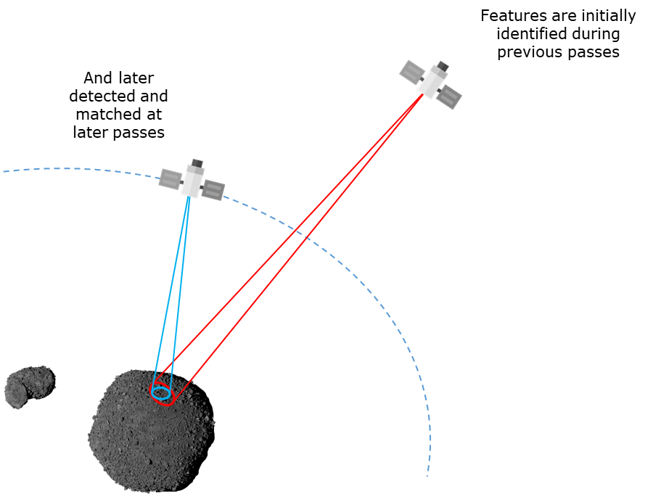
Figure 1. Enhanced Relative Navigation concept.
A high-level diagram depicting the blocks of the ERN is provided in Fig. Figure 2. From the image acquired by the spacecraft camera a first stage of Feature Extraction is executed. The feature extraction comprises two steps: a feature detection step, where salient regions of the image are identified, and a feature description step, where a compact vector of values describing the area surrounding the feature is built. This vector, also called, descriptor, allows comparing and matching features in different images. The output of the Feature Extraction block is a list of features (together with their descriptors) that is compared with a reference landmark database within the Landmark Matching block. The landmark database stores the 3D coordinates of the landmarks together with a feature descriptor. The result of the matching process is a list of correspondences between the features detected in the camera image and features in the database. These 2D-3D correspondences are used in the Pose Estimation block to estimate the position and the orientation of the camera with respect to the asteroid.
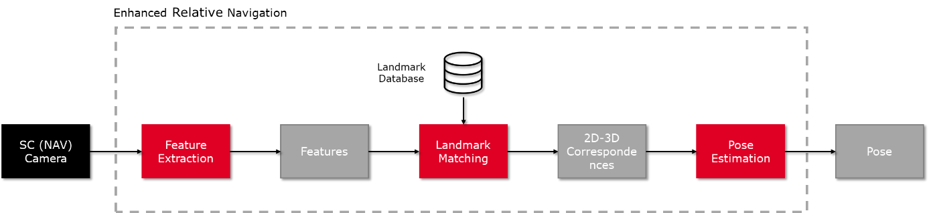
Figure 2. Functional blocks of the Enhanced Relative Navigation.
As the reader can notice, a very important stage is the creation of the Landmark Database, which needs to cover the areas of the asteroid that are to be navigated and with a high accuracy so that the Navigation can use it to reset the accumulated error resulting from the propagation of relative measurements.

Feature Extraction and Matching
The feature extraction block is based on the D2-Net network proposed by M. Dusmanu et. al. [2].
Sparse local features have been applied successfully under a wide range of imaging conditions. These methods follow a detect-then-describe approach that first applies a feature detector to identify a set of keypoints or interest points. The detector then provides image patches extracted around the keypoints to the following feature description stage. The output of this stage is a compact representation for each patch.
However, they typically perform poorly under extreme appearance changes or in weakly textured scenes. Recent results indicate that a major reason for this observed drop in performance is the lack of repeatability in the keypoint detector: While local descriptors consider larger patches and potentially encode higher-level structures, the keypoint detector only considers small image regions. As a result, the detections are unstable under strong appearance changes. This is due to the fact that the low-level information used by the detectors is often significantly more affected by changes in low level image statistics such as pixel intensities. Nevertheless, it has been observed that local descriptors can still be matched successfully even if keypoints cannot be detected reliably. Thus, approaches that forego the detection stage and instead densely extract descriptors perform much better in challenging conditions. Yet, this gain in robustness comes at the price of higher matching times and memory consumption.
The aim of this technique is at obtaining the best of both worlds, i.e., a sparse set of features that are robust under challenging conditions and efficient to match and to store. To this end, it is proposed a describe-and-detect approach to sparse local feature detection and description: Rather than performing feature detection early on based on low-level information, the detection stage is postponed. A set of feature maps is first computed via a Deep Convolutional Neural Network. These feature maps are then used to compute the descriptors (as slices through all maps at a specific pixel position) and to detect keypoints (as local maxima of the feature maps). As a result, the feature detector is tightly coupled with the feature descriptor. Detections thereby correspond to pixels with locally distinct descriptors that should be well-suited for matching. As a result, the proposed algorithm follows a describe-and-detect approach which is able to detect keypoints belonging to higher-level structures and locally unique descriptors.
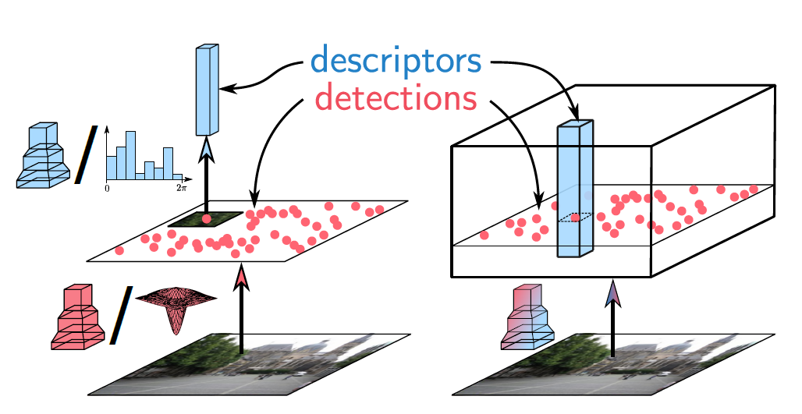
- detect-then-describe | - detect-and-describe
Figure 3. Comparison between different approaches for feature detection and description. Pipeline (a) corresponds to different variants of the two-stage detect-then-describe approach. In contrast, our proposed pipeline (b) uses a single CNN which extracts dense features that serve as both descriptors and detectors. Image courtesy of M. Dusmanu [2].
The VGG16 architecture [5], pre-trained on ImageNet [1] and truncated after the conv4_3 layer, was used to initialize the feature extraction network.
At test time, in order to increase the resolution of the feature maps, the last pooling layer (pool3) from F with a stride of 2 is replaced by an average pooling layer with a stride of 1. Then, the subsequent convolutional layers (conv4_1 to conv4_3) are replaced with dilated convolutions with a rate of 2, so that their receptive field remains unchanged. With these modifications, the obtained feature maps have a resolution of one fourth of the input resolution, which allows for more tentative keypoints and a better localization. The position of the detected keypoints is improved using a local refinement at feature map level following the approach used in SIFT [3]. The descriptors are then bilinearly interpolated at the refined positions.

ERN Database Generation
The generation of the landmark database is an important stage as it largely affects the accuracy of the ERN solution but also its feasibility (when the ERN can be called).
Two main strategies are considered, the first one using directly the images acquired on-board with the associated navigation, and the second using the images acquired for Ground navigation and orbit determination, together with their navigation.

Database Generation using On-Board Images
Given the relative dynamics between the spacecraft and the asteroid, in which the second is observed multiple times during different passes, the most straight forward approach is to generate the database directly in one pass and use this database in later passes.
This approach is simple to implement, as there are no dependencies with Ground. However, it is subject to the higher error of the on-board navigation (which will ultimately affect the accuracy of the ERN as it mostly recovers the error up to the point in which the database was created).

Database Generation using Ground Navigation Images
The second approach is to use the navigation images acquired for orbit determination together with its navigation solution. The navigation images are acquired every hour during periods of 16 hours (the remaining 8 hours are the communication window used to download them to Ground).
The database produced using this method would have a considerably lower error (since the on-Ground navigation solution will be more accurate) and hence the performances of the ERN would be much better. On the other hand, the dependencies with Ground (data needs to be uploaded to the spacecraft) makes it more difficult to implement at mission level.
The number of points on the trajectory in which the ERN could be executed might also be lower as it would be on those previously observed in a navigation image and with comparable conditions. The comparable conditions refer to:
- Asteroid view angle: The area of the asteroid must be seen with a similar incidence angle.
- Ground sample distance: The area of the asteroid must be seen with a similar resolution.
- Illumination conditions: The area of the asteroid must be seen under similar illumination conditions.

Navigation
The translational navigation is based on a hybrid EKF/UKF filter developed by GMV in several previous projects. The scheme block of the navigation algorithm is depicted in Fig. Figure 4. The propagation of the state is performed within the EKF part of the filter in order to reduce the computational load, while the measurement update is performed through an unscented transform to account for the highly nonlinear measurement equations. The filter also contains a state reconfiguration mechanism that is used to manage the addition and removal of features to the filter state. Furthermore, this mechanism is used in case an erroneous measurement is detected through a Mahalanobis check. The propagation step is executed at a frequency of 1 Hz and the measurement update is performed whenever a new image is available. Since the measurement is provided with a delay (due to image transmission and image processing times), the navigation state is estimated N seconds behind the current time and propagated forward to provide an estimate available for use by the guidance and control algorithms.
Figure 4. Translational navigation algorithm.
The navigation filter has also the ability to fuse the information coming from an altimeter. When available, the altimeter measurements can be used to estimate the bias of the ellipsoidal model of the asteroid with respect to the surface and provide a range estimate. In order to use the altimeter, the state is augmented with additional state – the bias of the altimeter.
The hybrid UKF filter used for the navigation filter with unknown features is justified due to the non-linearity of the measurements being fed to the filter. The shape model used to translate pixel coordinates into Cartesian coordinates and vice versa introduces non-linear derivatives that are complicated to handle by means of an EKF. However, the Enhanced Relative Navigation is directly providing a position vector with its covariance. Thus, the measurements are purely linear and the UKF scheme is not justified.
To ease the formulation, an EKF was proposed for the ERN. The position vector provided by the ERN is treated as a direct measurement to estimate the complete state vector (position and velocity) of the spacecraft. Thus, the velocity is also corrected during the measurement updates by means of the previously correlation introduced by the dynamics propagation.

DATASET GENERATION AND TRAINING
The training data for the proposed detector requires pixel-wise correspondences from different images. One possible approach to obtain such information could be to run a classical feature extraction technique and use those correspondences. However, with such method we would not be exploiting the potential of the network as we would be just making it learn how classical methods work.
The solution was to provide the network with images, the camera poses corresponding to those images and quite importantly, the camera intrinsics and the depth maps associated with the viewpoints. With this information, the system can warp points detected in a training image to another one overlooking the same structure. This way the network can learn not only how the appearance of points change with the relative position of the camera, but also how the appearance changes with the illumination (note that if we were using feature correspondences from a classical method, we would not be teaching the network how the structure changes with the illumination, as classical methods are typically not robust to large illumination changes).

Image Generation
During the generation of the images database, specifically in the generation of the synthetic images, several parameters are used to infuse variability into the generated dataset. It was important that the dataset represented the range of target parameters evenly, to not overfit the training of the model to a specific subspace of it.
This scenario posed multiple challenges. Firstly, the knowledge about the asteroid was assumed to be limited to its approximate geometric shape. The nature and characteristics of its surface were not completely known and added uncertainty. The approach we took was to aim for a generic system, through training on a big population of randomly generated samples with the same characteristics of the estimated surface of the asteroid.
Several factors affect how interest features are seen in the images:
- Translations
- Illumination changes
- Pose changes
- Scale changes
- Rotations
The pipeline for the training data generation is depicted in Fig. Figure 5. The starting is a coarse model of the asteroid, in this case the Didymos Reference Model, where an approximate shape of Didymain is provided based on radar measurements. The appearance of the asteroid is defined by setting the albedo parameters together with the boulder and craters parameters. All these inputs are provided to PANGU Surface Modeller tool, which creates the asteroid model in the PAN format. The next step is the actual generation of the images and depth maps. This is achieved with PANGU Viewer tool, for which we provide as inputs the previously generated model, the viewpoints, the Sun positions as well as the camera and other environmental parameters (such as the sky, Sun irradiance, shadow modelling,…). The output, as just mentioned, is a set of images and corresponding depth maps covering the asteroid from multiple points and under different illuminations. The different viewpoints and Sun directions were obtained by sampling spheres centred in the asteroid.

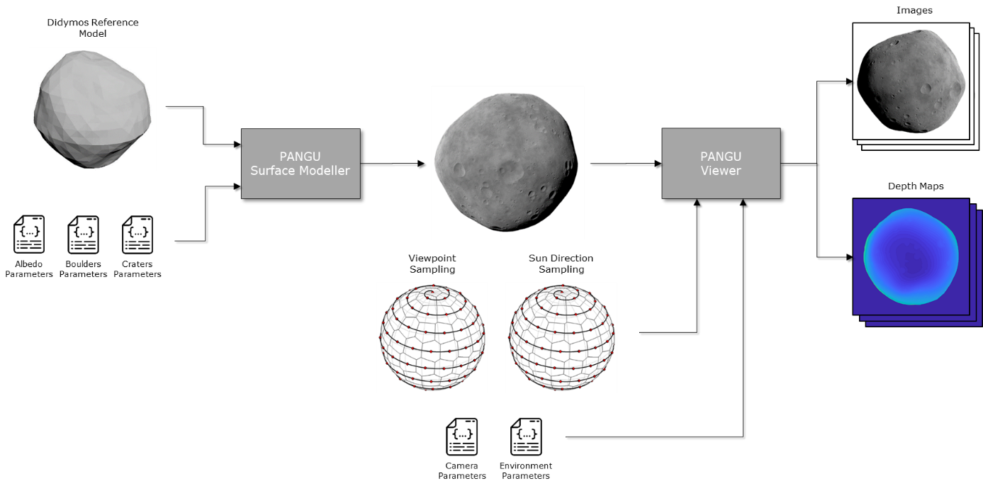
Figure 5. Training images generation.
Given that the most notable features to be expected in an asteroid are craters and boulders, two different models were used for the training, one with a more crater-based appearance and another with a rocky-based appearance. Fig. Figure 6 shows some same training images of the two models.
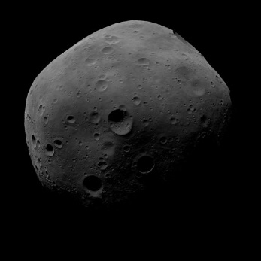 | 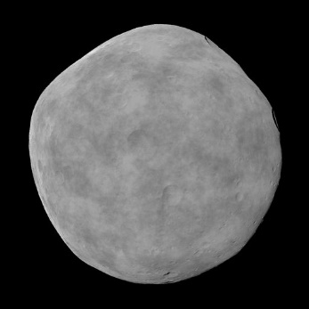 | 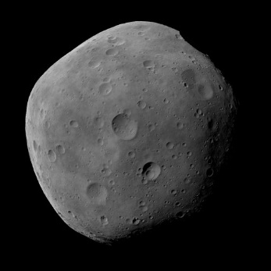 | 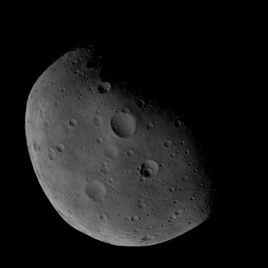
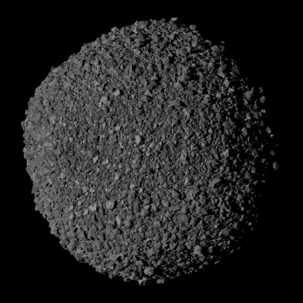 | 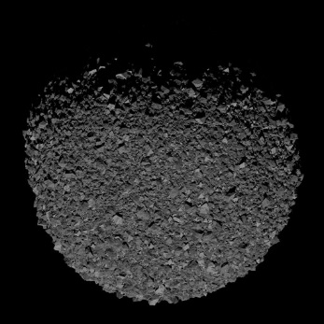 | 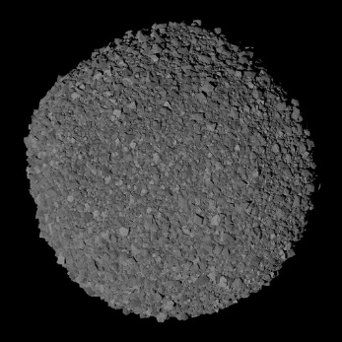 | 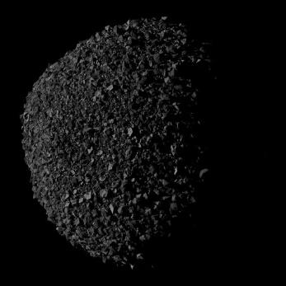
Figure 6. Sample training images

Training
Once the architecture, the loss function and the training data are fixed there are still some parameters that rule the training and must be configured. These parameters are called hyperparameters and the training results depend on them. The hyperparameters can configure the input size, the maximum number of epochs, the learning rate and the optimizer.
The hyperparameter selection was performed by exclusively analyzing the training and validation loss along the epochs, taking into account its value, behavior and convergence. However, a set of unitary metrics have been implemented to track the performances during the training process. The loss function is sufficient for the hyperparameter tuning but might not linked to other higher level aspects we know they benefit a good navigation solution and therefore it does not make possible to judge (without running close loop simulations) whether a trained model should result in better or worse navigation performances. These unitary metrics recorded performances linked to the navigation. Table 1 below summarizes the unitary metric definitions.
Table 1: Metric summary.
Name | Description
Inlier mean | Number of matched points
Coefficient of variation | Number of points within each of the cell of a uniform subsampling of the image.
Inertia coefficient | Inertia ratio between uniform and current keypoints distribution
Area inside the curve | Percentage of the images where keypoints has been detected
Area inside de curve filtered | Percentage of the overlapping where keypoints has been detected
Average distance between landmark (and filtered) | Average distance to the nearest keypoint.
Pixel error mean | Distance in pixel between the Ka keypoint (image A) projected in B and the correspondent Kb keypoint in image B.
Training loss | Based on the triplet loss, tend to decrease distance between correspondent descriptor vectors and increase between no correspondent descriptor vector

RESULTS
As previously stated, proximity operations around a small asteroid are very good candidates for the use of the proposed technique. For this reason, the chosen project reference scenario has been the Very Close Fly-By (VCFB) phase of the Hera mission.
Hera is part of the Asteroid Impact Deflection Assessment (AIDA), an international collaboration between NASA and the European Space Agency (ESA) for planetary defence. NASA’s contribution is the Double Asteroid Redirection Test (DART) mission, a kinetic impactor launched end 2021 that impacted the Dimorphos, the small moon of binary asteroid Didymos, in September 2022.
ESA’s contribution is the Hera mission, which will investigate the binary asteroid system, to measure the results of DART’s impact for asteroid deflection and to provide scientific observations.
The proximity operations of Hera are divided in different phases depending on the mission objectives, and decreasing the minimum distance to Dimorphos. The last phase is the experimental phase which consists of very close fly-bys (VCFB) of the DART crater.
This phase requires autonomous trajectory guidance to decrease the fly-by altitude when the autonomous navigation achieves sufficient accuracy. The complex autonomous algorithms for trajectory navigation and guidance will be rehearsed in the previous phases of the proximity operations.
It is however important to remark that none of the decisions were designed for this particular mission. Hera was considered as a very realistic test case. The validation of the algorithm was performed in close-loop using the Hera mission simulator developed by GMV in the framework of Hera [4] and adapting it to the defined interfaces and with the mission scenario definition.
First, we report the position error of the Hera scenario, whose navigation is based on Feature Tracking and Altimeter. This is useful to be taken as the baseline and to compare results with. Given that the Navigation Filter uses the ERN only to correct the translation, all plots will refer to the position error.
Fig. Figure 7 shows the position error of the Navigation when using Feature Tracking (FT) and the Altimeter (ALT). The blue line shows the actual error at each instant of time whereas the red line shows the 3-sigma being considered by the filter. Each line corresponds to one sample of the Monte Carlo simulation. The navigation is performed with respect to Didymain up to t≈27000, and with respect Dimorphos, from that time onwards.
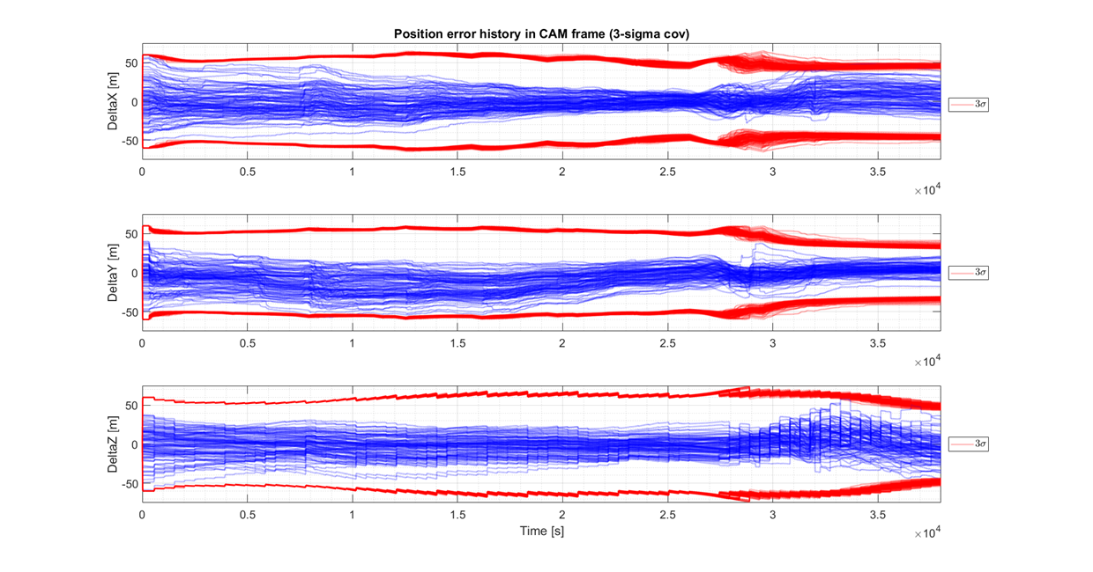
Figure 7. Position error FT+ALT (Hera reference navigation)
Fig. Figure 8 shows the position error when using Feature Tracking and ERN (hence, no altimeter) with eight activations while navigating with respect to Didymain and with two activations while navigating with respect Dimorphos. These eight activations correspond to three different areas of the asteroid observed during the Rehearsals while orbiting around the asteroid. Three activations are performed when the spacecraft sees the first and third areas of the asteroid depicted in Fig. Figure 9 (left), and the remaining two when spacecraft sees the second area. This distribution of the activations allows a better integration of the corrections within the filter, increasing the observability.
Regarding Dimorphos, given that the relative trajectory is mostly a linear approach, the two activations correspond to the same area of the asteroid (see Fig. Figure 9, right).
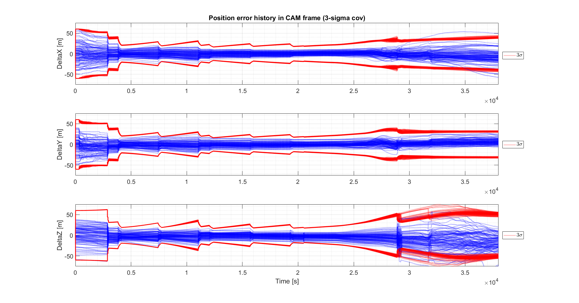
Figure 8. Position error FT+AI_ERN
We can clearly notice how the error is quite constrained during the first part of the trajectory (the one corresponding to Didymain) and how each activation of the ERN, especially the first ones, reduces the error. This can also be observed in the covariance, which decreases in each of the activations.
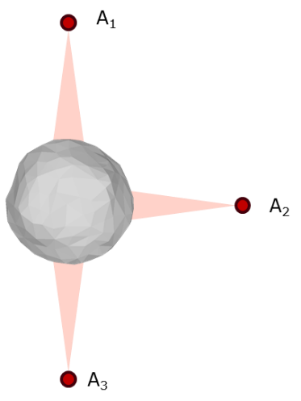 | 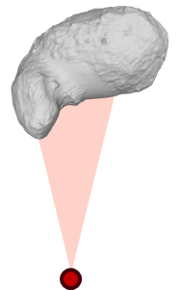
Figure 9. Left, distribution of the areas for the 8 ERN activations on Didymain; right, area of the two ERN activations on Dimorphos.
An advantage of the modular architecture of the ERN is that it allows replacing the main functional blocks by different implementations. In this sense, we have also evaluated the performances achieved already at navigation level replacing the proposed Feature Detector, based on the D2 Network, by a more classical detector based on SIFT.
Fig. Figure 10 shows the position error when using Feature Tracking and an ERN based on SIFT detector/descriptor rather than the proposed AI-based detector. The difference in the first part of the trajectory, when navigating with respect to Didymain is almost negligible. When navigating with respect to Dimorphos, a larger number of corrections are successful (this can be better noticed in the red lines corresponding to the covariance, where we can see that for SIFT_ERN and the first activation in Dimorphos, all lines are concentrated) and the overall error at the end of the trajectory is a little bit smaller.
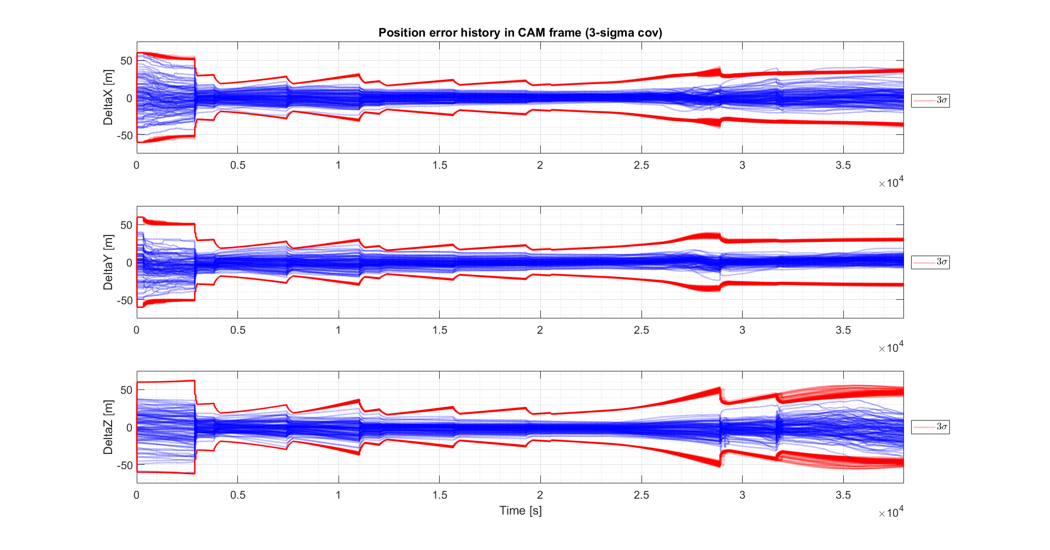
Figure 10. Position error FT+SIFT_ERN
Table 2 summarizes the results of these tests and observe numerically the improvements provided by the ERN with respect the nominal FT+ALT navigation in Hera. The errors are provided at times t=25000, before switching from primary to secondary, and t=38000, the end of the trajectory.
Table 2: Error statistics.
Test case | Statistic | t=25000 |  |  |  | t=38000
 |  | x [m] | y [m] | z [m] | total [m] | x [m] | y [m] | z [m] | total [m]
FT_ALT | min_error | 0.04 | 0.04 | 0.33 | 1.42 | 0.55 | 0.01 | 0.21 | 5.00
FT_ALT | max_error | 15.65 | 24.88 | 28.06 | 35.66 | 45.99 | 20.91 | 44.82 | 59.64
FT_ALT | mean_error | 0.56 | -1.7 | -2.24 | 14.41 | 5.23 | 4.55 | -5.92 | 20.71
FT_ALT | std. dev. | 6.37 | 9.57 | 10.51 | 6.41 | 13.9 | 7.02 | 14.81 | 10.61
FT_ALT | 95% cases below | 23.98 |  |  |  | 39.72
FT_AI_ERN | min_error | 0.04 | 0.02 | 0.06 | 1 | 0.03 | 0.03 | 0.28 | 3.59
FT_AI_ERN | max_error | 11.43 | 14.43 | 22.64 | 23.43 | 57.39 | 25.23 | 74.23 | 93.72
FT_AI_ERN | mean_error | 1.81 | 0.71 | -4.56 | 9.43 | -8.14 | 6.77 | -16.75 | 26.89
FT_AI_ERN | std. dev. | 4.16 | 5.08 | 6.73 | 4.85 | 15.35 | 6.54 | 17.34 | 15.66
FT_AI_ERN | 95% cases below | 18.68 |  |  |  | 51.23
FT_SIFT_ERN | min_error | 0.07 | 0.01 | 0.01 | 1.39 | 0.06 | 0.02 | 0.15 | 3.27
FT_SIFT_ERN | max_error | 10.87 | 11.18 | 14.57 | 16.59 | 36.77 | 18.26 | 47.35 | 55.71
FT_SIFT_ERN | mean_error | 0.68 | 0.8 | -2.68 | 7.6 | 0.27 | 2.9 | -8.05 | 17.09
FT_SIFT_ERN | std. dev. | 3.81 | 4.37 | 5.24 | 3.31 | 10.19 | 5.08 | 13.55 | 9.6
FT_SIFT_ERN | 95% cases below | 13.15 |  |  |  | 34.26
As it can be noticed, the error during the first part of the trajectory is always better for the FT+ERN combination. As mentioned before, we can also observe that the AI-based ERN combination performs slightly worse than the SIFT-based ERN. We found this was due to the following reasons:
- Features were worse distributed (tent to concentrate always in higher gradients, such as in the asteroid limbo or shadows)
- Less matches were typically found, providing worse pose estimates (especially in more challenging situations)
- More sensitive to scale. This is more noticeable in the Dimorphos, as in the database created during the Rehearsals, Dimorphos is seen from a farther distance compared to the actual approach during the VCFB.
Robustness to Asteroid Shape and Appearance
Due to the uncertainty on the asteroid shape and appearance, dedicated tests on evaluating the performance of the ERN under different shapes (more concave asteroid vs convex one) and appearances (cratered, rocky). The shape of the asteroid did not have any relevant impact on the performances. Conventional IP ERN provided comparable performances independently of the appearance of the asteroid.
On the other hand, the Hybrid ERN was indeed impacted by this appearance, especially for the rocky version. There were considerably lower detection and matching rates, which translated into less effective and accurate corrections. Specific trainings of the CNN with only cratered or only rocky asteroids behaved slightly better than the combined trainings (using both images with craters and images with rocks). The same problems already identified for the default scenario also happened in the appearance variations: worse distributed features, less matches and sensitivity to scale.
Sensitivity Analyses
Given the dependence of having a database created under similar conditions to the moment when ERN is actually called, it was important to understand how close these conditions need to be. For this reason, we performed different sensitivity tests on the three factors that have the major influence: illumination conditions, viewing direction and viewing scale.
The algorithm shown to be robust to differences in illumination ranging from -15 to -60, where the accuracy was fairly constant in all cases. The covariance, nevertheless, captured the increasing uncertainties and clearly indicated when the measurements were not reliable. For the positive values, the range is more limited and the ERN provides accurate measurements up to +15 degrees.
The reason of this asymmetric range is that the nominal phase angle is approximately -30 degrees. The algorithm is robust to large differences in the phase angle (up to 60 degrees) as long as the difference only translates into projected shadows more or less elongated, but in the same direction. If the difference in the phase angle translates into shadows almost disappearing (due to a phase angle of 0 degrees) or projecting in the opposite direction, the algorithm is not capable of finding matches between the reference database and the current image.
Regarding to the viewing direction, up to a difference of ±10 degrees in the viewing direction between the database and the on-board image, the ERN performed without significate degradation. Starting on ±20 degrees, the performance was degraded but the covariance managed to capture this decrease in the performance.
With regards to the difference in scale, up to a scale factor of 2, the ERN performed without significate degradation (with increasing covariance, showing the lower confidence) but starting on 2.5, the performance was slightly degraded. For a scale factor of 3, the algorithm hardly provides good measurements. Again, the covariance captured the degradation.
Laboratory Validation
The algorithm has also been validated in a GMV’s robotic facility, platform-art©, using a real camera and asteroid mock-ups instead of using synthetic images.
The chosen camera was representative of the proposed camera for the Hera mission, providing the same field of view and resolution.
Previous Hera mock-ups available at GMV had a scale factor of about 2000, which means a Didymain mock-up of 40cm diameter and Dimorphos mock-up of 10cm diameter This was considered the best trade-off value for Hera because they were originally oriented at simulation of phases at farther distances to validate the centroiding algorithm and they lack lower-level detail.
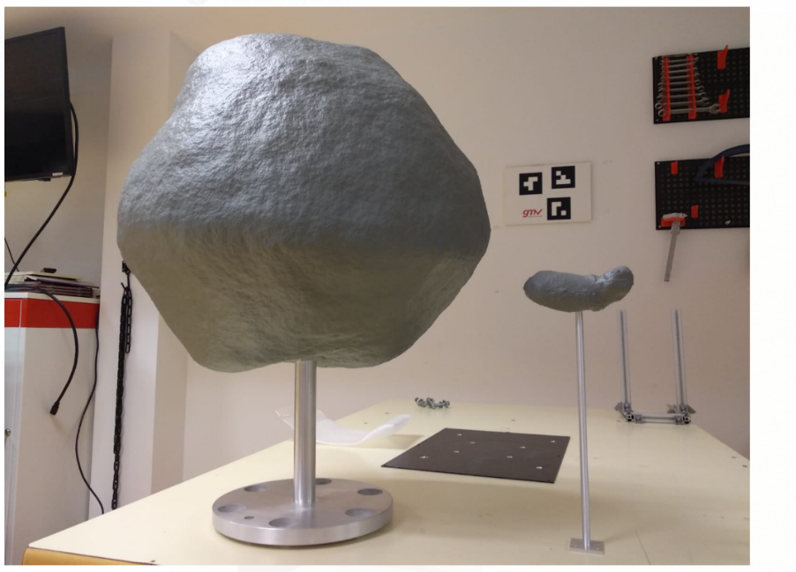
Figure 11. 1:2000 Hera mock-ups
For this work, considering that the focus is on simulating the VCFB and the final part with Dimorphos, the proposed solution was thus to simulate the first part of VCFB with the previous 1:2000 mock-up of Didymain and simulate the final part of VCFB with a new 1:300 mock-up of Dimorphos. The creation of a larger size mock-up also allowed adding small sized details missing in the existing model. The VCFB trajectory became two separate trajectories (one for Didymain and one for Dimorphos), where we maximized the coverage that was so constrained due to the use of a narrow FOV at short distances. Fig. Figure 12 shows the new manufactured model and a close-up showing the fine detail added to simulate the asteroid relief at closer distances.
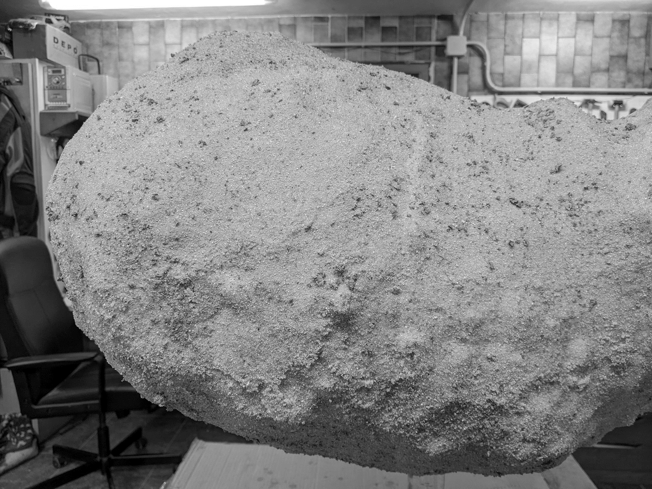 | 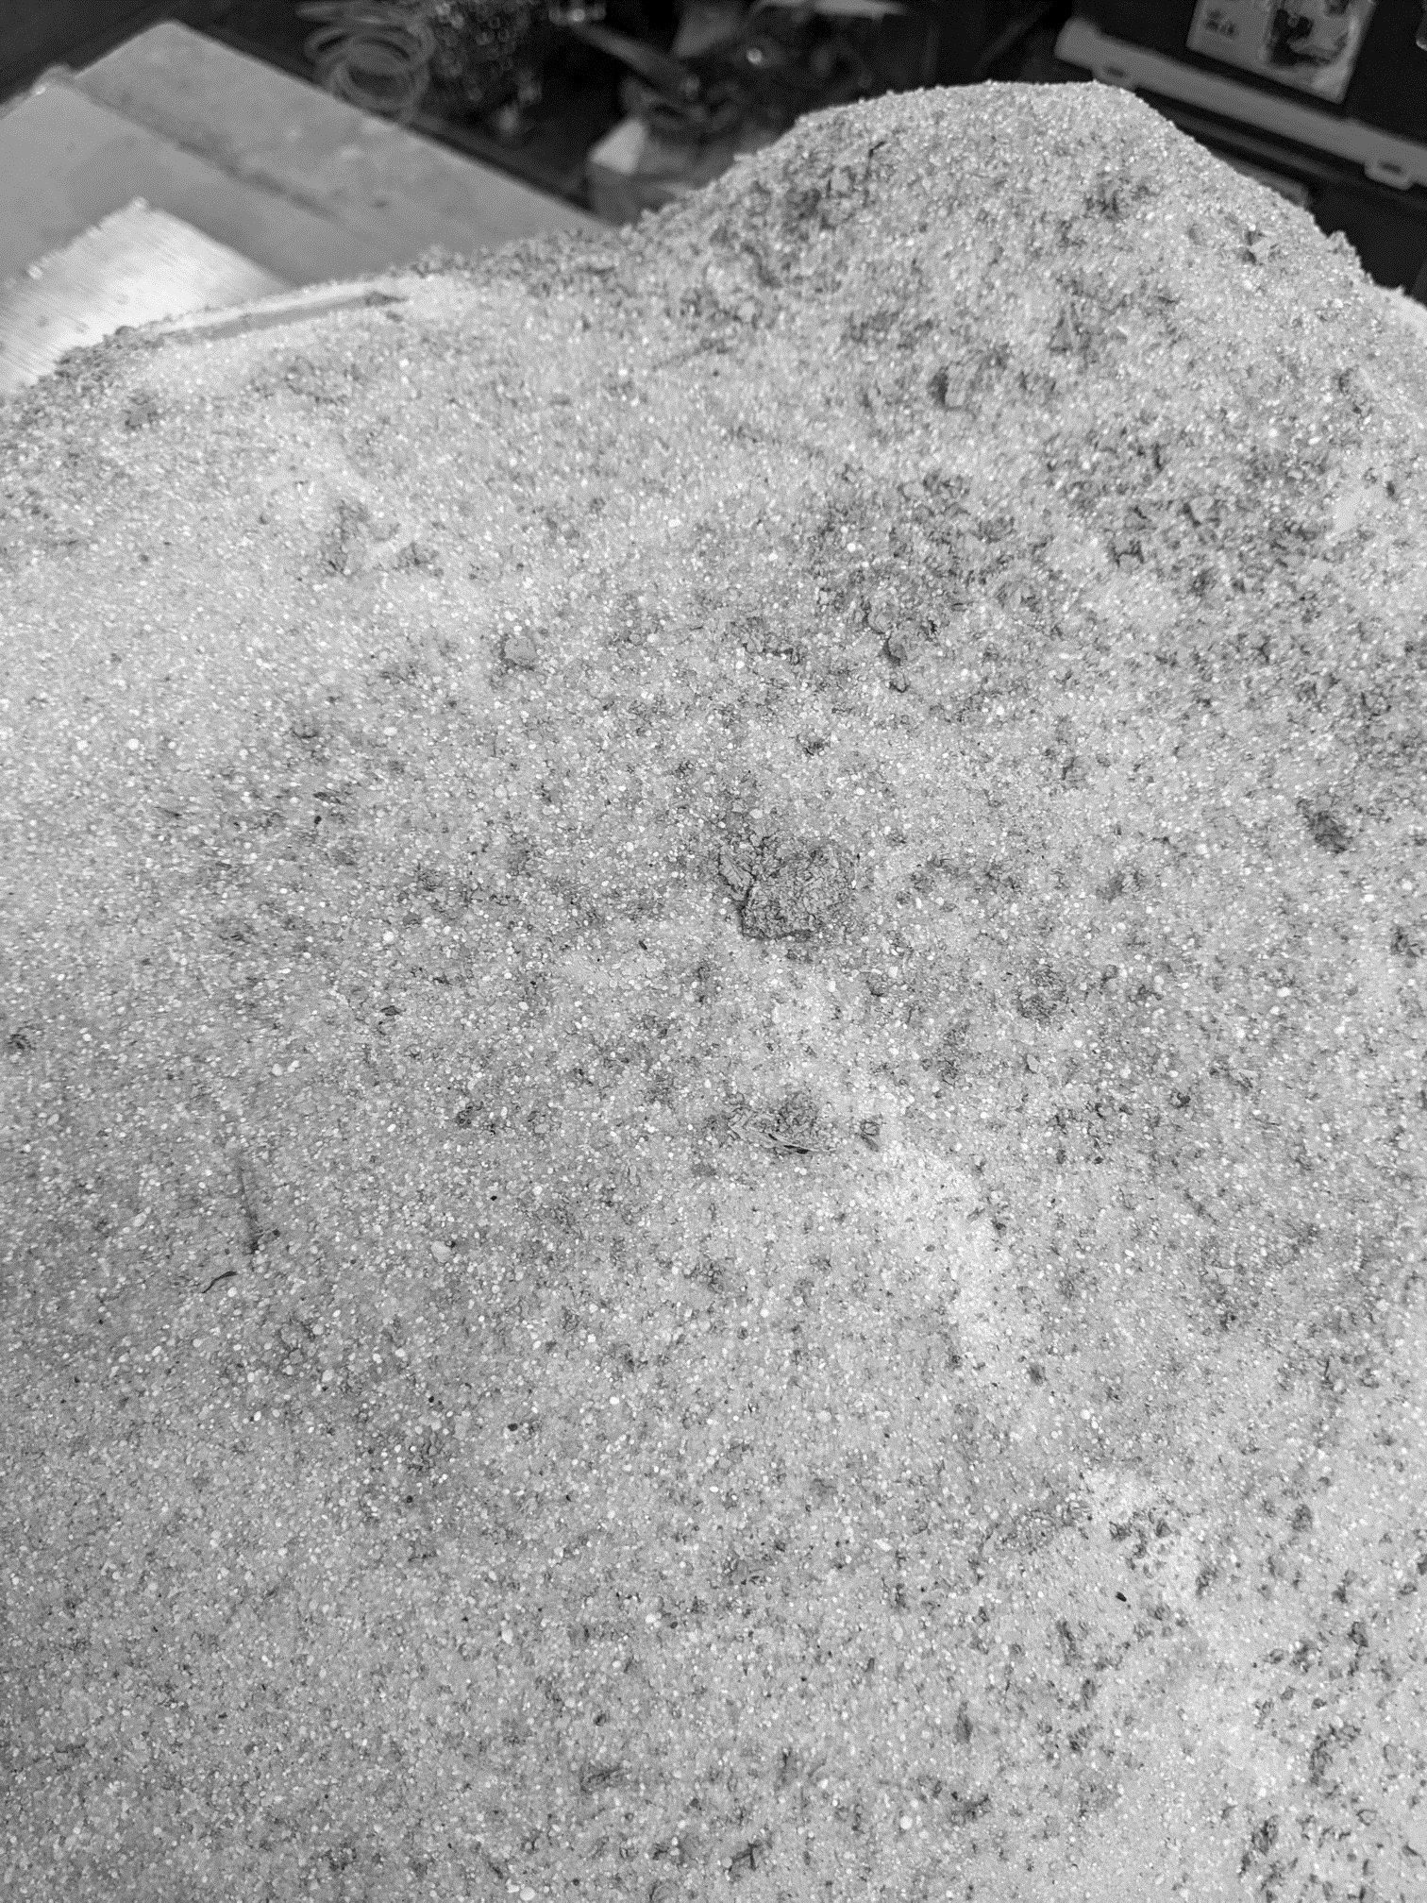
Figure 12. New model of Dimorphos
The same VFCB trajectory used in the previous simulations was implemented in the laboratory. Fig. Figure 13 shows a comparison between the reference image generated with PANGU and the one captured at the laboratory. Note that due to physical constrains, exactly the same illumination conditions could not be recreated.
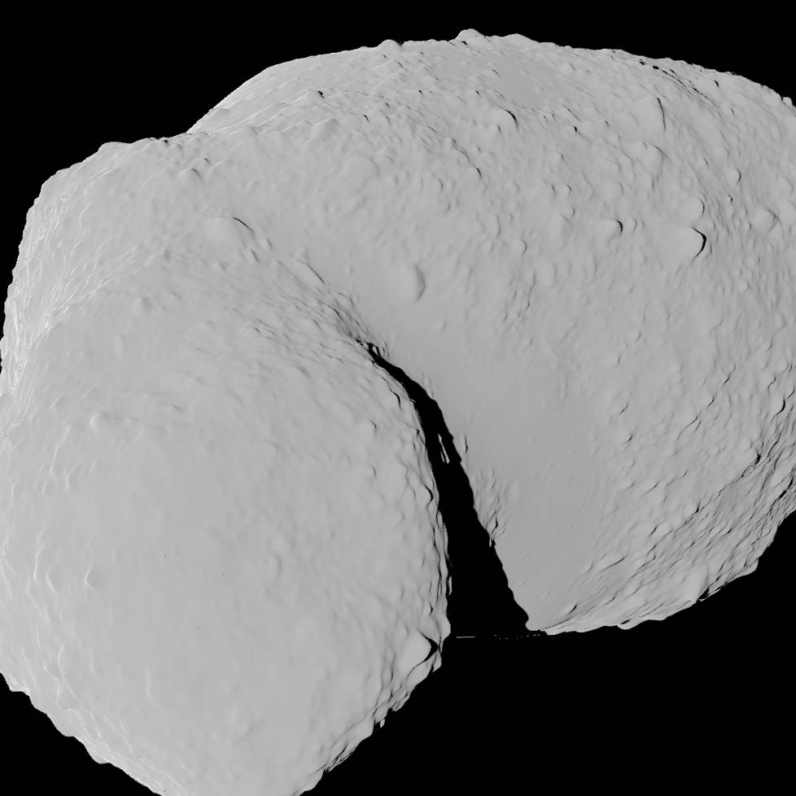 | 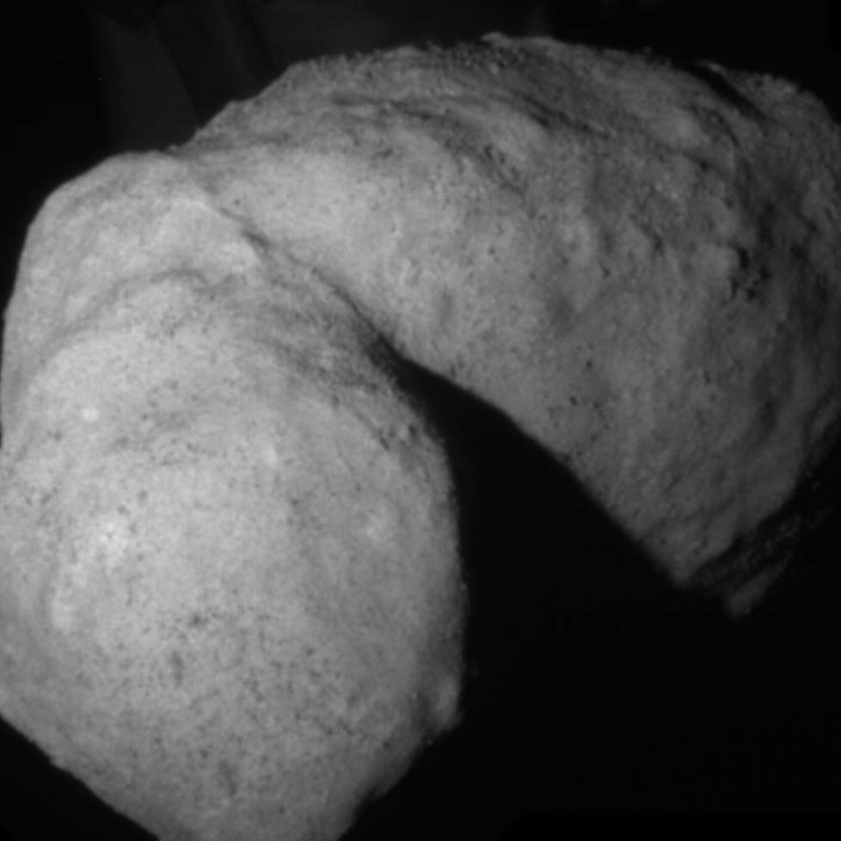
Figure 13. Reference (PANGU) image vs Laboratory image
The observed performances in the laboratory were s slightly lower than those obtained in the synthetic images. In addition, the covariance show less confidence on the measurements. Nevertheless, it is important to note that these performances should not be compared directly with those obtained with the synthetic images due to the additional sources of error:
- Ground-truth obtained in the laboratory is not perfect because of the calibration residuals and errors in the robots telemetries.
- Scaling factors. The primary mock-up has a scale of 1:2000, whereas the mock-up of the secondary has a scale of 1:300. This does not mean the results obtained in the laboratory tests should be divided by 1:2000, because the navigation errors used to create the database were scaled accordingly, but inaccuracies both of the algorithm and in the ground-truth are scaled by a large factor.
Even with these issues and also with an excessively simple mock-up of Didymain (this model was manufactured within Hera for farther distances), the algorithm performed well and no significant degradation of the performances was found.

CONCLUSIONS
A navigation architecture has been proposed using image processing techniques integrated within a navigation filter performing the data fusion of the UP and the rest of GNC sensors.
Different proposals have been considered following conventional IP algorithms but also new AI-based approaches, together with a hybrid version trying to combine benefits from both worlds.
The exhaustive testing and validation campaign has allowed to evaluate the performances of the Enhanced Relative Navigation under a wide range of situation and confirm its suitability for a mission such as Hera. The following list summarizes the main conclusions obtained:
The combination of Feature Tracking and ERN (without altimeter) provides comparable and even slightly improved performances to the nominal Feature Tracking plus Altimeter navigation of Hera if the database is created with the on-Ground navigation solution.
- Activations in Dimorphos are needed to achieve this higher performance.
- Creating a database for Dimorphos with images sent to Ground can be more challenging from an operations point of view as it involves observing it first under similar conditions to those to be faced during the actual ERN execution (this was shown to be fairly reasonable to achieve for Didymain).
- Nevertheless, sensitivity analyses have shown a reasonable tolerance to illumination conditions, viewing angle and scaling, which should facilitate this problem.
- Still, even if no ERN is used in Dimorphos, and just Feature Tracking is used for this part, the navigation solution does not degrade significantly (only the range accuracy is slightly reduced).
The database creation with the on-board navigation solution does not bring benefit except as a contingency in case of an (unexpected) filter divergence. This is due to the good design of the Hera navigation filter, which uses a SLAM-based approach and therefore no direct integration of the error in the relative measurements of the Feature Tracking is taking place. In case of a simpler filter design, where current pose is achieved as an integration of relative measurements, the ERN would allow resetting the overall accumulated error to a value comparable to the one when the database was created.
The ERN provides comparable performances independently of the appearance of the asteroid, and no additional training or tuning is needed. HIL tests have confirmed the solution is not affected when switching to real images acquired by a real camera.
AI-based ERN has also a slightly worse performance than the conventional ERN.
- Features are worse distributed (tend to concentrate always in higher gradients, such as in the asteroid limbo or shadows)
- Less matches are typically found, providing worse pose estimates (especially in more challenging situations)
- More sensitive to scale.
- More sensitive to the asteroid appearance, requiring a dedicated training for the asteroid appearance to improve its performance.
The AI-based solution has also shown its suitability and potential to be used for navigation purposes, but still need to be consolidated, especially considering the additional implications they impose (training, execution time…).
As future work, a breadboarding of the algorithms in representative HW should be performed to characterize the execution time (although given that no continuous ERN corrections are to be performed, the requirement on the execution time could be less demanding than for the FT which is executed continuously). Given the dependencies with Ground operations, a more comprehensive study of the required interfaces and the definition of the Concept of Operations, especially for the on-ground database generation would also be required.

REFERENCES
- J. Deng, W. Dong, R. Socher, L-J Li, K. Li, and L. Fei-Fei: ImageNet: A large-scale hierarchical image database. Proceedings Computer Vision and Pattern Recognition, 2009.
- M. Dusmanu.I. Rocco, T. Pajdla, M. Pollefeys, J. Sivic, A. Torii and T. Sattler: D2-Net: A Trainable CNN for Joint Description and Detection of Local Features. Proceedings Computer Vision and Pattern Recognition, 2019.
- D. G. Lowe: Object recognition from local scale-invariant features. Proceedings International Conference on Computer Vision, Corfu, Greece, pp. 1150–1157, 1999.
- Á. Palomino, A. Pellacani, F. Da Silva, A. Alcalde, F. Pace, A. Cortesse, R. Contreras, F. de Arribas, F-A. Stancu, and P. Colmenarejo: Design, Development, Validation and Verification of the HERA GNC subsystem.
- K. Simonyan and A. Zisserman: Very deep convolutional networks for large-scale image recognition. Proceedings International Conference on Learning Representations, 2015.

