ESA Telecom’s Pioneer programME: achievements and evolution
Philippe Sivac ⁽¹⁾, John Shirlaw ⁽²⁾, Clive Edwards ⁽³⁾, Christopher Topping ⁽⁴⁾
(1) European Space Agency, ESA Toulouse Office, 18, Avenue Edouard Belin, 31401 Toulouse Cedex 9, France, philippe.sivac@esa.int
(2) European Space Agency, ESA/ECSAT, Fermi Avenue, Harwell Campus, Didcot, Oxfordshire OX11 0FD, United Kingdom, john.shirlaw@esa.int
(3) European Space Agency, ESA/ESTEC, PO Box 299, 2200 AG Noordwijk, The Netherlands, clive.edwards@esa.int
(4) European Space Agency, ESA/ESTEC, PO Box 299, 2200 AG Noordwijk, The Netherlands, christopher.topping@esa.int

introduction
The paper will present the achievements of ESA’s Advanced Research in Telecommunications Systems (ARTES) Pioneer programme and provide perspectives and trends anticipated for future projects.

Pioneer has been a very successful Partnership programme under ARTES, enabling launch of 18 nanosatellites since 2018 (Figure 1), each embarking advanced technologies and demonstrating space-based applications and services. Through the Pioneer development contracts and launches, several entrepreneurs have already established themselves as reliable Space Mission Providers, capable of offering in-orbit validation services on the world market.

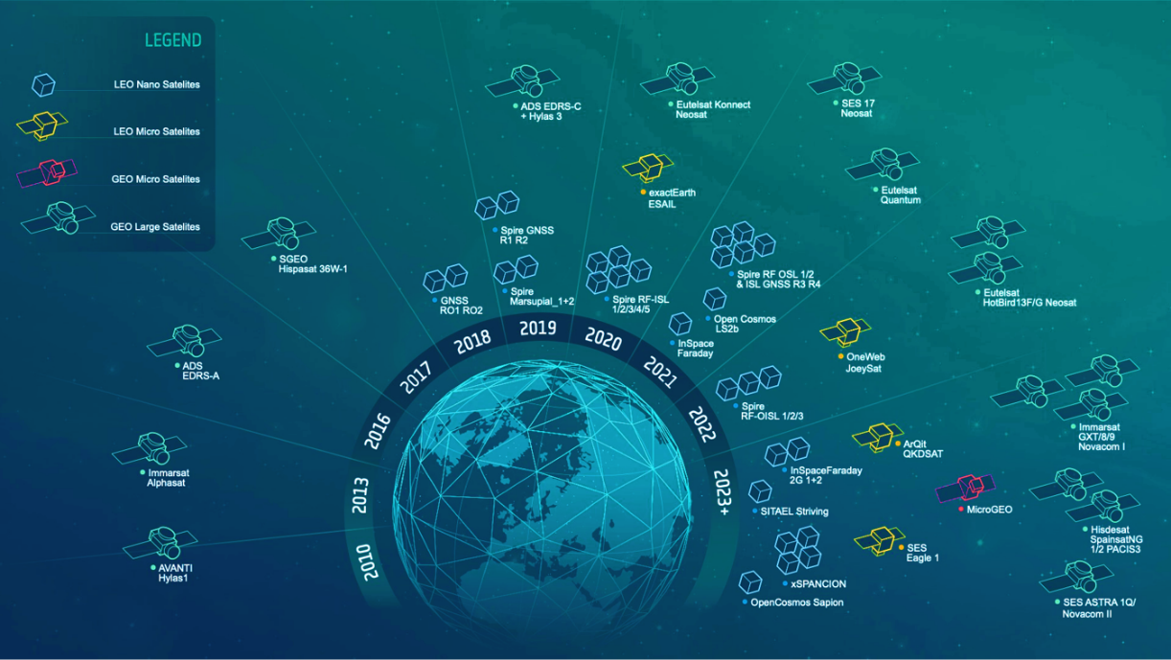
Figure 1. Past and planned Pioneer Launches (in blue), complementing
ESA Telecom’s successful Partnership Projects portfolio

The pioneer concept and Scope
Pioneer aims at supporting the emergence of commercial entities that are interested in becoming one-stop-shop service providers for In-Orbit Demonstration or Validation (IOD/IOV) missions. Those entities should offer to both private and public entities affordable and effective access to space for testing, validating and/or operating innovative solutions.

For example, the customer of a Pioneer entity can be an operator or service provider needing to test a new service, a manufacturer needing to qualify a new technological solution, or an institution/national agency wishing to test a new technology or to develop a new application. Today, both private companies and public institutions wishing to implement those missions face a high barrier to entry. The “offer to fly” across Europe is based on isolated initiatives which tends to make access to space infrequent, and lengthy. It is also costly and often has long and unpredictable schedules.

Obviously, New Space entrepreneurs can provide “offers to fly” on a much more cost competitive and faster scale than traditional space actors. ESA’s Pioneer programme’s main objective is to boost industry, and in particular the New Space entrepreneurs, to develop the skills and infrastructure to provide these frequent IOD/IOV opportunities.

Pioneer projects are based on the successful Partnership Project concept, where the European Space Agency (ESA) and its Telecommunications and Integrated Applications Directorate co-fund the innovative aspects of a project with a private partner. In the case of Pioneer, the ESA project covers all phases of a space mission, from system engineering tools to platform design, build and test of technologies and full end to end systems, through to deployment and data delivery to customer (Figure 2).

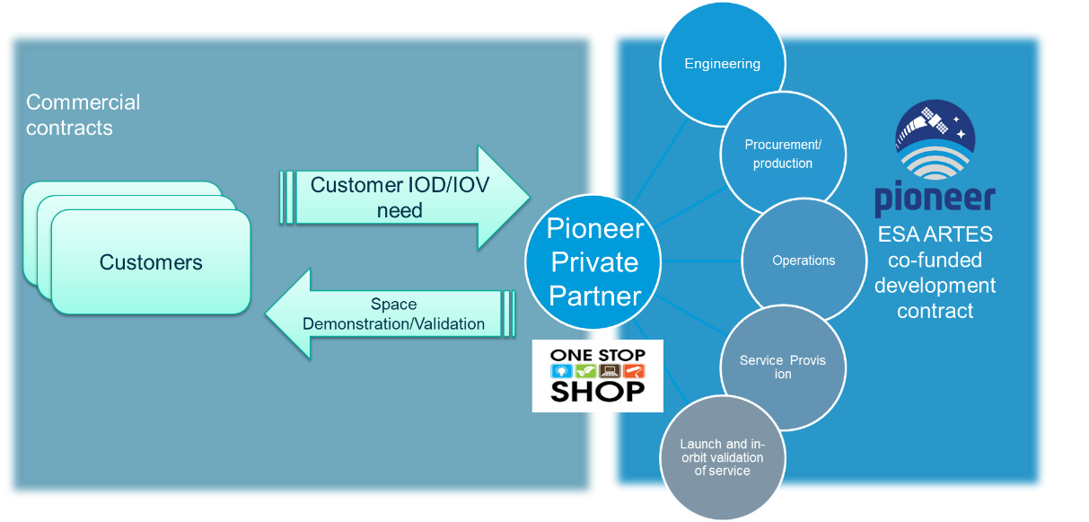
Figure 2. The Pioneer concept

The pioneers

Since 2016, several private companies have partnered with ESA to become Pioneer primes based on New Space approach. With 18 spacecraft launched and up to 11 more planned in the 2022-2023 period, the programme has been and continues to be successful in helping new entrepreneurs emerge on the market. The 6 Pioneer Primes today are:
- Spire (UK) with 16 spacecraft launched, ranging from 3U to 6U has been the most active with in-orbit demonstrations, on its own behalf, of various aviation, maritime and data services.
- Open Cosmos (UK) launched an Internet of Things service demonstration based on a 3U satellite in 2021, with another launch planned in 2023
- In-Space Missions (UK), launched a first 6U satellite in 2021, and has 2 more larger satellite launches planned for 2023, with still spare capacity for several other demonstration payloads and services
- AAC Clyde Space (UK) is planning to demonstrate Internet of Things with 12U satellites in the 2023 time frame
- SITAEL (I) is working on a 75 kg platform, with up to 5 payloads, for launch in 2023
- Space Inventor (DK), on a smaller scale with a 6U satellite planned in 2023

In addition, Airbus (F) has also been active in Pioneer to adapt its LEO platform to a multi-mission environment.

Achievements
While each Pioneer project is a self-standing independent activity, there are a number of common achievements worth noting for prospective companies who may wish to join Pioneer or its follow-on scale-up programme, Sprint.

4.1 Mission Achieved – Delivering Commercial Services
In line with the objectives of Pioneer, most of the New Space companies within the Pioneer programme are now offering IOD and IOV services on the market. These companies have in fact been able to set up the equivalent of a business unit dedicated to space services, leveraging on the infrastructure developed under Pioneer. This new business doesn’t just make use of the Pioneer spacecraft hardware and software innovation, but of the whole suite of tools developed in the project. The most successful Pioneer companies are now engaging with commercial and institutional entities worldwide. The new developments have become part of their standard offerings, enabling sales of IOD/IOV services as well as more consolidated data services. Additionally, partnership with ESA has also proven to be helpful to the Pioneer entities to attract new customers to their space service, with ESA’s supervision and guidance on the more innovative developments perceived as mitigating technical risks.

4.2 Scalability
One of the common themes that has come out of different Pioneer projects, is the need for scalability of the platform offering. In this aspect, ESA has supported different SMPs to scale their offering from 2 or 3 U Satellites, up into 6 and 12U or even larger spacecraft including up to 150 kg small satellites. In some cases scalability is an integral part of the mechanical structure design, allowing different configurations with standard mechanical elements. The advantage of having larger platforms to offer for an SMP is the availability of more, power, and critically earth deck space for instruments and antennas.

4.3 Inter Satellite Links
Another common theme that the different SMPs are finding that their customers are interested in is the availability of Inter Satellite Links (ISL) for both communicating between co-operating spacecrafts, but also to reduce the latency of data delivery to their end customers.. ESA has therefore supported different SMPs to develop the infrastructure required to provide this capability to their customers. This has included the development of both Radio-Frequency (RF-ISL) and Optical (O-ISL) capabilities. The key for optical is to create a capability that can be deployed at scale to support a reasonable sized constellation, while maintaining an appropriate price point, and maximising the utilisation of COTs parts and processes.

The other side of providing inter satellite links, is their operational use. When to pass data from one spacecraft to another and which one, along with the trade-off that choosing to make an ISL contact, may mean that the primary spacecraft payloads need to be switched off in these power managed/limited spacecraft. It has been fascinating to support these trade-offs, as part of a delay tolerant network definition and to review the SMPs different approaches to the optimisation of their ISL solutions to meet their required quality of service.

Another aspect of the use of the inter satellite links, is the need to maintain spacecraft in an appropriate spatial relationship. At the orbital altitudes of most of these services, the horizon is only 5000 km away. Thus depending on the different launch separation velocities and utilisation of the spacecraft which changes the drag of the spacecraft, it can take a relatively short time before active management of the orbit is required, to allow the spacecraft to stay visible to each other.

4.4 AOCS
In creating their Space Mission provide Services a number of the SMP providers have upgraded their AOCS systems, this has varied, depending on the companies approach, between developing their own AOCS algorithms running on standard hardware, to completely replacing a commercial AOCS, with an in-house solution allowing the company more opportunities for customisation and the ability to enhance the product to meet customer needs. The ability to offer improved pointing performance to either support customer missions or the use of O-ISL, has lead most companies to introduce star trackers into their offering, either using commercial off the shelf products, or in house developed sub-systems, the development of which was supported as part of the Pioneer programme.

4.5 Propulsion
Propulsion is an area which is developing rapidly in the Cubesat and Nanosat fields. More capable spacecraft are being developed with the need of significant propulsion capability for orbit acquisition and correction manoeuvres, life extension and de-orbit management. In the Pioneer programme, innovative propulsion solutions have been investigated including both conventional chemical propulsion systems and high performing electric propulsion. The ability to incorporate these systems into the Pioneer projects is an enabler for constellations where significant delta-V is required for constellation orbit acquisition, phasing, collision avoidance and end-of-life de-orbiting. The trade-off between the use of electric propulsion and the availability of power for the primary mission is another complex trade-off which has been a common theme which the companies have had to solve.

4.6 Edge Computing
Another area which appears to be of interest to different SMP customers is the provision of Edge Computing, particularly for running Artificial Intelligence applications. These vary from advanced FPGAs such as the Xilinx Ultra-Scale Plus, to GPUs such as the Nvidia Jetson processor. These offer the opportunity for the SMP to deploy additional services, to support “Mass less” payloads, which can be uploaded to an already in-orbit spacecraft. A number of the SMPs supported under Pioneer are now offering this capability.

4.7 On-Boarding Customer Payloads
Another consideration which each of the SMPs has realised it need to address, in developing its Space Mission Provider Service, is how to support their customers to develop the item they want to fly. Particularly, how to work with the interfaces the SMPs platforms make available, be that a particular flavour of CAN bus, or which low voltage power lines are available. Furthermore the integration of the payloads into the flight control interface to allow the customer to control and manage their payload once it is in orbit is another challenge. Within the Pioneer programme, each SMP has developed their own unique solution to this challenge, varying from using COTS single board computers, to bespoke developments.

4.8 Model Based System Engineering
Model Based System Engineering (MBSE) techniques are becoming increasingly important in helping to address the inefficiency which can occur in traditional satellite system development approaches. The MBSE approach can help to streamline not only the system engineering design, but also extend into other areas such as production and test management, launch service coordination, operations and downstream customer interface integration. Within the Pioneer programme model-based systems engineering architectures are being developed using a framework based on the ESA Space System ontologies. The architectures being developed are flexible enough to be able to interface with other tools across a wide range of business areas driving efficiency and reducing costs across the whole business enterprise.

4.9 Workstreams
From the ESA side of working with industry to manage up to 7 individual, parallel complex and multi-dimensional projects, a key innovation has been the introduction of workstreams into the projects. Different elements of the project are split into different work streams, thus for instance, the AOCS upgrade may be in one work stream, while the ISL may be in another one and MBSE a third. Each work stream can then run at its own pace, with the company able to dynamically prioritise different work streams to adapt to their evolving needs to respond to the market.

outlook
The Pioneer programme aims to continue supporting industry, in view of the various trends that are emerging and the interest of industry to evolve and remain at the forefront of innovation. Among others, the following evolutions have been identified: bigger spacecrafts, more integrated customer experience and environment for payload tasking and data delivery, integration of propulsion capability, multi-sensor capability, autonomous operations and on-board intelligence.

Looking to these future projects, the Pioneer objectives remain very much up to date, namely to support industry competitiveness by attracting entrepreneurs and service providers in the satcom market, thus furthering the adoption of new satcom solutions to offer affordable and timely IOV/IOD opportunities. This in turn lowers the entry barriers faced by public and private entities wishing to demonstrate new and advanced technologies, systems, services and applications in a representative operational environment.

There is a clear need to continue fostering innovation and improve the level of ESA support both financial and technical towards industry. The programme frame in ARTES is being updated, to allow up to 80% co-funding by ESA for SMEs. It should be noted however that the launch costs of the first mission, aimed at validating the company’s infrastructure, will no longer be supported, in line with other conditions of similar ESA programmes.

sprint
“Graduating” Pioneer primes, who have demonstrated mature infrastructure, up to in-orbit validation missions, proving their capability to host, fly and operate payloads on behalf of their customers, in line with the one-stop-shop concept, may wish to extend their offering further with specific services targeting dedicated applications. Sprint is proposed to be implemented in the frame of ESA’s ARTES programme, to stimulate this further growth of New Space entrants. The objective is to support the innovative aspects of new small satellite type missions for markets and services requiring connectivity and other space applications. This may include satcom capabilities augmented by Internet of Things, earth observation, computing and on-board or on-ground Artificial Intelligence capabilities.

Sprint industrial partners may include:
- industrial partners that demonstrated their capabilities under Pioneer and are now planning to validate and extend their service offering further;
- new partners, with demonstrated capabilities in the field of small satellite missions, wishing to reach towards pre-operational status, in partnership with ESA, for their new services.

Sprint will provide all the necessary expertise to the industrial partner, drawing the required skills from ESA’s Telecommunications and Integrated Applications Directorate as well as others and in particular, ESA’s Technical Directorate.

Conclusion
Through Pioneer, industry is well positioned to offer one-stop-shop access to space, minimising barriers to entry and catalysing new and disruptive space-based applications for the benefit of the growing community of entrepreneurs and newcomers to the space sector and for private and institutional actors looking for a quick, cost-effective solution to validate their product or service in orbit.

The Pioneer programme will soon benefit from improved co-funding conditions, aligned with other ESA partnership schemes, which in practice, means that ESA can co-fund up to 80% for Small and Medium Enterprises.

Beyond Pioneer, ESA Telecoms is introducing Sprint to accompany the Pioneer primes to the next step in service delivery and support new companies seeking to partner with ESA to reach pre-operational status of innovative services beyond IOD/IOV.

