INSTRUCTIONS TO AUTHORS FOR THE PREPARATION OF PAPERS

Principal Author Name (1), Co-Author Name (1), Co-Author Name (2)

(1) Affiliation, Complete mailing address (including country), Email: {author.one; author.two}@email.int

(2) Affiliation, Complete mailing address (including country), Email: author.three@email.int

***Abstract*—The proceedings of 40th ESA Antenna Workshop will be published by ESA on a USB stick. Authors must deliver their full papers by 6 September 2019 as electronic PDF files via the 40th ESA Antenna Workshop Portal. Please read the following instructions for the preparation of your paper in accordance with ESA’s standards for conference proceedings. Each submission should resemble these instruction sheets in format and style. Start with a concise abstract (limited to 15 lines or 150 words) that summarises the contents of the paper.**

# General Specifications

The paper must be prepared in this two-column format and **must not be longer than** 8 pages.

# Word Template

## Page Layout

* Paper format: standard A4 (297x210 mm),
* two-column format (8 cm each column),
* margins: top 27 mm, left and right 21 mm,   
   bottom 35 mm,
* fully justified,
* the header should be left empty,
* the footer should not be modified,
* do not add page numbers.

Font:

Text: Times New Roman

Variable: Times New Roman italic

Symbol: True Type Symbol font

Type Size:

Paper title: 14 pt bold capitalized (**TITLE**)

Author(s): 10 pt (Author)

Affiliation(s): 10 pt (Affiliation)

Normal text: 10 pt (regular text)

Captions: 9 pt (Fig. x. Figure.)

Text in tables: 9 pt

Symbols: 10 pt (Ω ≅ φ )

Sub/superscript: 7 pt (x y)

## Title and Author Affiliation

The paper title, author(s) name(s), affiliation, complete mailing address and email should be centred at the top of the first page using the fonts and type sizes indicated above. If there are several authors, the complete affiliation should be given for each of them using superscripts (1) in the authors (2) list to refer to them.

# Major Headings

## Section Headings

This sheet has been typeset in accordance with the style to be followed for the headings. Use the Roman numerals for the numbering of major headings and capitalized alphabet letters for section headings. Major headings are to be in small capitals with initial capitals. Section headings are to be in normal letters with the first letter of each word being capitalized.

### Subsection headings

A subsection heading is defined using small Roman numerals. They are to be in normal letters with only the first letter of the first word being capitalized.

Unless really necessary, it is preferable to limit the use of this subsection headings as well as any other lower level of headings.

### Section heading fonts

Section headings and subsection headings are to be in lower case with initial capitals and italic font.

# Equations

Equations are to be numbered consecutively throughout the paper. Each equation number must be unique. Equations should be centred, with the equation number in parentheses flush with the right-hand margin of the column. Always refer to equations by number, as Eq. 1 or Eqs. 3-6, not as “above” or “below”. There are two options to insert equations in a Word document, depending on the version of Microsoft Word being used.

## Equations in Microsoft Word 2010

In this case, it is possible to include directly the numbering in the equation by adding “#(xx)” at the end of the equation. This technique is used in Eq. 1, where “#(1)” is added at the end of the equation. Numbering increment needs to be done manually for each equation.

$$\begin{aligned}f_{0}=\frac{c}{λ_{0}}\#\left(1\right)\end{aligned}$$

## In Previous Versions of Microsoft Word

In this case, the numbering has to be added outside of the equation using the formatting in Eq. 2. The drawback of this approach is that fractions are reduced in this case as the equation is embedded in a line.

$f_{0}=\frac{c}{λ_{0}}$ (2)

If those two options do not work, equations may be inserted as pictures. In this case, one must ensure that the resolution is sufficient.

# Figures and Tables

Figures and tables can extend over two columns if required. Figure captions should be centred below the figures; table captions should be centred above the tables. Use full word “Figure 1” or “Table 1” in the caption. Use the abbreviation “Fig. 1” or “Tab. 1” in the text (even at the beginning of a sentence).

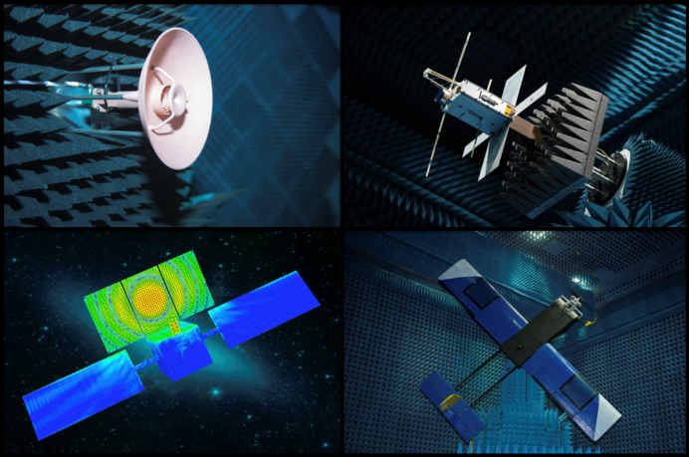

Fig. 1. 40th ESA Antenna Workshop picture.

# Abbreviations and Acronyms

Define abbreviations and acronyms the first time they are used in the text, even after they have been defined in the abstract. Do not use abbreviations in the title unless they are unavoidable.

# Bibliography

Number citations consecutively in square brackets [1]. Refer simply to the reference number, as in [3]. Do not use “Ref. [3]” or “reference [3]” except at  
the beginning of a sentence: “Reference [3] was…”. You may use the functionality “Cross-reference” of Word to create a link between the text and the reference section. The title of the book or of the journal should be in italic script. Further information is available in “How to reference a publication” at:

http://www.esa.int/esapub/conference/references.pdf

# References

1. W. Rotman, R.F. Turner. Wide-angle microwave lens for line source applications. IEEE Trans. Antennas Propag., vol. 11, no. 6, pp. 623-632, Nov. 1963.
2. A.S. Gutman. Modified Luneburg lens. J. Appl. Phy., vol. 25, no. 7, July 1954.
3. W.C. Cummings. Multiple beam forming networks. Lincoln Lab. Tech. Note, Apr. 1978.
4. W.A. Imbriale, S. Gao, L. Boccia. Space antenna handbook. Ed. John Wiley & Sons, May 2012.

# PDF Preparation and Submission

In order to allow reasonable quality printing, please avoid excessive compression when making your PDF file. Generally, image resolutions should be 600 dpi for monochrome, 300 dpi for greyscale and colour.

VERY IMPORTANT***:*** EMBED ALL FONTS and set PDF’s security method in “document properties” to “No Security”.

Deadline for submission is:

6 September 2019

Papers are to be submitted via the ESA Antenna Workshop Portal.

The file name must clearly identify the paper. Use the abstract number followed by the name of the main author (e.g. 1752728smith.pdf). Use only lower case.   
DO NOT name your file “XXX.pdf”.

Papers must be delivered by **6 September 2019** at the latest, to ensure inclusion in the conference proceedings.

For further information about preparing your paper, please contact:

**ESA Conference Bureau**

**Phone: (+31) 71 565 5005**

Email: [esaconferencebureau@atpi.com](mailto:esaconferencebureau@atpi.com)