Improving concurrent design processes by introducing Virtual Rapid Design Prototyping within the Australian National Concurrent Design Facility

J.-C. Meyer¹, Dr. D. Griffin², Prof. R. Boyce¹

¹UNSW Canberra Space, Canberra, Australia, jan-christian.meyer@unsw.edu.au
²Skykraft Pty. Ltd, Canberra, Australia

- Virtual Rapid Design Prototyping improves space mission conceptualisation
The Virtual Rapid Design Prototyping process takes the rapid prototyping philosophy into the conceptual design phase allowing for very quick design iterations in a DevOps-style approach. Instead of prototyping hardware, virtual satellite models are built rapidly using the concurrent design (CD) software. The software includes a simulation framework accessing the mission data through the provided Application Programming Interface (API) and thus simulates the mission. A 1-day simulation takes less than 5 minutes in real time. The comprehensive simulation results that include power profiles, component temperature profiles, mission cost, link budgets and other products, subsequently form the basis for the next design iteration (Figure 1). The simulation step is performed within the CD session and replaces operation of the hardware prototype in the traditional rapid prototyping process.
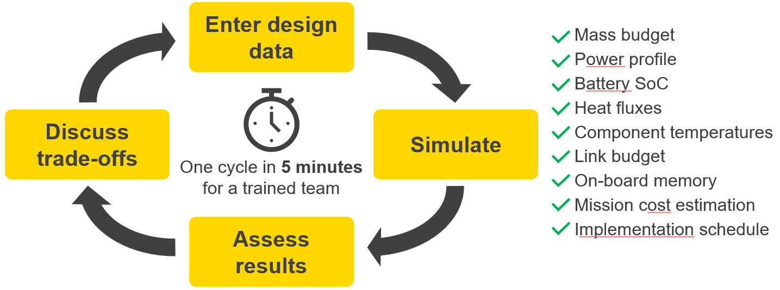
Figure 1: Schematic view of Virtual Rapid Design Prototyping concept
By also leveraging the classical elements of CD, this process has shown that it can produce a mission design concept ready for detailed design and procurement in 8 half-day sessions. The introduction of time-dependent profiles even in the conceptual design stage allows for an optimisation of design margins, thus increasing design efficiency.
- New tools generally enable more efficient processes, but they may be different from old ones
While in general it is true that a software tool should support an existing organisational process, there are benefits to be gained from adapting processes to improvements introduced by new tool technology. A valid analogous example is the introduction of computer aided design (CAD). Initial CAD tools were 2D drawing programs, replacing the paper-based drawing process with the digital equivalent. Modern tools first design the virtual 3D part before generating the 2D drawing from it. Introducing this additional step into the process still made it overall more efficient because the quality of the drawings increased.
- Concurrent design processes are not yet utilizing all possibilities provided by existing software
The main elements for a CD center are hardware, models, tools, processes and a team. Most modern CD software packages aim at capturing mission data. Interfaces, such as APIs, are built into them, but their use is mainly advertised to connect with domain-specific tools, examples of which often show tools used in detailed design lifecycle phases. A comprehensive assessment of CD opportunities that arise from the combination of modern CD software with processes tailored towards the strengths of these tools has not yet been conducted.
- Improvements are most evident under specific conditions
Virtual Rapid Design Prototyping can be applied to any CD center utilising any of the available modern CD software packages. A non-negligible effort upfront is required to create an integrated ensemble of analysis tools that are set up to produce the right desired results in all envisaged study cases and sufficiently quick. Involved tools should be configured such that each participant’s work maximises using their core expertise. For example, a thermal engineer should be able to concentrate on defining thermal properties, but not need to model geometry. This configuration has to find the correct balance between automation and generalisation to cover the intended range of use cases as efficiently as possible.

