**Deflection and Disruption Models & Testing**

**MOMENTUM ENHANCEMENT AS A FUNCTION OF IMPACTOR SCALE SIZE: MOMENTUM TRANSFER MECHANISMS**

James D. Walker (1), Sidney Chocron (1)

(1) *Southwest Research Institute, 6220 Culebra Rd., San Antonio, TX 78238, USA*

[james.walker@swri.org](mailto:james.walker@swri.org), [sidney.chocron@swri.org](mailto:sidney.chocron@swri.org)

**Abstract**

Momentum enhancement is the increase in momentum transferred to an impacted body above the momentum of the impactor. It is typically denoted as β – 1. Experimental studies have shown that for many impacted materials, including metals and consolidated geological materials, the momentum enhancement is an increasing function of the size of the impactor. From the perspective of deflecting asteroids, this is a promising result, since we expect to impact the asteroid or comet nucleus with a spacecraft on the order of a meter across.

The size dependence has only been shown experimentally up to centimeter scale. High velocity impacts measuring momentum enhancement have been performed for impactors of at most 3 to 4.5 cm in diameter. For example, the plots below show impacts at 5.77 km/s into an aluminum target with a range of impactor diameters, from 0.16 cm to 3 cm. It is interesting to see that the ejecta mass appears to saturate around 1 cm diameter, but the momentum enhancement continues to increase at an even faster pace. Interestingly, the plots also show that hydrocode impact computations, with an appropriate failure model, match the ejecta mass but do not match the momentum enhancement results (also shown) [1]. Similar size scaling increase of momentum enhancement has been observed in large concrete and sandstone targets, at speeds of 2 km/s, and will be presented [2].

Since we hope to extrapolate this momentum enhancement behavior, it is important to understand its physical origins, as it is possible that the momentum enhancement will saturate for some impactor diameter unless we can show the mechanism precludes saturation. Since the mass saturates but the momentum enhancement does not, it is clear the momentum enhancement increase due to size is not due to an increase in ejecta mass. (Obviously, an increase in ejecta mass does increase momentum enhancement, but there is another mechanism at work here beyond the mass saturation.) In this presentation, we look at the mechanics of the impact and ejecta process and look at reasons for the increase in momentum transfer to the impacted object during the cratering process.

The overall topic is of considerable interest. If we can argue that the size scaling continues to meter size scales, then we obtain βs of greater than 10 for spacecraft scale impacts into asteroids, which makes the hypervelocity impactor a method of interest for deflecting potentially dangerous asteroids and comet nuclei. If the size scaling does not continue but rather saturates at a small diameter, it is likely that βs will be relatively small for such impacts. Thus, understanding this size scaling behavior is at the center of understanding the usefulness of deflecting impactors through hypervelocity impact.

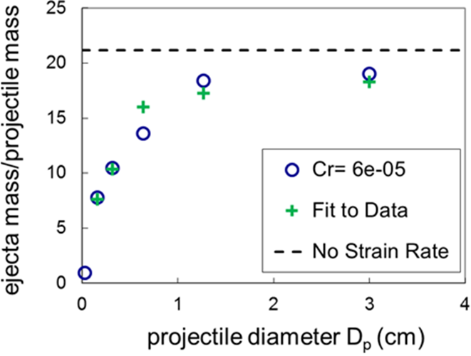 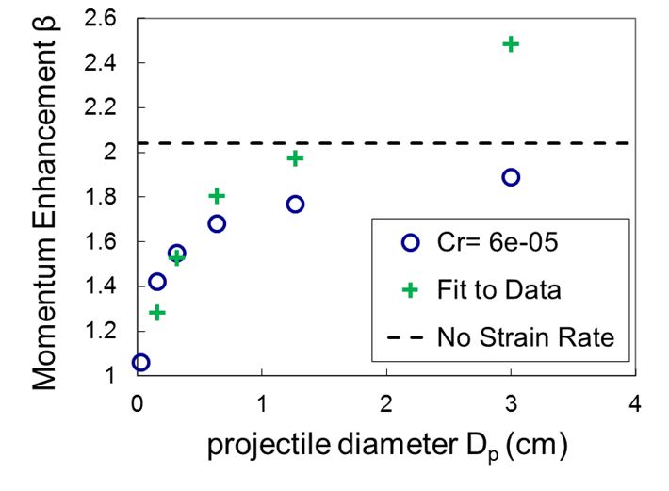

**Figure 1**. Experimental results for 5.77 km/s impacts for a range of project sizes, performed at NASA Ames and SwRI (green crosses). CTH computations with a sophisticated failure model (blue circles) [1].

1. “Size Scaling of Hypervelocity-impact Ejecta Mass and Momentum Enhancement: Experiments and a Nonlocal-shear-band-motivated Strain-rate-dependent Failure Model,” J. D. Walker, S. Chocron, D. J. Grosch, Int. J. Impact Engng 135 (2020) 103388:1-14 DOI: 10.1016/j.ijimpeng.2019.103388.
2. “Hypervelocity Impact on Concrete and Sandstone: Momentum Enhancement from Tests and Hydrocode Simulations,” S. Chocron, J. D. Walker, D. J. Grosch, S. R. Beissel, D. D. Durda, and K. R. Housen, Proceedings of the 15th Hypervelocity Impact Symposium, Destin, FL, April 14 – 19, 2019.

**************************************

***Comments:***

*Alternative session: NEO Characterization Results*

*Preference for Oral Presentation*