PDC2021
Vienna, Austria

Please submit your abstract at https://atpi.eventsair.com/7th-iaa-planetary-defense-conference-2021/abstractsubmission

You may visit https://iaaspace.org/pdc

(please choose one box to be checked)
(you may also add a general comment - see end of the page)

Key International and Political Developments
Advancements and Progress in NEO Discovery
NEO Characterization Results
Deflection and Disruption Models & Testing
Mission & Campaign Designs
Impact Consequences
Disaster Response
Decision to Act
Public Education & Communication

Photometric analysis of NEOs in Arecibo supporting from NEOROCKS project

H. Medeiros^{(1,2)}, J. de León^{(1,2)}, J. Licandro^{(1,2)} , M. Serra-Ricart^{(1,2)} , M. Popescu⁽³⁾ , N. Pinilla-Alonso⁽⁴⁾, M. Devogéle⁽⁵⁾
⁽¹⁾Instituto de Astrofísica de Canarias, C/ Vía Láctea s/n, 38205, San Cristóbal de La Laguna, Tenerife (Spain), hmedeiros@iac.es
⁽²⁾Universidad de La Laguna, Departamento de Astrofísica, 38205, San Cristóbal de La Laguna, Tenerife (Spain)
⁽³⁾Astronomical Institute of the Romanian Academy, 5 Cuţitul de Argint, 040557 Bucharest, Romania
⁽⁴⁾Florida Space Institute, University of Central Florida, Orlando, FL 32816, USA
⁽⁵⁾Lowell Observatory, 14000 W Mars Hill Rd, Flagstaff, AZ 86001, USA

Keywords: NEOs, NEOROCKS, radar, photometry

ABSTRACT

The near-Earth objects (NEOs) include asteroids and comets that are in orbit close to the Earth. In some cases, they can even cross the Earth’s orbit. The NEOs are one interesting population of small bodies for several reasons. There are objects that constitute a potential impact hazard. Because of the close approach to the Earth, they are more accessible to spacecraft, to detailed observations from ground-based facilities, and also allow us to study asteroids two to three orders of magnitude smaller than those observable on the main belt asteroids.

The NEO Rapid Observation, Characterization and Key Simulations (NEOROCKS) project is funded (2020-2022) through the H2020 European Commission programme to improve knowledge on NEOs by connecting expertise in performing small body astronomical observations and the related modelling needed to derive their dynamical and physical properties. The IAC, and in particular members of the Solar System Group, participates in the NEOROCKS project and is currently leading one specific task to do observations of NEOs in support of the Arecibo Planetary Radar. These supporting observations include times-series photometry (lightcurves), visible to near-infrared spectroscopy, and astrometry (orbit determination). To do that we are using the telescopes from Roque de Los Muchachos and Teide Observatories, located at La Palma and Tenerife islands, respectively (Spain).

Considering the current situation of the Arecibo telescope, in this work we focus in the obtention and analysis of lightcurve data for those targets that were observed in the past by the Arecibo telescope and have good signal-to-noise (SNR) radar data. Our photometry is intented to support and complement radar data and to help deriving physical properties like rotational period and shape. We have observed 8 asteroids to obtain their lightcurve. Figure 1 shows one example of lightcurve from the asteroid (52768) 1998 OR2, that we are observing in studing with Arecibo team. These are preliminary results.

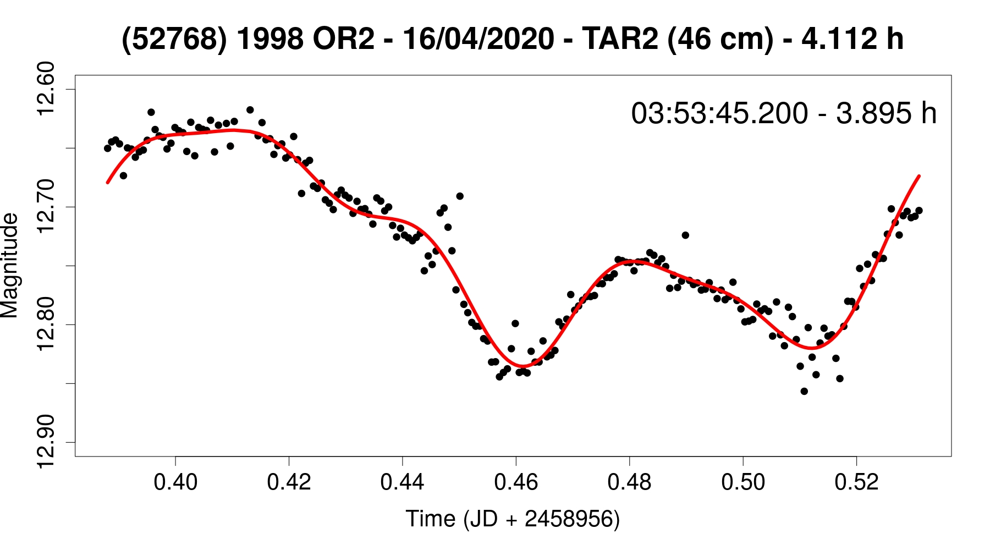

Figure 1: Ligthcurve from the asteroid (52768) 1998 OR2 obtained on February 16, 2020 by observations in Telescopio Abierto Remoto (TAR2) at Teide Observatory. The black points are the data observed, the red line the fit, and on the upper right is the value of rotational period derive of the fit.

**************************************

Comments:

