**A Tale of Two Models: Using Concurrent Engineering and MBSE to Develop AeroCube 10**

R. Stevens1*,

*1The Aerospace Corporation, El Segundo, CA, USA, *Primary author contact details:* resteven@aol.com

1. **Introduction**

Systems engineers often use two types of models to develop space systems; analytical models and descriptive models. They use analytical models that interconnect lower level subsystem tools to analyze total system behavior and properties such as payload performance, mass budgets, and power budgets. However, systems engineers are also responsible for tracking requirements, establishing the system concept of operations (ConOps), and assigning verification and validation (V&V) activities to ensure that the system will achieve the mission objectives. To help engineers with these tasks, interconnected descriptive models come in handy. Our team used a combination of analytical concurrent engineering tools and descriptive MBSE models to develop a pair of CubeSats called AeroCube 10.

1. **Analytical Concurrent Engineering Model (CEM)**

In contrast to many large satellite programs, the team’s early objective was to determine what satellite missions could be performed using vehicles that deploy from a standard CubeSat deployer. Using a multidisciplinary concurrent engineering approach, we performed several system concept designs and analyzed various options to select a feasible design solution that met customer objectives.

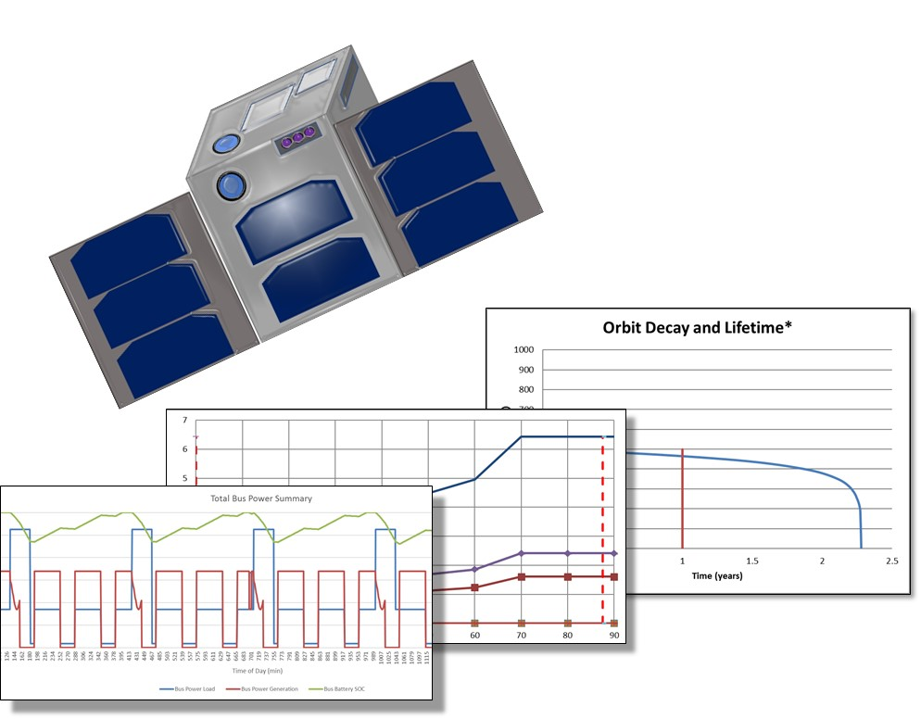

Figure 1: A CEM tool was used to evaluate CubeSat design feasibility

1. **Descriptive SysML Model**

In previous AeroCube projects, systems engineers had captured project artifacts in the form of static documents, such as requirements spreadsheets, interface control documents, and verification lists. For AeroCube 10, however, the team captured these important descriptions in a SysML model and interlinked them together. For example, we linked requirements with V&V activities and a physical architecture. Document artifacts were no longer central to the design process and were only exported as desired. This model based approach was developed with reusability in mind for the next AeroCube.

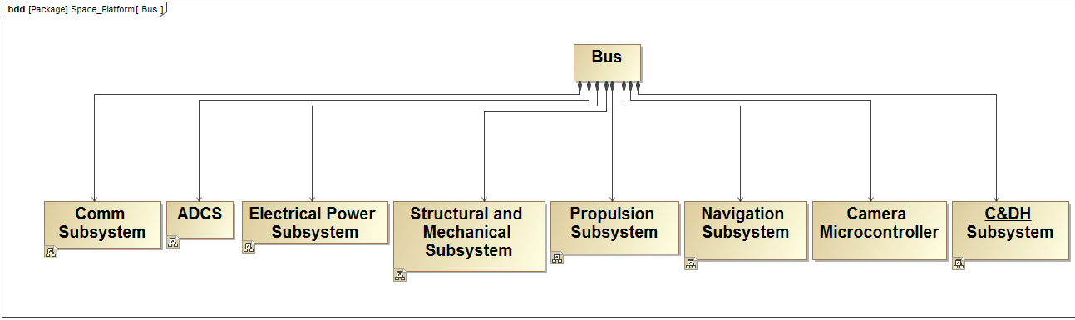

Figure 2: Requirements, physical architecture, and V&V activities were captured in a SysML model

1. **Model Integration**

Recognizing that the two types of models can share information, we linked them together to directly couple our concept design with our requirements, ConOps, and V&V activities. For example, a maximum mission altitude calculated using a CEM tool can be directly imported into a SysML model as a requirement, where it is then associated with vehicle ConOps and assigned verification by test activities. The processes developed here are also extensible to larger spacecraft programs.