**Improved Collaborative Optimization for Multidisciplinary Design Optimization Problems**

S. Zhang*1; E. Minisci2*; M Liu1; Y Huang1 and A Riccardi2*

*1Northwestern Polytechnical University, Xi’an, China*

*2University of Strathclyde, Glasgow, UK,*Authors’ contact details:* [*edmondo.minisci@strath.ac.uk*](mailto:edmondo.minisci@strath.ac.uk)

1. **Introduction**

In this contribution, an improved version of the standard collaborative optimization (CO), a distributed optimization method for multidisciplinary design optimization (MDO) [1], is proposed. The key idea in Improved Collaborative Optimization (ICO) is to consider the global objective in each subspace optimization problem with an additional interaction channel for coupling variables, while maintaining an easy coordination of design variables for system level problem. The improved collaborative optimization has two main advantages: 1) ICO enhances the subspace design authority; 2) ICO makes it possible for direct information interaction among subspaces. See Figure 1 for the frame work of ICO.

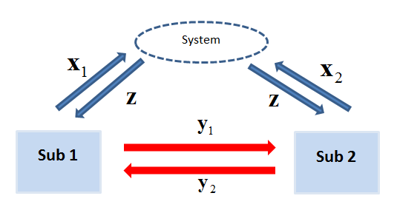

Figure : ICO with two disciplines

1. **The method of ICO**

The system level is an unconstrained minimization problem with a memory of coupling variables:



The subspace level is an independent optimization problem:



1. **Solution process and application**

In the first step, the initial system level targets for shared variables and a set of initial coupling variables are sent to each subspace. The subspace treats the targets and necessary coupling variables as parameters, allowing it to solve its optimization problem without requiring other subspaces’ constraints or analysis information. The subspace returns target responses and the output of discipline analysis (coupling variable/state variable) to the system level. In the second step, the system level obtains the average of the target responses returned from the subspaces. Besides, it stores the coupling variables provided by the subspaces directly. The targets and coupling variables are then updated. The process is repeated until compatibility is realized. The results on analytic and engineering test cases show that ICO performs better than CO in terms of computational efficiency.

1. **References**

[1] Martins, Joaquim RRA, and Andrew B. Lambe. "Multidisciplinary design optimization: a survey of architectures." *AIAA journal* 51.9 (2013): 2049-2075. O.C. Zienkiewicz and R.C. Taylor, *The finite element method*, 6th Edition, Elsevier, 2005