COSM3 – Concurrent design application using a CDP4 SDK based client.

A. Tosetto^{1*}; M.Gorlani¹

¹Blue Engineering Srl, Turin, Italy, *Primary author contact details: a.tosetto@blue-group.it

- Introduction
COSM, developed in collaboration with THALESALENIA, is evolved in COSM3 a client for CDP4/OCDT based on RHEA CDP4 SDK.
The core of COSM3 software has been completely renewed, its functionalities include most of the original features of COSM and are implemented in a new environment that is always connected to the model data on the server. The user of COSM3 can use all the functionalities of COSM and more, with the new possibility to operate according to a concurrent way to work in a real collaborative environment. New features have been developed accordingly, such as “Recycle Bin” management and the Report Generator.

With respect to the old version, the tool is developed for company internal needs about transportation sectors, some features present in the Railways and Automotive plugins are integrated into the main tool, and these two plugins are renewed according the new arrangement. COSM3 remains open to new development thanks to the plugin architecture.

  - Vehicle Design Application
At the time of this abstract COSM3 is recently planned to be used in a vehicle design project
A concurrent Engineering Database will be the repository of main parameters. Dimensions, masses, performance, costs and geometry will be stored in a EngineeringModel enabling several domains to work, taking the advantage of concurrent design approach. Model Elements will be assigned several domain such as:
- System Engineering
- Cost
- Performance
- Configuration/Mass
- Electric

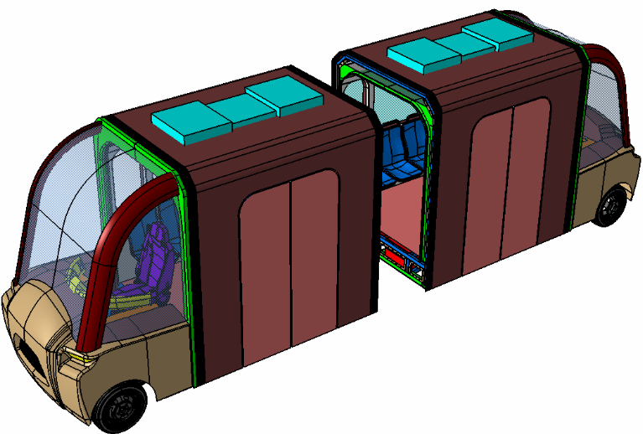
Figure 1: Example of Geometry managed by COSM3.

