Concurrent Design & Data Facility (CD²F): conceptualizing a next-generation CDF

M.-A. Chavy-Macdonald^{1*}; J.-P. Kneib¹

¹EPFL Space Center, Lausanne, Switzerland, *marc.chavy-macdonald@epfl.ch

- Introduction
Concurrent Engineering has many benefits, with a factor of 4 reduction in time and 2 in cost for Phase 0 and A design reported at ESA’s ESTEC facility. CDF studies are also reputed for their high quality. Despite this, there is limited empirical evidence of better “design quality” – because this concept itself is ill-defined. Meanwhile, the Internet of Things & Big Data show how novel sensors & data bring pivotal transformation.
  - Background: the Design Observatory
A “Design Observatory” (DO) is a concept invented at Stanford, “as an integrated environment to observe, analyse, and intervene into design activity”, e.g. by ethnographers recording engineers designing [1]. It provides valuable empirical data to Design Research, allowing the improvement or validation of design methods, processes & tools. Indeed, to improve and sustain high levels of innovative design, we must effectively manage design performance, including creating tailored design processes, and well-performing tools, technology & team structures. This requires a fundamental understanding of design practices which currently does not exist [1]. Recently, many novel sensors and software can capture & display new design data during synchronous collaborative design, an approach validated in a new facility at MIT (Fig. 1) [2].
- Proposed concept: the Concurrent Design & Data Facility
The Concurrent Design & Data Facility (CD²F) synergistically fuses the CDF & DO concepts into a highly innovative platform for both design, & design method advances. Limitations of each concept are curtailed: instrumented design allows the very first rich empirical data for evaluation of design tools & methods in a CDF, for iterative improvement. On the other hand, a CDF provides an ideal environment for observation – collocated, concurrent, transparent design – with many of the advantages of design ethnography, and outputting real designs. The latter’s value greatly reduce the data’s cost, and professionalize the process.
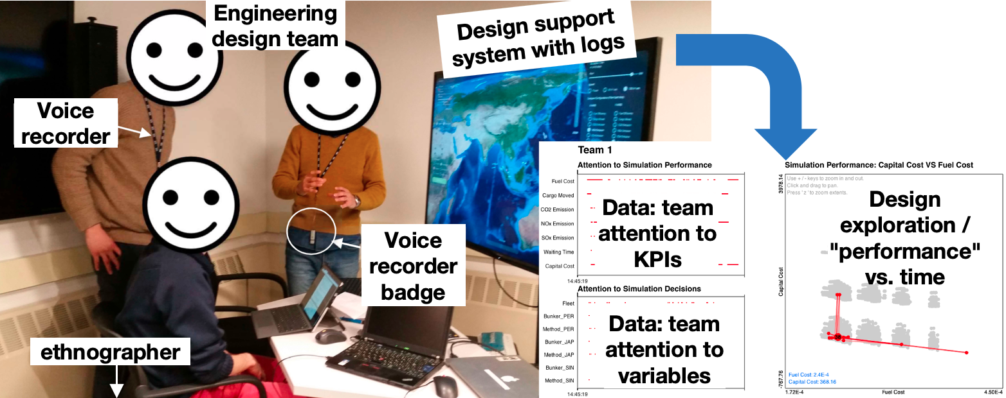
Figure 1: Instrumented Design Observatory concept, and captured data of process. Adapted from [2]
- Expected benefits & facility design
The design methods employed will accumulate ever-more hard empirical data on their efficacy – and will be continuously improved using the design observation data. Design credibility will increase: for example, simple training or decision-making methods for design might be easily validated. R&D outputs will increase (double?) from both actual novel designs, and continuous design method testing. Requirements, and a conceptual design for the facility have been developed, for feedback from the community. Some key design choices are presented, including the amount & method of data capture, and sensor selection.
- References
[1] Törlind, P., Sonalkar, N., Bergström, M., Blanco, E., Hicks, B., McAlpine, H.: Lessons Learned and Future Challenges for Design Observatory Research. In: 17th (ICED) International Conference on Engineering Design, vol. 2, pp. 371–382. Palo Alto, CA, USA (2009).
[2] Pelegrin, L., Moser, B., Wanaka, S., Chavy-Macdonald, M.A., Winder, I.: Field guide to interpreting engineering team design behavior with sensor data. In: CSD&M: Complex Systems Design & Management, pp. 303–218. Springer, 2019.

