Concurrent Engineering Method to implement Advanced Manufacturing Technologies for Spacecraft Design

M. Samoil^{1*}, M. Mulser¹, S. Jahnke¹, M. Rohrbeck¹, P. Vermeer¹, A. Wyen², R. Palicka², J. Slavik², S. Gerené³, M. Fijneman³, I. Roma⁴, L. Pambaguian⁴

¹ OHB System AG, Bremen, Germany, moritz.samoil@ohb.de
² OHB Czechspace s.r.o., Brno, Czech Republic, ariane.wyen@ohb-czech.cz
³ RHEA Group, Leiden, The Netherlands, s.gerene@rheagroup.com
⁴ ESTEC European Space Technology Centre, Noordwijk, The Netherlands, ilaria.roma@esa.int

- Abstract
OHB System has been involved in various projects related to Advanced Manufacturing technologies (e.g., ceramic composite materials, solid state bonding, advanced coatings and additive manufacturing). Several technologies demonstrated a high potential for application in the space sector, by enabling significant improvement in performance, mass/cost saving, and reduction of lead-time or assembly/integration effort. In order to leverage the full potential of these technologies, the engineering process of high-end spacecraft parts needs to be adapted accordingly. Multiple fields of expertise are required to conclude on the most suitable manufacturing technology and find optimized design concepts [1].
Concurrent Engineering (CE) is an effective tool to conduct multidisciplinary design sessions especially in the early project phases. At OHB, Concurrent Engineering was originally implemented for satellite system level assessments of space missions, rather than for specific design on part level. To be able to transfer the CE approach to this new application level, a new methodology and work flow is needed, especially if Advanced Manufacturing technologies are aimed to be incorporated [2].
To explore and develop the aforementioned capability, a consortium led by OHB System and including OHB Czechspace as well as RHEA conducted an activity entitled “Design of Space Hardware using a CDF like Methodology” that was funded by the European Space Agency (ESA) within the General Studies Programme (GSP). The aim was to establish a guideline for the design of challenging parts and components for OHB’s future satellite projects.
A methodology was developed and evaluated based on six multi-functional use cases from different technical domains. It divides the overall design process into preliminary and detailed CE sessions. The preliminary session is based on a conceptual brainstorming with the aim to identify different concepts. Critical aspects such as the general purpose of the part, functional requirements, material properties, necessary manufacturing equipment, verification & test methods and assembly & integration procedures were taken into account. All technical features and attributes of the parts were listed and categorized with the ECSS-E-TM-10-25 compliant software CDP4® to enable consistent technical exchange between development steps. A trade-off facilitates the assessment and selection the most efficient concept. The final design is created in a detailed session with an emphasis on traceable requirement compliancy.
This paper summarizes the output of the activity with a focus on the developed methodology for the Concurrent Design of spacecraft parts considering Advanced Manufacturing technologies. The tools & methods that were developed and applied during the sessions will be presented and explained.
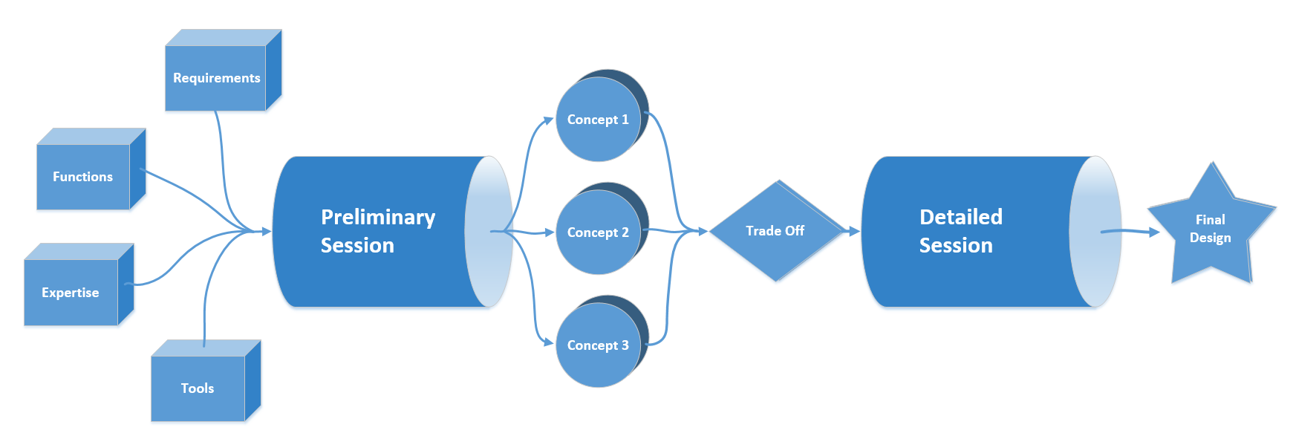
Flow chart for the Concurrent Engineering Method
- References
[1] Final Report, ESA GSP study “System impact of additive manufacturing technologies design features” by OHB System, 2017.
[2] Pambaguian, L. et al: Space Hardware Advanced Manufacturing Engineering: SHAME, SECESA 2016, Madrid, Spain, 2016.

