From Requirements to Design Parameters: Building a preliminary System Traceability Model with CDP4© under the framework of ESA’s CDF Space Mission Design and Assessment Studies.

C. Redondo^{1*}; S. Gerené²

¹Former RHEA Group, Madrid, Spain, *Primary author contact details: c.redondo.apa@gmail.com
²RHEA Group, Leiden, the Netherlands

- Introduction
Concurrent Design and Engineering is a systemic approach in which space mission design is addressed, involving the performance of a multidisciplinary team framed in a complex and dynamic environment in which a massive amount of data is exchanged among domain experts. Its multidisciplinary nature and the heavy dependencies between domains of expertise require the definition of a specific methodology which is capable of facilitating the management of the system design, as well as the use of a tool that enables its implementation, among other key elements described in [1].
- System Traceability Model
This paper investigates a CD&E methodology which makes use of the CDP4© (ECSS-E-TM-10-25A implementation, [2]) and the THESEUS Case Study, which is publicly available, has been used as main data source. A complete CDP4 Engineering Model has been created following the space system architecture depicted in Figure 1, containing a detailed description of the system and subsystems requirements, functions and products and their foreseen relationships, introducing design parameters in an effort of integrating the data exchange process into the system allocation process. Ultimately, an Excel Add-In has been created which, partially linked to the CDP4 Engineering Model, serves as a visualisation tool for this domain-driven mapping. The generic structure of the logical processes that have been followed and implemented with CDP4 for the Model construction is exemplified in Figure 2.
The CDP4 Engineering Model and its partially linked Excel Add-In streamline iteration processes and enhance the verification of subsystems requirements and design against design parameters modification, ultimately exposing what is the design parameters influence on the requirements satisfaction through intermediate traces (products and functions) in a source/target domain of expertise relationship effort.
The reader shall note that for the scope of this research the Excel Add-In has to be regarded as a nice to have feature to be used jointly with CDP4 since a complete data link automation from the Engineering Model to the Excel Worksheets has not been developed.
- Figures
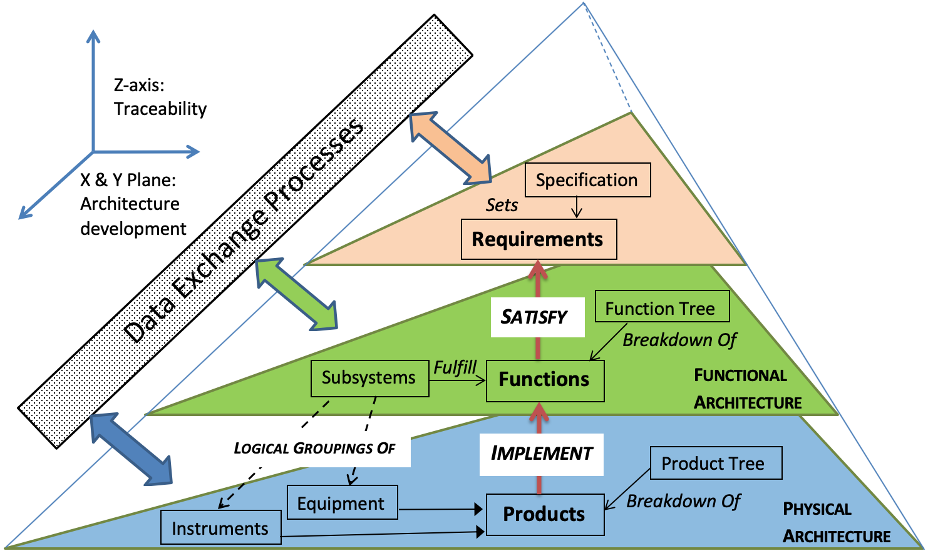  Figure 1: ECSS-S-ST-00-01C - Glossary of Terms Conceptualization [3]. | 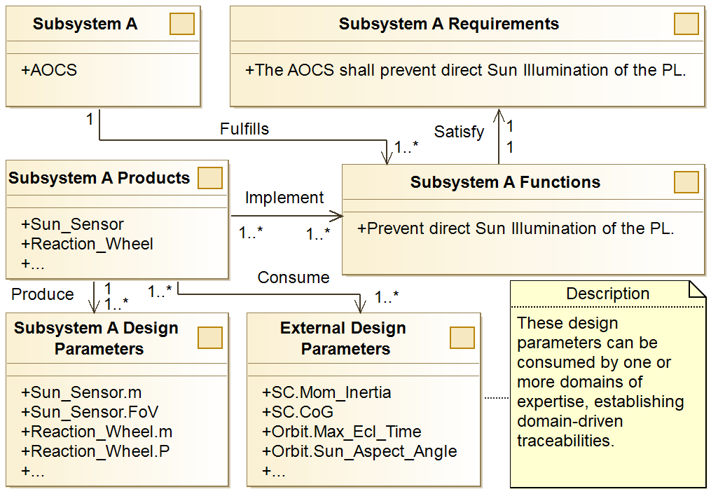  Figure 2: System Allocation and Data Exchange Processes Integration: THESEUS example.
- References
[1] Bandecchi, M., Melton, B., and Ongaro, F., “Concurrent engineering applied to space mission assessment and design,” ESA Bull. Sp. Agency, 1999.
[2] ECSS, “ECSS-E-TM-10-25A - Engineering Design Data Model Exchange,” ECSS Stand., 2010.
[3] ECSS, “ECSS-S-ST-00-01C - Glossary of terms,” ECSS Stand., 2012.

