AI-Powered & Cloud Based Concurrent Systems Engineering Platform

S. Pate¹
¹Ashiyana Space Ltd, London, UK, sweetypate@ashiyana.space

- Introduction
Traditionally space systems design process starts with a benchmark configuration & follows a sequential & document based approach with several iterations. It is an inefficient & time consuming approach that limits innovation with inconsistencies and lacks traceability. There is a need to explore the modern technologies & software tool-chains for efficient space systems design like AI-driven algorithms, IoT enabled digital twin and cloud-based concurrent engineering platforms. This paper highlights the research work at Ashiyana Space Ltd, that provides a fully managed service on the cloud that allows AI-based concurrent systems engineering and IoT enabled digital twin interaction for multi-disciplinary teams to design complex systems.

- Concurrent Systems Engineering Platform
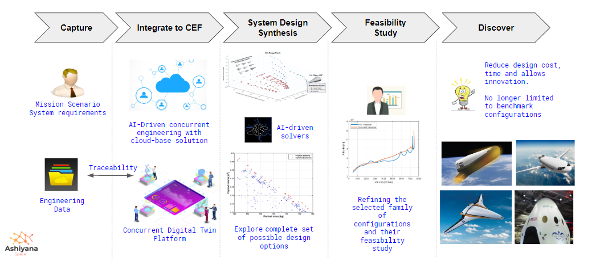
Figure 1: Design Workflow [Ashiyana Space Ltd, 1, 2]
Figure 1 gives the overall workflow of the platform under research at Ashiyana Space Ltd. The platform provides a fully managed service on the cloud that allows AI-based concurrent engineering to perform system design synthesis, feasibility studies and derive innovative optimal solutions quickly, easily, and economically compared to the traditional approach.

It allows us to integrate design disciplines on a single platform with a digital twin interface, where the in-build AI-based solvers enable us to explore the complete set of feasible design solutions and derive the best optimal solution rather than limiting to the benchmark configuration. High traceability of engineering data with changing mission and system requirements is achieved through the cloud based data capture & concurrent engineering. It will drastically reduce the design cost time and accelerate innovation.

3. References
[1] Pate, S., Rana, L. & Brinkman, D., “System Design Synthesis And Multi-Disciplinary Optimisation Of a Conceptual Re-Entry Vehicle Using An Integrated Design Process", 8th International Systems & Concurrent Engineering for Space Applications Conference (SECESA 2018), Glasgow, Scotland, September 2018.
[2] Pate, S., Rana, L. & Brinkman, D., “Innovative System Design Synthesis And Optimization of Re-Entry Vehicles Conceptual Design ", International Astronautical Congress, Bremen, Germany October 2018.

