Depositional environments during OAE1a (Early Aptian) in the Eastern Russian Platform and during OAE1b (Early Albian) in the Middle Caspian: new data
Pavlova, O.V., Zorina, S.O., Kadirov, I.I., Galiullin, B.M., Morozov, V.P. and Eskin, A.A.

Kazan Federal University, 18 Kremlyovskaya str., Kazan, 420008, Russia, svzorina@yandex.ru

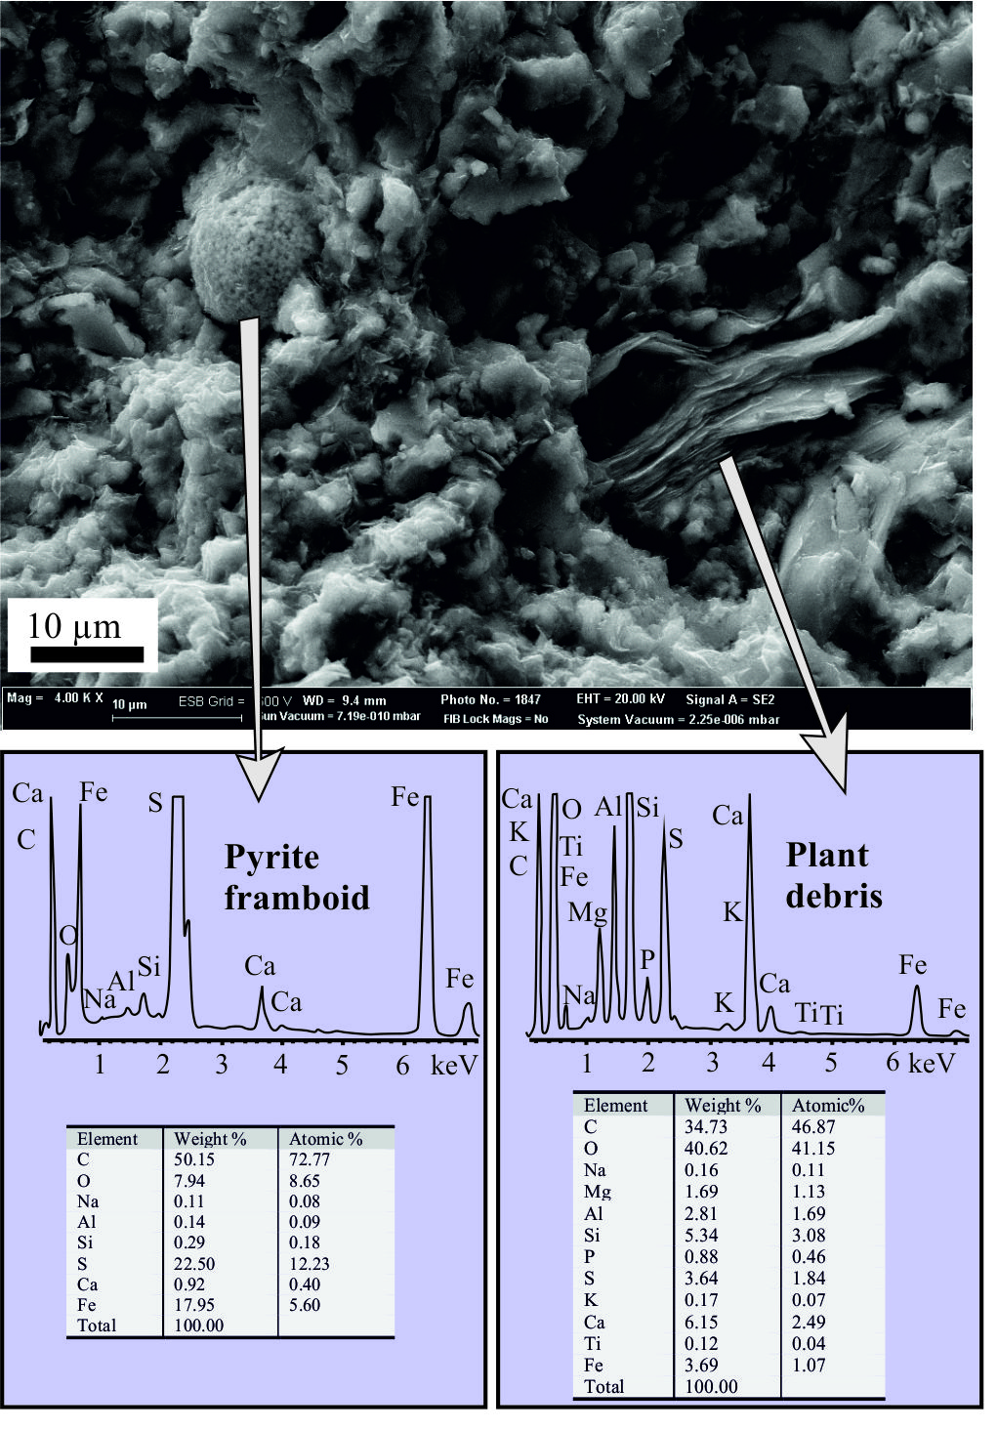
Detailed investigation of mineral composition and microstructure of the black shales corresponding to the Oceanic Anoxic Event 1a (OAE1a) in the Eastern Russian Platform and to the OAE1b in the Middle Caspian basin by X-ray powder diffraction and scanning electron microscopy (SEM) with energy-dispersive spectroscopy (EDS) can provide important constraints for depositional environments in the sedimentary basin.

Black shales with pyrite framboids evidently indicate the euxinic (sulfidic) condition with increased organic matter preservation [1, 2, 3]. Disintegrating framboids point to partial or complete dissolution of the organic matter inside the framboids due to increasing water oxidization. So, it is more correct to speak not about anoxia in the basin, but about euxinia, a state with toxic levels of hydrogen sulfide concentrations [2]. Disintegrating framboids point to partial or complete dissolution of the organic matter inside framboids due to increasing water oxidization.

The OAE1a on the Eastern Russian Platform was heterogeneous. The intercalations of concretionary limestones underlying and overlying by the bituminous shales corresponding to the OAE1a, consist of coccoliths skeletons from the Lower Aptian Rhagodiscus angustus nannofossil zone. These coccolithic limestones indicate episodic cessation of stagnation, rapid oxidization, and restoration of normal marine conditions for a short period.
Figure 1. SEM and EDS data from the bituminous shales corresponding to OAE1a in the Eastern Russian Platform

References
[1] Cavalazzi B et al. (2014) Geol ore deposit 56:395-408
[2] Meyer KM and Kump LR (2008) Annu Rev Earth Planet Sci 36:251–88
[3] Wang L et al. (2012) Palaeogeogr Palaeoclimatol Palaeoecol 333-334:218–227
[4] Wignall PB et al. (2005) Palaeogeogr Palaeoclimatol Palaeoecol 216:183–88

