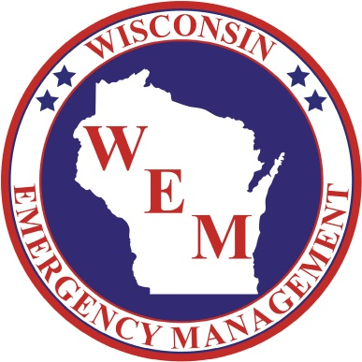

54th Annual

2022 Governor’s Conference on Emergency Management & Homeland Security
March 7-9, 2022 | Kalahari Resort/Wisconsin Dells
Exhibitor Opportunities

The 2022 Governor’s Conference on Emergency Management & Homeland Security will take place March 7-9 at Kalahari Resorts & Conventions in the Wisconsin Dells.

Questions on the 2022 exhibitor opportunities may be directed to Paul Hughes at (608) 242-3309 or pauld.hughes@wisconsin.gov.

Exhibitor Opportunities
EXHIBITOR ADVERTISER
- Footer banner color ad in the Conference program
- Exhibitor space for promotional use
- Exhibitor’s logo/name listed on select printed and digital promotional materials
- 50-word company description and logo on the Conference website and mobile app
- Complimentary conference registration for one organization representative
Cost of Advertiser Participation - $750
Non-Profit Advertiser Rate - $300
Electrical Hook-Up - $50

EXHIBITOR
- Exhibitor space for promotional use
- Exhibitor’s logo and/or name listed on select printed and digital promotional materials
- 50-word company description and color logo on the Conference website and mobile app
- Complimentary conference registration for one organization representative
Cost of Exhibitor Participation - $600
Non-Profit Exhibitor Rate - $150
Electrical Hook-Up - $50

Printed Guide Ad Specifications

Dimensions
- Full Page (Gold and Silver Sponsors)
  - 5.57in w x 8.75in h (including 0.125in bleeds)
- Half Page (Bronze Sponsors)
  - 5.57in w x 4.5in h (including 0.125in bleeds)
- Footer Banner (Exhibitor Advertiser
  - 5.57in w x 2.5in h (including 0.125in bleeds)
Minimum Resolution: 300 dpi

Accepted File Formats: PDF, EPS, TIFF, PSD; CMYK color space

Note: Please keep all important type and images at least a quarter inch inside the ad dimensions (safe area)

Mobile App Ad Specifications
(Gold and Silver Sponsors)

Dimensions: 640px w x 90px h

Minimum Resolution: 72 dpi

Accepted File Formats: JPEG, PNG, or other image files; RGB color space

