*Sponsorship Proposal*



**October 23-25, 2023**

**KI Convention Center**

**Green Bay**

# Previous Sponsors & Exhibitors

Thank you to the following Sponsors and Exhibitors at the 2022 Wisconsin Governor’s Cybersecurity Summit:

**Platinum Level**

Capital Data and Extreme Networks

# Gold Level

InfoSec

Wisconsin Cyber Threat Response Alliance

# Silver Level

AE Business Solutions and Palo Alto

Splunk and Carahsoft

# Bronze Level

F5

Proofpoint

Spectrum Enterprise

Tanium

Tenable

UW- Extended Campus

Zscaler and Crowdstrike

# Exhibitors

* Cybersecurity and Infrastructure Security Agency
* Fortinet
* Kyndryl
* PDS – A Converge Company
* RSA
* Tenable



**Women in Cybersecurity – Monday, October 23**

This event is both designed and presented by leading women in Cybersecurity. The one-day conference will feature a program that focuses on educating women on the opportunities available in Cybersecurity.

# Sponsorship Packages

Following are the sponsor opportunities for the **Governor’s Cybersecurity Summit** and **Women in Cybersecurity**.

Sponsors have the option to participate solely as a **Women in Cybersecurity** sponsor.

Sponsors may also elect to sponsor **Women in Cybersecurity** in addition to a **Governor’s Cybersecurity Summit** sponsorship. Sponsorship options are noted below.

## WOMEN IN CYBERSECURITY SPONSORSHIP

* Recognition as a sponsor on the **Women in Cybersecurity** page located on the

Cybersecurity Summit website

* Recognition in the **Women in Cybersecurity** section of the Cybersecurity Summit printed program

* Complimentary exhibitor booth during **Women in Cybersecurity**

* One complimentary attendee registration

***Women in Cybersecurity Sponsorship only - $3,000***

***Add Women in Cybersecurity to one of the below sponsor levels - $1,000***

## PLATINUM SPONSOR: Only one available

* Recognition as the exclusive sponsor of the Cyber Social Vendor Reception
* Recognition as the sponsor of the opening keynote speaker
* Inclusion of logo and/or name on select printed and digital promotional materials
* Rotating banner advertising on the Summit mobile app
* Recognition on select printed and digital signage at the event
* 50-word company description and color logo in the printed program, on the website and mobile app
* Full-page color ad upgraded to premium positioning in the printed program
* Complimentary exhibitor space at the Summit – option to increase to a double-space
* Complimentary conference registrations for six organization representatives

***Platinum Level Participation - $12,500***

***Add Women in Cybersecurity - $1,000***

## GOLD SPONSOR: Only two available

* Recognition as a sponsor of the Hospitality Networking Reception
* Recognition as the sponsor of the opening keynote speaker
* Inclusion of logo and/or name on select printed and digital promotional materials
* Rotating banner advertising on the Summit mobile app
* Recognition on select printed and digital signage at the event
* 50-word company description and color logo in the printed guide, on the website and mobile app
* Full-page color ad upgraded to premium positioning in the printed guide
* Complimentary exhibitor space at the Summit
* Complimentary conference registrations for six organization representatives

***Gold Level Participation - $10,000***

***Add Women in Cybersecurity - $1,000***

## SILVER SPONSOR: Only three available

* Recognized sponsor(s) of the Networking Lunch
* Invitations for four organization representatives to the VIP opening reception
* Inclusion of logo and/or name on select printed and digital promotional materials
* Recognition on select printed and digital signage at the event
* 50-word company description and color logo in the printed guide, on the website and mobile app
* Full-page color ad in the printed guide
* Complimentary exhibitor space at the Summit
* Complimentary conference registrations for three organization representatives

***Silver Level Participation - $7,500***

***Add Women in Cybersecurity -$1,000***

## BRONZE SPONSOR: Only six available

* Recognized sponsor(s) of the Welcome Continental Breakfast
* Invitations for two organization representatives to the VIP opening reception
* Inclusion of logo and/or name on select printed and digital promotional materials
* Recognition on printed and digital signage at the event
* 50-word company description and color logo in the printed guide, and on the website and mobile app
* Half-page color ad in the printed guide
* Complimentary exhibitor space at the Summit
* Complimentary conference registrations for two organization representatives

***Bronze Level Participation - $5,000***

***Add Women in Cybersecurity - $1,000***

## EXHIBITOR: 15 available spots

* Inclusion of logo and/or name listed on select printed and digital promotional materials
* 50-word company description and color logo on the Summit website and mobile app
* Recognition on select signage at the event.
* Exhibitor space at the Summit
* Complimentary conference registration for one organization representative

***Exhibitor Participation - $1,500***

***Add Women in Cybersecurity - $500***

## Small Business Partner: 15 available spots

* Inclusion of logo and/or name listed on select printed and digital promotional materials
* 50-word company description and color logo on the Summit website and mobile app
* Recognition on select signage at the event
* Complimentary conference registration for one organization representative

***Exhibitor/Small Business Partner Participation - $1,000***

## Sponsor Terms and Conditions

Thank you for your sponsorship of the **2023 Wisconsin Governor’s Cybersecurity Summit** and/or **Women in Cybersecurity**. We look forward to having your organization join us.

**Event Information**

October 23-25, 2023

KI Convention Center, Green Bay

**Following the completion of your sponsor registration, you agree to be bound by the full Sponsor/Exhibitor/Partner Terms and Conditions:**

1. Registration: To register as a sponsor, exhibitor, or partner with the Wisconsin Governor's Cybersecurity Summit, you must complete the appropriate registration option and make required payments.

1. Booth Assignments: Booth assignments are made by event management. While we will attempt to accommodate every exhibit space request, event management may need to modify the exhibit space to best serve the interests of the event. Booths are placed in the following order:
   1. Sponsors will receive priority placement.
   2. Exhibitors are placed in the order registrations are received.

1. Cancellation Policy: To receive a full refund, cancellation requests must be made in writing and emailed to Dawn Zanoni at dawn.zanoni@wisconsin.gov no later than Friday, September 22, 2023. Cancellations occurring between September 23 and October 6, 2023, will receive a 50% refund. Cancellations made on or after October 7, 2023, are ineligible for a refund.

1. Equipment Provided: Exhibit space allocation provided for this show includes an 8-foot table, 2 chairs, and table-top signage. If you require a larger space, please submit a request to event management at dawn.zanoni@wisconsin.gov.

1. Exhibitor Hours: TBD

1. Show Setup Times: Exhibitors may drop off/set up exhibition materials Sunday evening or Monday morning, times to be determined. Please proceed to the KI Convention Center, where you will receive further information. On-site staff will be available to assist as needed.

1. Force Majeure: If the Summit is cancelled due to circumstances beyond our control, we will make every attempt to reschedule to another date and/or venue and offer you the opportunity to transfer your registration. If the event is cancelled entirely, we will provide refunds to exhibitors and sponsors based on any funds remaining to us after satisfying all our obligations in respect to the cancelled event.

**Shipping Information**

Exhibition materials may be sent no earlier than October 13, 2023, to:

Hyatt Regency

ATTN: Governor's Cybersecurity Summit (October 23-25, 2023)

333 Main Street

Green Bay, WI 54301



### Sponsorship Agreement

We, the undersigned, agree to be a sponsor for this event. We have included all the necessary information and have included our contribution or agree to send our contribution no later than Friday, September 29, 2023.

ORGANIZATION:

CONTACT PERSON:

|  |  |
| --- | --- |
| ADDRESS: |  |
| PHONE: | E-MAIL: |

**PARTICIPATION LEVEL**: (Please check one)

* Platinum Level Sponsor $12,500
* Gold Level Sponsor $10,000
* Silver Level Sponsor $7,500
* Bronze Level Sponsor $5,000
* Add on Sponsorship for Women in Cybersecurity $1,000
* Exhibitor $1,500
* Add on Exhibit for Women in Cybersecurity $500
* Small Business Partnership $1,000

As a 2023 Governor’s Cybersecurity Summit sponsor, exhibitor or partner, our organization agrees to the above contribution. We understand that commitments must be made no later than September 22, 2023, and contributions must be submitted by September 29, 2023.

Sponsor Representative Signature Date

If other arrangements are necessary or you require further information on the enclosed materials, please contact Dawn Zanoni at (608) 266-3978 or dawn.zanoni@wisconsin.gov.



**Printed Guide Ad Specifications** Dimensions:

* Full Page (Platinum, Gold and Silver Sponsors):

5.75in w x 8.75in h (including 0.125in bleeds)

* Half Page (Bronze Sponsors):

5.75in w x 4.5in h (including 0.125in bleeds)

Minimum Resolution: 300 dpi

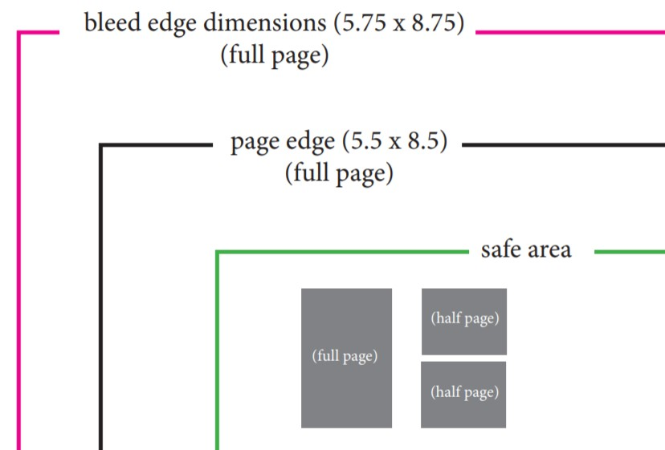NOTE: Please keep all important type and images at least one-quarter inch inside the ad dimension (safe area).

File formats: PDF, EPS, TIFF, or PSD; CMYK color space



**Mobile App Ad Specifications**

(Gold and Silver Sponsors)

Dimensions: 640px W x 90px H

Resolution: 72 dpi

File formats: JPEG, PNG, or other image file; RGB color space

