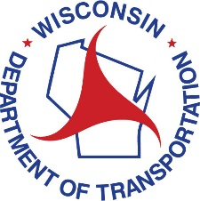
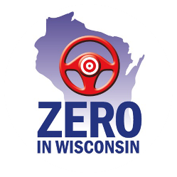
Governor’s Conference on Highway Safety
August 29-31, 2022 - Chula Vista, Wisconsin Dells

EXHIBITOR OPPORTUNITIES

EXHIBITOR PREMIUM
• Full page color ad in the conference program
• Exhibitor space in premium location for promotional use
• Exhibitor’s logo/name listed on select printed and digital promotional materials
• 50-word company description and logo on the conference website and mobile app
• Complimentary conference registration for two organization representatives
• Additional representatives at the special rate of $75/person

Cost of Exhibitor Participation (if registered by August 1, 2022) - $350
Cost of Exhibitor Participation (if registered after August 1, 2022) - $400
Electrical Hook-Up - $10

EXHIBITOR ADVERTISER
• ½-page color ad in the conference program
• Exhibitor space for promotional use
• Exhibitor’s logo/name listed on select printed and digital promotional materials
• 50-word company description and logo on the conference website and mobile app
• Complimentary conference registration for two organization representatives
• Additional representatives at the special rate of $75/person

Cost of Exhibitor Participation (if registered by August 1, 2022) - $300
Cost of Exhibitor Participation (if registered after August 1, 2022) - $350
Electrical Hook-Up - $10

EXHIBITOR
• Exhibitor space for promotional use
• Exhibitor’s logo and/or name listed on select printed and digital promotional materials
• 50-word company description and color logo on the conference website and mobile app
• Complimentary conference registration for one organization representative
• Additional representatives at the special rate of $75/person

Cost of Exhibitor Participation (if registered by August 1, 2022) - $250
Cost of Exhibitor Participation (if registered after August 1, 2022) - $300
Electrical Hook-Up - $10

