Exhibitor and Partner Information

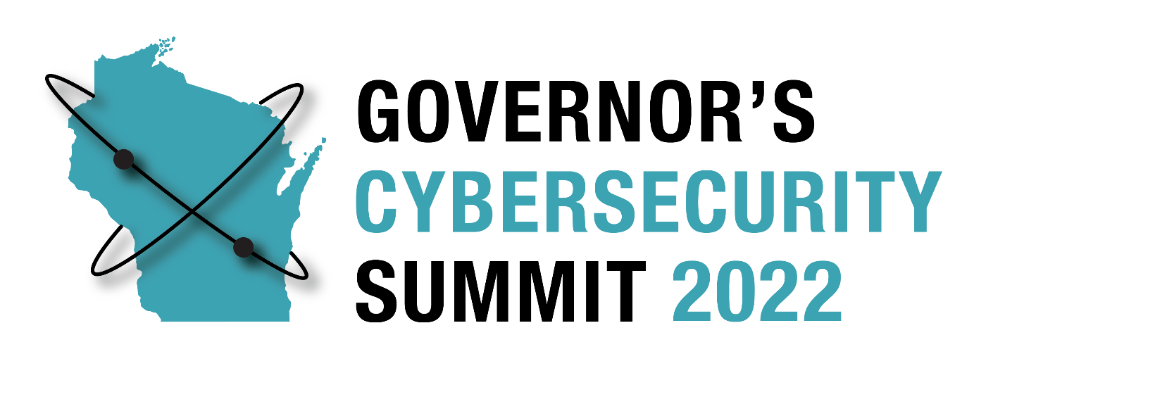

October 23-25, 2022

Glacier Canyon Lodge and Conference Center
Wilderness Resort

Wisconsin Dells
Past Sponsors & Exhibitors
Thank you to the following Sponsors and Exhibitors at the 2021 Wisconsin Governor’s Cybersecurity Summit:

Gold Level
InfoSec

Silver Level
Deloitte
Cybersecurity Center for Business / UW - Whitewater

Bronze Level
AT&T
PDS
Qualys
Tenable
Varonis
WICTRA

Exhibitors

- AE Business Solutions
- Artic Wolf & Capital-Data
- AT&T
- CDW
- Cybersecurity Center for Business / UW-Whitewater
- Deloitte
- Fortinet
- Infosec
- InfraGard National Members Alliance

- Kyndryl, Inc
- Palo Alto Networks
- PDS
- Qualys
- Tenable
- Varonis
- Wisconsin Cyber Threat
Response Alliance
- Zscaler

2022 EXHIBITOR and PARTNER OPTIONS AND DETAILS

EXHIBITOR: 15 available spots

- Inclusion of logo and/or name listed on select printed and digital promotional materials
- 50-word company description and color logo on the Summit website and mobile app
- Recognition on select signage at the event
- Exhibitor space at the Summit
- Complimentary conference registration for one organization representative

Cost of Exhibitor Participation - $1,500

Add-on Women in Cybersecurity - $500

NEW! Women in Cybersecurity – Sunday, October 23
This event is both designed and presented by leading women in Cybersecurity. The one-day conference features a program that focuses on educating women on the opportunities available in Cybersecurity.

Small Business Partner: 15 available spots

- Inclusion of logo and/or name listed on select printed and digital promotional materials
- 50-word company description and color logo on the Summit website and mobile app
- Recognition on select signage at the event
- Complimentary conference registration for one organization representative

Cost of Small Business Exhibitor Participation - $1,000

Exhibitor Terms and Conditions

Thank you for your sponsorship as an Exhibitor at the 2022 Wisconsin Governor’s Cybersecurity Summit and/or Women in Cybersecurity. We look forward to having your organization join us.

Event Information
October 23-25, 2022
Glacier Canyon Lodge and Conference Center, Wilderness Resort

Following the completion of your Exhibitor registration, you agree to be bound by the full Exhibitor Terms and Conditions:

- Registration: To register as a sponsor or exhibitor with the Wisconsin Governor's Cybersecurity Summit, you must complete the appropriate registration option and make required payments.

- Booth Assignments: Booth assignments are made by event management. While we will attempt to accommodate every exhibit space request, event management may need to modify the exhibit space to serve the best interests of the event. Booths are placed in the following order:
    - Sponsors will receive priority placement
    - Exhibitors are placed in the order registrations are received

- Cancellation Policy: To receive a full refund, cancellation requests must be made in writing and emailed to Dawn Zanoni at dawn.zanoni@wisconsin.gov no later than Friday, September 23, 2022. Cancellations occurring between September 24 and October 7, 2022, will receive a 50% refund. Cancellations made on or after October 7, 2022, are ineligible for a refund.

- Equipment Provided: Exhibit space allocation provided for this show includes an 8-foot table, 2 chairs, and table-top signage. If you require a larger space, please confirm with event management.

- Exhibitor Hours: TBD

- Show Setup Times: Exhibitors will be able to drop off/set up exhibition materials Sunday evening or Monday morning, times to be determined. Please proceed to the Glacier Canyon Conference Center within the Wilderness Resort, where you will receive further information. Onsite staff will be available to assist as needed.

- Force Majeure: In the event that the Summit is cancelled due to circumstances beyond our control, we will make every attempt to reschedule to another date (and/or place) and will offer you the opportunity to transfer your registration. If the event is cancelled entirely, we will provide refunds to exhibitors and sponsors based on any funds remaining after satisfying obligations in respect to the cancelled event.

Shipping Information
Exhibition materials may be sent no earlier than October 14, 2022, to:

Wilderness Resort
ATTN: Governor's Cybersecurity Summit (October 23-25, 2022)
45 Hillman Road
Wisconsin Dells, WI 53965

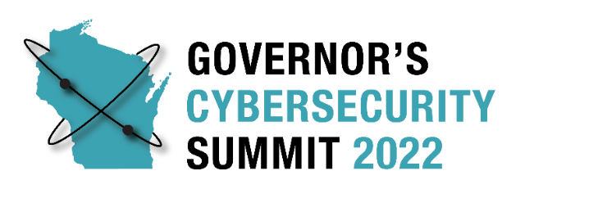
Sponsorship Agreement

We, the undersigned, agree to be a sponsor for this event. We have included all the necessary information and have included our contribution or agree to send our contribution no later than Friday, September 30, 2022.

ORGANIZATION:

CONTACT PERSON:

ADDRESS:

PHONE: E-MAIL:

PARTICIPATION LEVEL: (Please check one)
□ Platinum Level Sponsor $12,500
□ Gold Level Sponsor $10,000
□ Silver Level Sponsor $7,500
□ Bronze Level Sponsor $5,000
□ Add on Sponsorship for Women in Cybersecurity $1,000
□ Exhibitor $1,500
□ Add on Exhibit for Women in Cybersecurity $500
□ Small Business Partnership $1,000

As a Sponsor or Exhibitor of the 2022 Governor’s Cybersecurity Summit, our organization agrees to the above contribution. We understand that commitments must be made no later than September 23, 2022, and contributions must be submitted by September 30, 2022.

Sponsor Representative Signature Date

If other arrangements are necessary or you require further information on the enclosed materials, please contact Dawn Zanoni at (608) 266-3978, or dawn.zanoni@wisconsin.gov.

