Development of convolutional neural network-based automated segmentation using evolutionary algorithm on prostate MR images

S Matsuda
Department of Radiation Oncology, Tohoku University Graduate School of Medicine, Sendai, Japan
s.matsuda@med.tohoku.ac.jp

N Kadoya
Department of Radiation Oncology, Tohoku University Graduate School of Medicine, Sendai, Japan
kadoya.n@rad.med.tohoku.ac.jp

K Ito
Department of Radiation Oncology, Tohoku University Graduate School of Medicine, Sendai, Japan
i-kengo@med.tohoku.ac.jp

S Tanaka
Department of Radiation Oncology, Tohoku University Graduate School of Medicine, Sendai, Japan
s1290169@gmail.com

S Tanabe
Department of Radiation Oncology, Tohoku University Graduate School of Medicine, Sendai, Japan
tanabe@med.tohoku.ac.jp

Y Takayama
Medical Physics Section, Kanagawa Cancer Center, Yokohama, Japan
y-takayama@kcch.jp

S Tomori
Department of Radiology, National Hospital Organization Sendai Medical Center, Sendai, Japan
s.tomori.66@gmail.com

S Dobashi
Department of Radiological Technology, School of Health Sciences, Faculty of medicine, Tohoku University, Sendai, Japan
dobashi@med.tohoku.ac.jp

K Takeda
Department of Radiological Technology, School of Health Sciences, Faculty of medicine, Tohoku University, Sendai, Japan
tohoku.health.rad@gmail.com

K Jingu
Department of Radiation Oncology, Tohoku University Graduate School of Medicine, Sendai, Japan
kjingurad@yahoo.co.jp

Introduction
The automated segmentation work for the prostate on magnetic resonance (MR) imaging is challenging due to the intensity heterogeneity of the tissues. Recently, it is becoming generally to use U-net for deep learning based segmentation of medical images. However, it is not clear that U-net architecture was the best model for MR prostate segmentation. The purpose of this study was to explore the novel convolutional neural network (CNN) architecture to supplant conventional U-net using the evolutionary algorithm; a method to solve optimization problems modelled on the process of life evolution.

Method
50 transversal T2-weighted MR prostate volumes, obtained from MICCAI Prostate MR Image Segmentation 2012 (PROMISE12)[1], were studied. The datasets included ground truth segmentation for each of the cases. We divided all 50 volumes into axial images of 1377 slices. First, we constructed a 2D U-net architecture. Then, we explored the most optimal architecture using the evolutionary algorithm, which generated the networks form initial U-net model at random. Finally, 339 models were produced, and among them, the model with the smallest training error was evaluated. 10-fold cross-validation was introduced to evaluate the generalization performance of the proposal model. We didn’t perform any post-processing such as morphological operations or smoothing.

Results
We calculated Dice similarity coefficient (DSC) to evaluate the accuracy of segmentation results. The mean DSCs of our proposed model and initial U-net were 0.83±0.03 and 0.81±0.04, respectively. We achieved to develop a better model for MR prostate segmentation than the conventional U-net model by adopting the evolutionary algorithm.

Conclusion
We developed the new CNN model for MR prostate segmentation using the evolutionary algorithm. Our result showed the potential of constructing the novel neural network architectures that exceeded the accuracy of conventional ones.

References
[1] G. Litjens et al. (2014) Evaluation of prostate segmentation algorithms for MRI: The PROMISE12 challenge. Med. Image Anal. 18(2):359–373
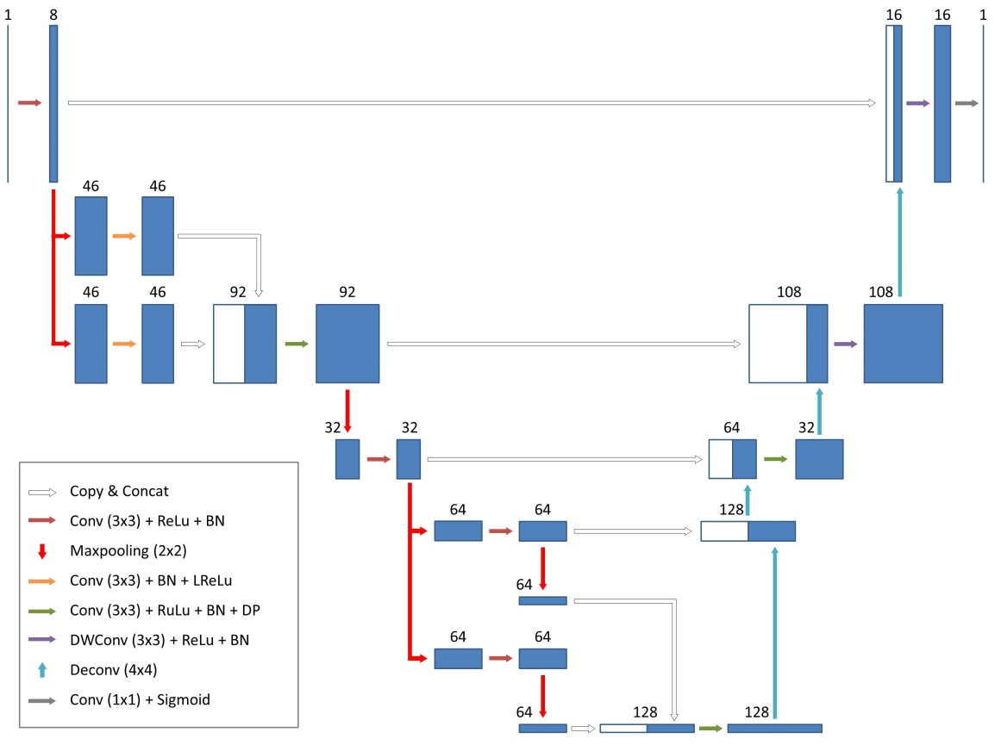
Fig.1. The proposed novel CNN architecture adopting the evolutionary algorithm.

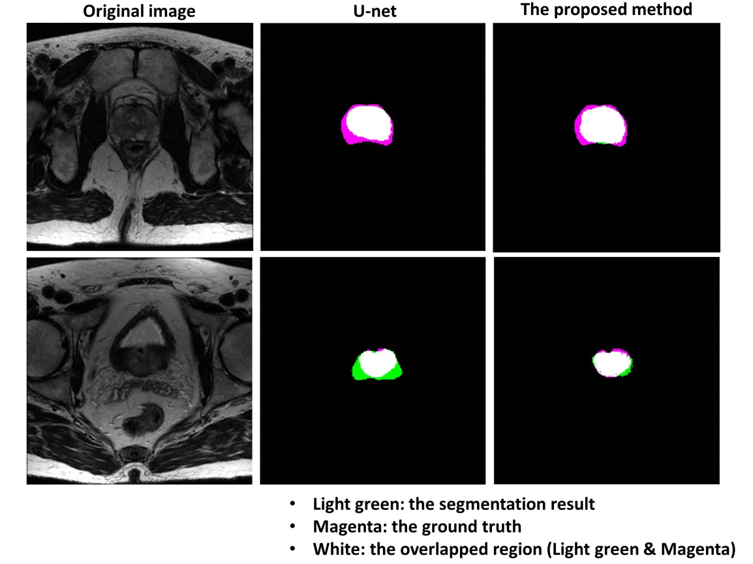
Fig.2. Typical cases of the segmentation results.

