What's the rush? New housing market absorption rate metrics reveal incentives to slow housing supply
Dr Cameron K. Murray¹

1 Henry Halloran Trust, The University of Sydney

Why do housing developers voluntarily slow their rate of new housing production when they make money from selling new homes? This question lies at the heart of current academic and political debates about the effect of planning and zoning on housing markets. A key part of the answer comes from analysis of the market absorption rate---the rate of new sales that maximises economic gains over time, both individually and collectively across the market. How much this rate varies with market conditions, outside of any potential planning constraints, is hard to observe with standard economic and housing metrics such as approvals, completions and so forth.

We propose four new metrics to show how sensitive the absorption rate is to market conditions, independent of potential planning effects, and the economic gains from matching the rate of supply to market conditions. They are as follows.

1. Development rate ratio (DRR)—average production rate to peak rate ratio
2. Development rate variability (DRV)—minimum production rate to peak rate ratio
3. Delay premium (DP)— average minus minimum price as a proportion of minimum price
4. Available delay premium (ADP)— maximum minus minimum price as a proportion of the minimum price

We calculate these metrics for a sample of ten major Australian housing subdivisions with over 2,000 dwellings where planning approvals have been granted, but where speed of the project development is a private choice, reveals the enormous degree that market conditions, particularly growth in demand, regulate the pace of new housing supply, independent of planning and zoning. We focus only on land sales in these projects. Property level sales records are used, with sale contract dates and prices allowing monthly sales frequency to be calculated, along with monthly average land prices on a per square metre basis. Focussing on land alone neatly shows the net financial incentives without having to estimate construction costs of new homes to determine the net gains from property development. For DP and ADP metrics, these can be multiplied by total production (in this case in terms of land area) at the minimum price to also show the dollar value gains from matching sales rates and prices to market conditions. These metrics are summarised in the below Table.

The average rate of production in this sample of major subdivisions is 33% of the maximum rate (DRR) and minimum rate is 1% of the maximum (DRV). Five per cent of month-project observations saw zero sales. Varying both the rate of sales and prices increased total revenue in these projects by 79% compared to a counterfactual of setting the price based on cost at the outset and selling all new dwellings at that minimum price (DP). Potential economic gains to delay can be large, with a 207% difference in total revenue available if all new dwellings were sold at the highest observed price rather than the lowest price over the project life (ADP). Because profit margins are just a fraction of revenues, even for land only subdivisions, the effect these price changes and delays on profits are amplified even further, suggesting that timing of sales is hugely important to the ultimate economic returns to property development. The dollar value translation of DP and ADP show that for most subdivisions the gains to delay are worth hundreds of millions of dollars.

These extraordinarily high variability and large economic returns to delay help communicate the logic of the market absorption rate and can contribute to improved academic and policy debates about the supply side of housing markets.

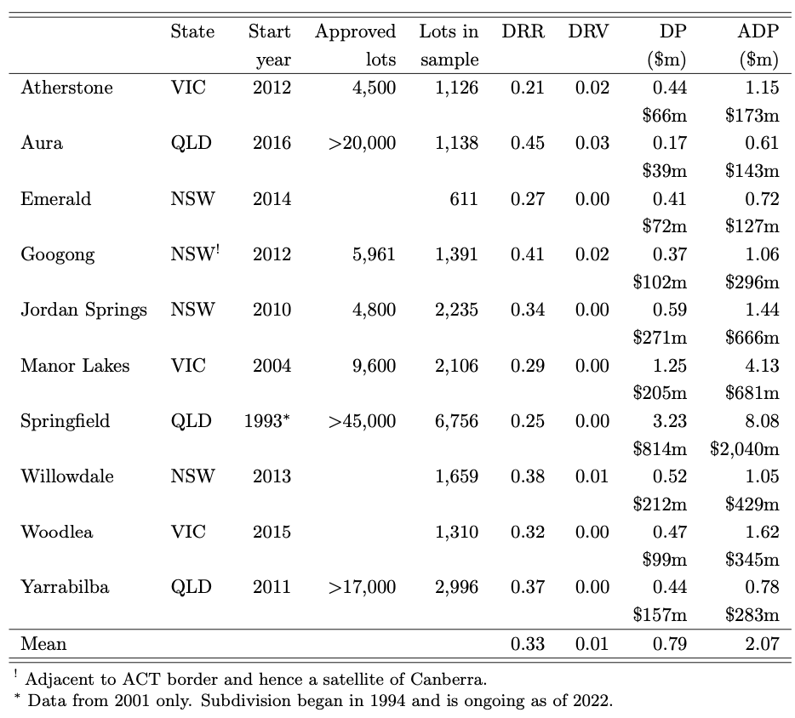

Key Words
Housing supply, Absorption rate, Variability

