Impact of COVID-19 related behavioural response on stock price volatility: an econometric investigation

**Chloe Burns**1

1 Australian National University

# Introduction and research questions addressed

The spread of COVID-19 across the globe has had marked impacts on human behaviour and interaction. Surveys, such as the Imperial College London YouGov COVID-19 behaviour tracker, have been vital in measuring the human response mechanism to the ongoing threat of infection. This study seeks to use such surveys to categorise human behaviour in Australia into three categories: fearful, careful and complacent. From here, the primary objective of this study is to investigate whether any short run or long run relationship exists between behavioural status and volatility in the Australian Securities Exchange (ASX), hereon referred to as stock price volatility (SPV). In this study, SPV is measured using Generalised Autoregressive Conditional Heteroscedasticity (GARCH) methodology. In addition, this study sought to investigate whether any short-term interactions measured via Vector Error Correction Model (VECM) methodology exists between behavioural status and SPV. For completeness, Granger-causal impacts between each variable set are investigated.

# How the research questions relate to the existing literature

Much of the recent research in this space has relied upon abnormal google search behaviours as a proxy for COVID-19 related fear. Sun et al. (2022) measured COVID-19 related fear in this manner and found this proxy to be linked to negative returns in the European stock market. Lyocsa et al. (2022) followed a similar proxy methodology, however expanded the analysis to conclude that COVID-19 related fear was predictive of market variance and volatility across 10 country stock indices, including the ASX. While google search trends are a useful proxy for estimating human behavioural response, this study argues that utilisation of the survey results maintains a more accurate representation of human behavioural response by virtue of being able to separate out nuanced changes in individual reactions to the world they live in, with less ambiguity around the intention of the behavioural signal.

Contrary to the use of google searches to proxy behavioural response, other studies such as Kusumahadi and Permana (2021) have deployed exchange rates as a metric to measure negative stock market responses. Using similar GARCH methodology, the authors conclude that the emergence and presence of COVID-19 in each country under analysis (excluding the United Kingdom) impacted stock market volatility. Again, this study argues that there is a degree of ambiguity associated with using an aggregate index as a representation of the behavioural status of the modelled population.

Vector Autoregression (VAR) modelling and associated impulse response functions (IRFs) have likewise been used to estimate impacts on the Australian stock market in the Australian context by Brueckner and Vespignani (2020). While the study contained herein uses VECM methodology, the insight from Brueckner and Vespignani (2020) is pertinent to the fact that there is a significant positive effect of COVID-19 infections on the performance of the ASX. These results, while interesting, again raise the issue as to what behaviour is being driven by the advent of COVID-19 cases in the community, and how such information is being interpreted by individual agents thus interacting with the stock market. This paper seeks to understand the gap presented by the differing behavioural states that may emerge from such information, or alternatively lack thereof.

# Motivation for studying the research question

It is well known and documented that individual decisions to engage with others and adhere to social distancing measures is critical in managing the spread of disease as detailed by official Government advice and mathematical modelling endeavours (such as Huang, Chen & Yan, 2021). However, there is a gap in the research to understand how different behavioural states – generated in response to COVID-19 – may impact the broader economy, including the stock market. A more nuanced approach to modelling COVID-related behaviours is thus required to fully understand and monitor impacts on economic outcomes in the domestic and international context. In addition, this study chose to model outcomes with regard to stock market volatility vis a vis stock market closing prices in order to investigate volatile outcomes in response to behavioural status, rather than unit level movements in price in one direction or another.

**Details of the methodology applied and preliminary findings**

Survey data used in this model has been sourced from YouGov (Jones, 2020) in a collaboration with the Imperial College of London to provide behavioural analysis on how different populations are responding to the pandemic. Specifically, this model focuses on question i_12_health_6 “*[Have you] avoided going out in general?”* to which the available options include *“Always”, “Frequently”, “Sometimes”, “Rarely”* or *“Not at all”*. This data was used to inform behavioural classification using the following assumptions:

* agents classified as **fearful** respond to the question with an answer of *“Always [avoid going out in general]”*;
* agents classified as **careful** respond to the question with an answer of *“Sometimes [avoid going out in general]”* or *“Frequently [avoid going out in general]”*, and
* agents classified as **complacent** respond to the question with an answer of *“Rarely [avoid going out in general]”* or *“Do not at all [avoid going out in general]”*.

Daily data was collected from the public repository for the period of 20 April 2020 to 31 January 2022.

**Figure 1.** Proportion of population by behavioural compartment

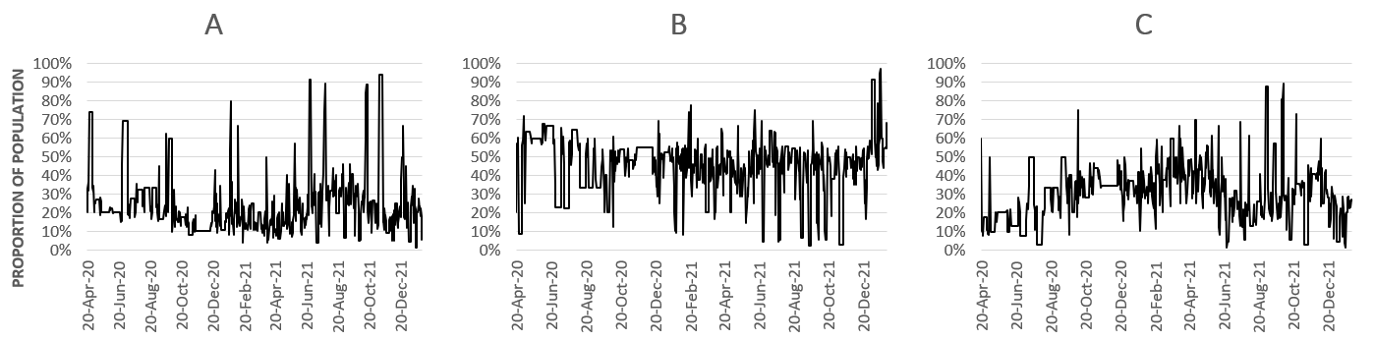

*Results presented as proportion of total sample respondents. Pane A = Fearful, pane B = Careful, pane C = Complacent.*

For ASX data, the daily closing price was collected for the period 20 April 2020 to 31 January 2022. Stock market volatility was measured using a GARCH model which was selected due to the capacity to model both autoregressive and moving average components in the heteroscedastic variance. This method also enables evaluation of the long-lagged effects of a shock with fewer parameters (Hill, Griffiths and Lim, 2011). Closing prices are subject to a GARCH (1,1) process to develop a GARCH variance series by specifying an autoregressive conditional heteroscedasticity (ARCH) model with a geometric lag structure imposed on the lagged coefficients.

**Figure 2.** ASX Closing Stock Prices, level and GARCH series

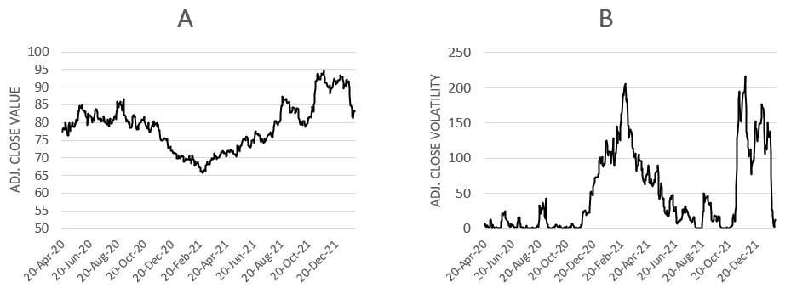

*Pane A = ASX Closing Price (Adjusted), pane B = ASX Closing Price (Adjusted) volatility (SPV).*

All time series were checked for stationarity using the Augmented Dickey Fuller test. The behavioural variables were found to be stationary, however stock price volatility was found to be non-stationary and as such a VECM was chosen for analysis. Results of the Johansen cointegration test found significant cointegrated relationships between stock volatility and fearful, careful and complacent behaviour respectively.

Given that the variables are cointegrated, it can be assumed that a long-term equilibrium relationship exists between the variables. In this case, the VECM can be applied to evaluate the short-run properties of the cointegrated series in levels. This kind of analysis provides indicative evidence of the nature of the relationships between the variables, in the absence of specific parameter estimates as supported by Sims (1980) and Sims, Stock and Watson (1990). In this way, rich dynamic relationships among variables may be analysed in a manner that allows insight into the response of variables following a policy change or shock. Optimal lag length was selected based on the Akaike Information Criterion (AIC).

Results of the VECM have been analysed with respect to IRFs. In this case, a shock is applied to each behaviour category which in turn affects stock market volatility. This study uses a standard Choleski decomposition to identify the effects of the shock. Figure 3 illustrates these IRFs for a 1 standard deviation innovation in each behavioural compartment. The x axis is measured in days, where the y axis reflects the direction and intensity of the impulse in the dependent variable away from its original level for 20 days post the initial shock.

**Figure 3.** IRF to Cholesky shock in each behavioural compartment

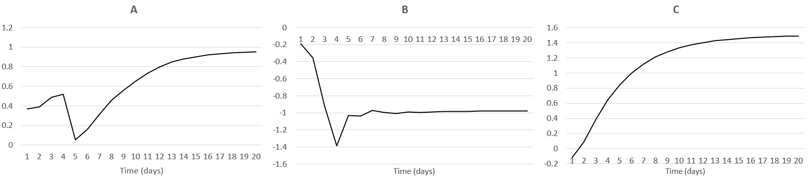

*A = SPV response to fear innovation, B = SPV response to careful innovation, C = SPV response to complacent innovation.*

Results from the VECM provides evidence for the following outcomes. First, a shock to the proportion of the population that is fearful implies an increase, followed by a sharp decrease, then persistent increase in SPV over the 20 days post innovation. This is not too dissimilar to a shock to complacent agents, which notes an initial decrease in volatility on the first day, followed by ever increasing volatility in the days thereon. Finally, a shock to the proportion of the population that is careful details an initial sharp decline in volatility, which after a brief recovery, remains negative for the duration of the horizon length (20 days).

To further analyse these results, granger causality tests were undertaken for each relationship under examination. The only significant causality was found between SPV and the fearful category, whereby SPV was found to granger cause fearful agents from lag (day) 9 through to 24.

# Conclusion

This study has presents a novel approach to quantifying the impact of COVID-19 behaviours on stock price volatility. In order to better understand and forecast SPV, further analysis is required to incorporate elements of human psychology and decision making into modelling efforts.

# Key Words

COVID-19, behaviour, GARCH, VECM, stock market analysis.

# Reference list

Brueckner, M., & Vespignani, J. (2021). COVID‐19 Infections and the Performance of the Stock Market: An Empirical Analysis for Australia*. Economic Papers: A journal of applied economics and policy*, 40(3), 173-193.

Hill, R. C., Griffiths, W. E., & Lim, G. C. (2018). *Principles of econometrics*. John Wiley & Sons.

Huang, H., Chen, Y., & Yan, Z. (2021). Impacts of social distancing on the spread of infectious diseases with asymptomatic infection: A mathematical model. *Applied Mathematics and Computation,* 398, 125983.

Jones, Sarah P., Imperial College London Big Data Analytical Unit and YouGov Plc. 2020, Imperial College London YouGov Covid Data Hub, v1.0, YouGov Plc, April 2020

Kusumahadi, T. A., & Permana, F. C. (2021). Impact of COVID-19 on global stock market volatility. *Journal of Economic Integration*, 36(1), 20-45.

Lyócsa, Š., Baumöhl, E., Výrost, T., & Molnár, P. (2020). Fear of the coronavirus and the stock markets. *Finance research letters*, 36, 101735.

Sun, Y., Li, H., & Cao, Y. (2021). Effects of COVID-Induced Public Anxiety on European Stock Markets: Evidence From a Fear-Based Algorithmic Trading System. Frontiers in Psychology, 12, 780992-780992.