Children and the Gender Earnings Gap: Evidence for Australia
Elif Bahar¹, Natasha Bradshaw¹, Nathan Deutscher¹, Maxine Montaigne¹

1 Australian Department of Treasury

Despite convergence in recent decades, there remain large disparities in earnings between men and women in Australia, as in many other countries. This paper uses an event study approach to estimate the impact of children on the gender earnings gap in Australia. Using survey data, we show that the arrival of children has a large and persistent impact on the gender earnings gap, averaging 55 per cent in the first five years following childbirth. In administrative we show this gap persists for the first ten years following childbirth. We attribute the gap in earnings to lower participation rates and reduced working hours amongst mothers. The decline in earnings for women is very similar regardless of their ‘breadwinner’ status in the household pre-birth, implying that relative earnings prior to birth have little influence on the intra-household allocation of paid work following childbirth.
International literature has shown that a primary driver of the gender earnings gap differences in the impact of parenthood on men and women, often termed the ‘motherhood penalty’ or ‘child penalty’ (see Kleven, Landais & Søgaard 2019). In this paper, we examine the impact of children on the gender earnings gap in Australia. We make three key contributions to the literature. First, we identify the child penalty in Australia up to 10 years following birth, allowing comparison to international estimates. Second, to our knowledge, we are the first paper in the international literature to estimate how the child penalty differs depending on the mother’s relative earnings within the household. We show that a significant and long-run child penalty exists even for mothers who significantly out-earn their partner, implying that relative earnings prior to birth have little influence on the intra-household allocation of paid work following childbirth. Finally, we plan to investigate heterogeneities in the child penalty across industry, occupation, and regions. This is particularly important given potential differences in family-friendliness and gender norms across these dimensions and given Australia has a highly gender-segregated labour market.
Using data from both the HILDA survey (2001-2019) and confidential personal income tax data collected from the ATO (1991-2018), we run an event study similar to Kleven, Landais & Søgaard (2019). Our approach exploits sharp changes in earnings around the birth of the first child for mothers and fathers, by comparing an individual’s income in the years post-birth to the year before birth, controlling flexibly for lifecycle and time trends (via a full set of age and year fixed effects). Our baseline specification using HILDA includes a balanced panel of parents who we observe for all years between 3 years before and 5 years after the birth of their first child.
We find a significant and persistent penalty attached to having a child for women, but not for men. The arrival of children results in an average gender gap in earnings of 55 per cent in the first five years following childbirth. Chart 1 plots the gender-specific impacts of children on wage and salary earnings over time, relative to earnings in the year before childbirth (i.e. the ‘motherhood penalty’). In the three years prior to childbirth, the earnings of men and women move in a similar way. However, following the birth of the first child, earnings of men and women immediately begin to diverge, with a significant gap remaining five years after childbirth.
Chart 1: Impact of children on earnings (%), by sex
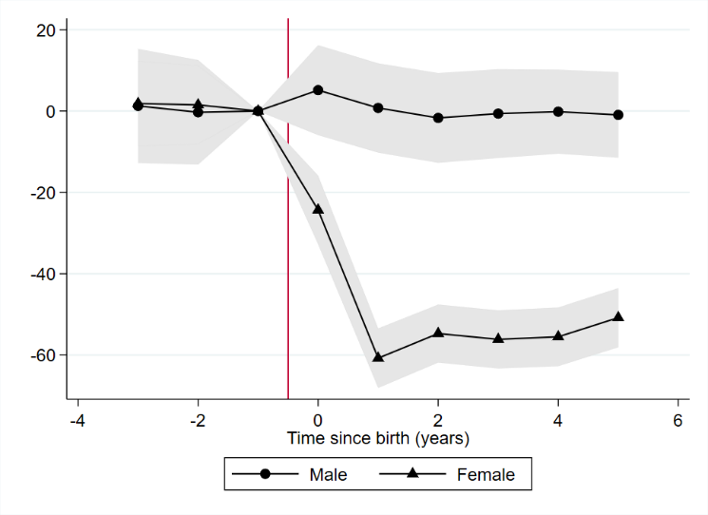
These effects are larger in magnitude than estimates for Denmark (25%), the UK (36%), the US (34%) and Sweden (40%), and smaller than estimates for Germany (70%) and Austria (71%) (Kleven et al, 2019). This may be driven by differences in gender and cultural norms, as well as institutional and policy settings across countries.
The ‘motherhood penalty’ can come from three margins – employment, hours of work, and the hourly wage rate. Chart 2 shows that all three margins contribute, with particularly large effects for employment and hours of work. There is a sharp drop in the probability of employment for women after childbirth, with only minimal recovery five years after birth (Panel A). For women who remain employed, hours worked falls significantly following birth and does not recover over the period (Panel B). Moreover, there is suggestive evidence of an hourly wage penalty for women who remain employed, averaging around 5 per cent in the five years following birth (Panel C). However, our measure for hourly wage is highly noisy due to data limitations in the HILDA dataset.

Chart 2: Impact of children on employment, hours worked and the wage rate (%), by sex
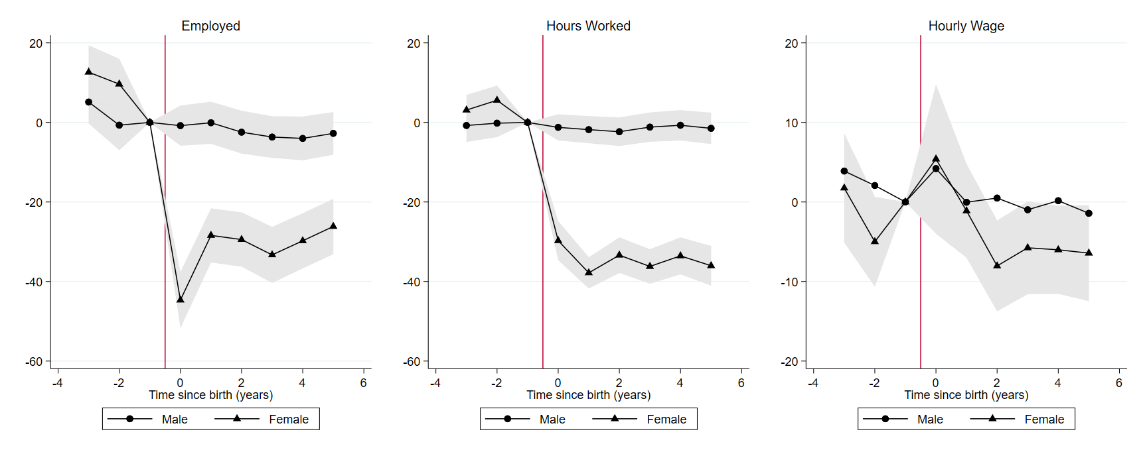

Across all three margins, the differences that emerge are driven entirely by women, with men largely unaffected. These effects highlight the strong labour supply implications of entry into parenthood for women.

Rationality, preferences, industry segregation or gender norms?

The estimates of the ‘motherhood penalty’ imply that children have large effects on the careers of women, relative to men. However, it is unclear whether this reflects a rational choice based on the earnings of parents, preferences, or constraints driven by workplace norms or institutions.
One explanation for the presence of a child penalty may be that couples make rational choices about the intrahousehold allocation of work and care. Namely, it makes rational sense for the partner with the lower income to take time off work to care for children given their lower opportunity cost of staying at home. To test whether our results are driven by rational economic decisions, we run separate regressions for women who are the primary earner in a couple before birth, and for women who are not (i.e. secondary earners). We define primary or secondary earner status using income from the year before birth, and include all men and women in a heterosexual couple (as stated on their tax return), regardless of whether the relationship continued post-birth. Around one-third of the partnered mothers in our sample are the primary earner prior to birth. We find no difference in the child penalty depending on earner status (Chart 3, LHS). That is, we estimate that women who were primary earners before birth experience a similar decline in earnings as mothers who were secondary earners within their household. The loss in earnings for mothers is also similar regardless of how much they out-earn their partner by (Chart 3, RHS).

Chart 3: Impact of children on women’s earnings (%), by breadwinner status

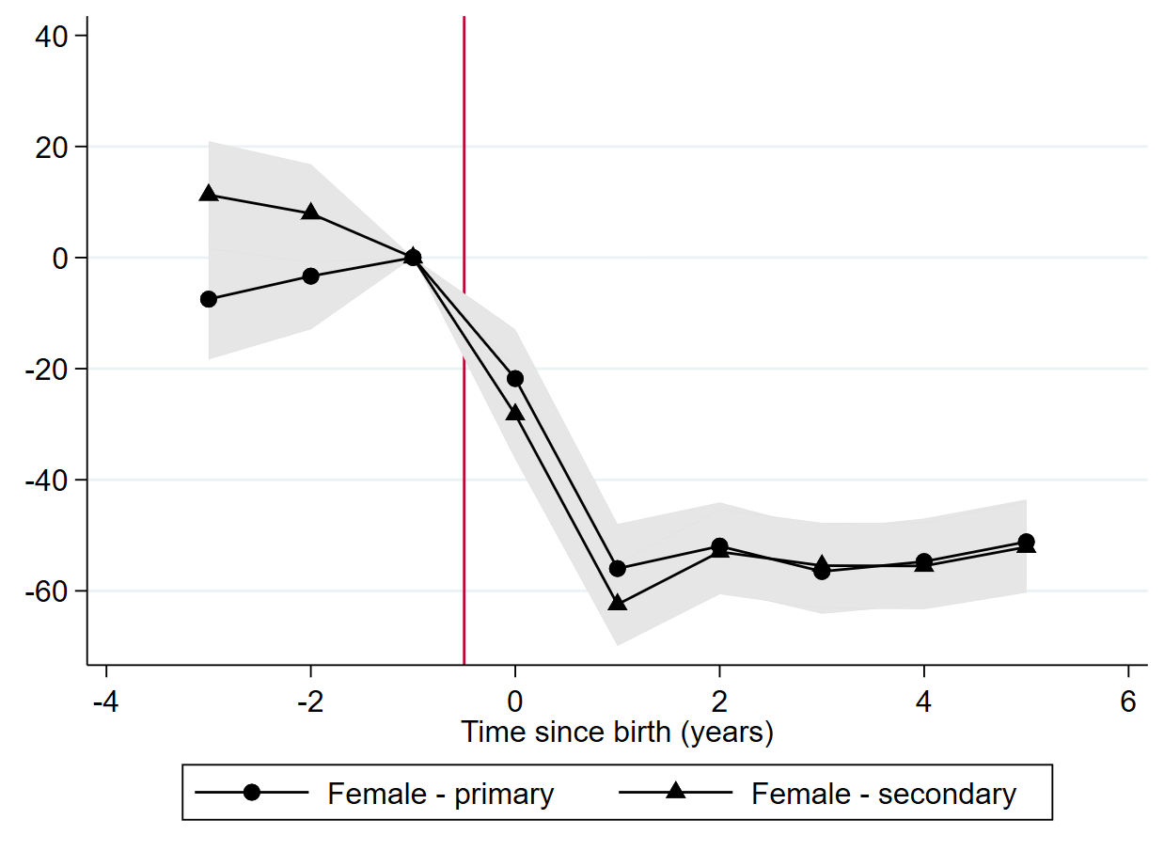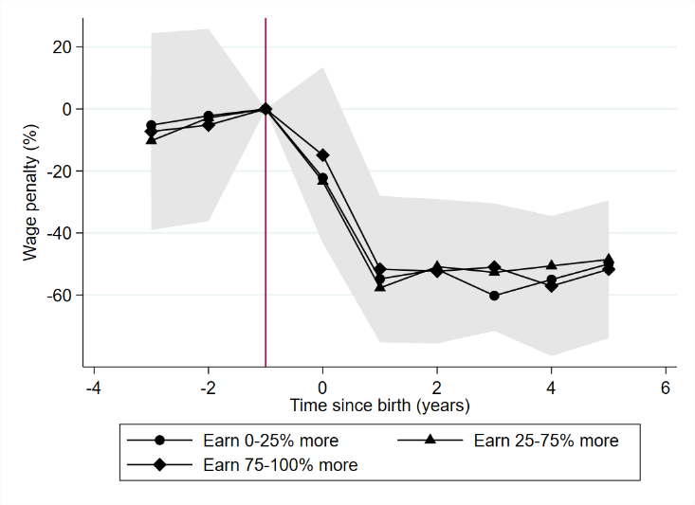

In absence of rational choices, we turn to preferences – the argument here is that household may still be making choices consistent with their preferences, even if those choices may not be economically rational. To analyse the preferences of parents, we study questions in HILDA around parent’s satisfaction with their employment opportunities and work-family life.
Following childbirth, mothers experience a decrease in satisfaction with their employment opportunities, in line with their worsening employment outcomes (Chart 4). The decline in women’s satisfaction with their employment opportunities begins to fall the year prior to birth and becomes significant one year after birth, indicating women may to some extent pre-empt reduced work opportunities prior to the arrival of children. However, their satisfaction troughs later than their employment outcomes, implying that the longer-term impacts of children may be unanticipated and that there are significant challenges in re-engaging in the labour market. In contrast, men’s satisfaction with their employment opportunities does not change significantly over time.
Overall, our results highlight the strong labour supply implications of entry into parenthood for women. These results are consistent with international studies suggesting these differences in labour market outcomes do not purely reflect different preferences between the genders, but also constraints that may be driven by differences in workplace norms or institutions. This suggests a role for policy in reducing these constraints, to allow new parents to share work and care responsibilities in ways that best suit their circumstances, needs and preferences.

Chart 4: Change in Parent’s satisfaction with their employment opportunities around childbirth (%)
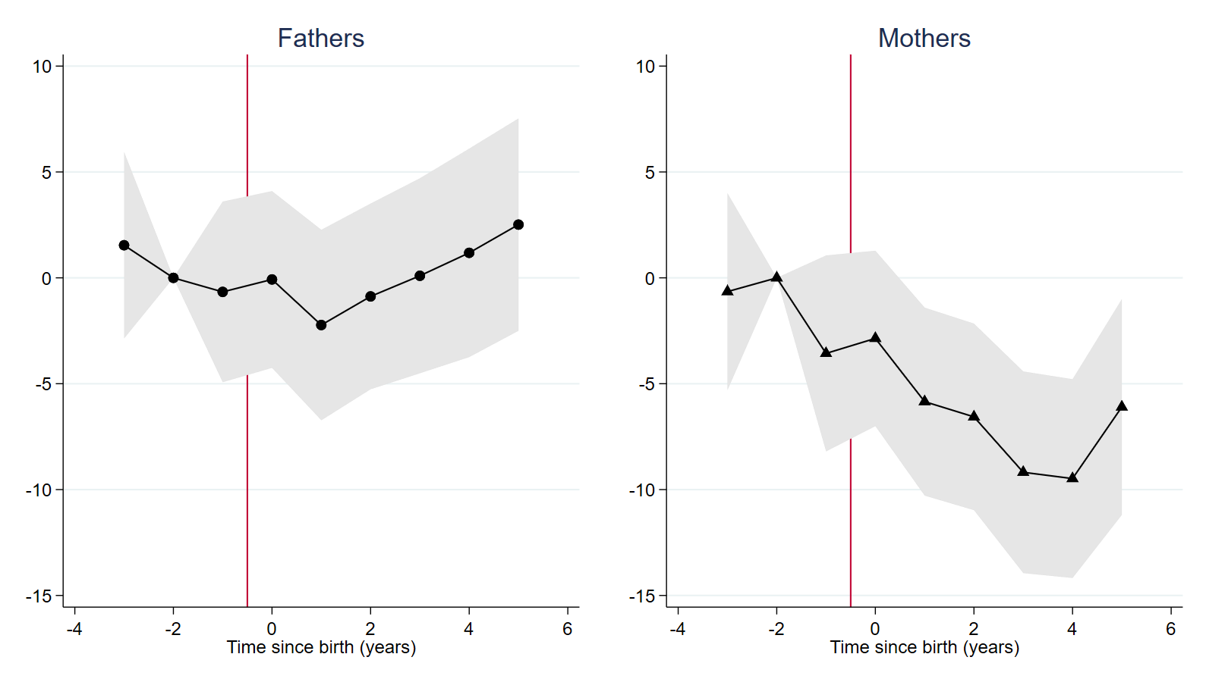

References
Kleven, H., Landais, C., and Søgaard, J. E. (2019), ‘Children and Gender Inequality: Evidence from Denmark’, American Economic Journal: Applied Economics, 11(4): p181–209.

Kleven, H., Landais, C., Posch, J., Steinhauer, A., Zweimüller, J. (2019), ‘Child Penalties across Countries: Evidence and Explanations’, AEA Papers and Proceedings, 109: 122-26.

Key Words
Motherhood, children, gender pay gap, participation, penalty

Presenter Biographies
Natasha Bradshaw
Policy Analyst, Australian Treasury
Natasha Bradshaw is a policy analyst at the Australian Treasury, where she produces research and provides advice on policies relating to women’s economic security. She previously worked as an applied microeconomist, using a range of large microdata assets to analyse the labour market and sources of market dynamism and productivity growth in Australia.
Elif Bahar
Applied Microeconomist, Australian Treasury

Elif Bahar is an applied microeconomist at the Australian Treasury, where she uses novel microdata to analyse Australian labour markets, track economic activity in real-time and inform economic policy. Some of her recent work includes tracking labour reallocation and productivity during COVID-19, labour market transitions during JobKeeper, and the impact of children on the gender pay gap. She previously worked as a research assistant at the University of New South Wales, where she also attained a Bachelor of Economics (Honours) and Bachelor of Arts.

For this extended abstract we present results only from HILDA. Our findings from Alife are consistent with the HILDA dataset and extend for a longer period. However, some of the extensions, including breaking down different employment outcomes, can’t be done with the Alife dataset because it does not contain hours of work. For this reason, we proceed with HILDA for our main analysis.
The estimated child penalties estimated here do not control for the other two margins, this explains why the penalties do not sum to the overall penalty.

