High speed Atomic Force Microscopy for visualizing plasma protein adsorption on silica nanoparticle-based coatings

Nuwan H. Arachchi^{A}, Takayuki Uchihashi^{B}, Paul J. Molino^{A}, Michael J. Higgins^{A*}

^{A}Intelligent Polymer Research Institute, ARC Centre of Excellence for Electromaterials Science, AIIM Faculty, Innovation Campus, University of Wollongong, Wollongong, NSW 2522, Australia.
^{B}Department of Physics, Nagoya University, Higashiyama Campus, Chikusa-ku, Nagoya 464-8602, Japan.

The development of materials for medical devices, including implants, stent and pacemakers and other medical consumables, remains a challenging research area due to the immediate adsorption of proteins onto biomaterial interfaces. Because of the higher surface activity of proteins, this initial protein adsorption occurs rapidly and may prevent other favourable biological interactions (Molino et al. 2012; Wilson et al. 2005). This is particularly an issue for surfaces that come into contact with blood, often resulting in blood coagulation, thrombosis and inflammation (Anderson et al. 2008). Therefore, a fundamental understanding of initial protein adsorption process on surfaces is of significant interest to effectively design biomaterials for advanced biomedical devices. In this work, we present the use of High-Speed Atomic Force Microscopy (HS-AFM) for visualizing dynamic molecular processes of plasma proteins at biomaterial interfaces.
HS-AFM system is capable of acquiring an image within 50-100 milliseconds (10 - 20 frames/second) with 1-2 nanometer lateral image resolution in liquid. Imaging speed and resolution of HS-AFM enables to obtain a sequence of images of real-time dynamic molecular events in nanoscale. Those single molecular observations have provided an insight to address the dynamics of single proteins in terms of initial adsorption processes, including the moment when they first bind and subsequent formation of a protein layer.
In this research, silica nanoparticle-based coating was used as the substrate, since silica naoparticles are commonly employed by the coating industry due to their low coat material, mechanical robustness and the possibility of functionalizing the particles with different chemistries. Coatings were prepared on gold mylar by spin coating a colloidal silica solution (4% solution of LUDOX® HS-40). Then the silica coatings were functionalized with different chemistries using silanes having specific functional groups (i.e. –OH, –CH₃, –NH₂). HS-AFM imaging of the coatings was carried out while proteins on the silica coating and flowing a protein solution through the silica coating.
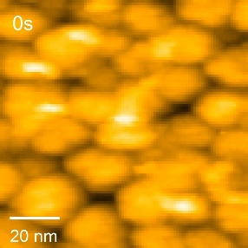
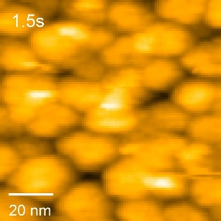
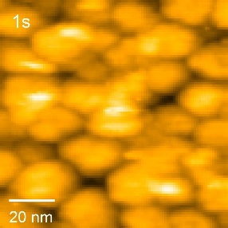
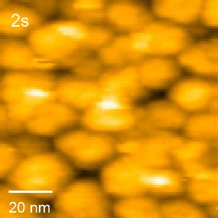
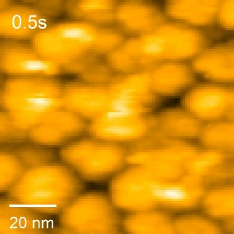
The presentation will show dynamics and interactions of single protein molecules (fibrinogen and bovine serum albumin) on the silica nanoparticle-based coating (Fig. 1.). In general, height, width, perimeter, area, position and roughness changes of protein molecules/surface were measured in terms of dynamic molecular events observed during the initial adsorption process.

Fig. 1. HS-AFM observations of fibrinogen on silica nanoparticle-based coating.

References
Anderson, J.M., Rodriguez, A. & Chang, D.T. (2008). Foreign body reaction to biomaterials. Semin. Immunol., 20, 86-100.
Molino, P.J., Higgins, M.J., Innis, P.C., Kapsa, R.M.I. & Wallace, G.G. (2012). Fibronectin and Bovine Serum Albumin Adsorption and Conformational Dynamics on Inherently Conducting Polymers: A QCM-D Study. Langmuir, 28, 8433-8445.
Wilson, C.J., Clegg, R.E., Leavesley, D.I. & Pearcy, M.J. (2005). Mediation of Biomaterial-Cell Interactions by Adsorbed Proteins: A Review. Tissue Eng., 11, 1-18.

mhiggins@uow.edu.au

