**Efficient Micro and Nano Patterning of SWCNTs via Discontinuous Dewetting and Liquid-Bridge-Mediated Nanotransfer, and Application in CNT/Silicon Heterojunction Solar Cells**

*Alexander CorlettoA, Joe G. ShapterA*

AAustralian Institute of Bioengineering and Nanotechnology (AIBN), The University of Queensland, Brisbane, Queensland, Australia



**Introduction**

To exploit the excellent properties of carbon nanotubes (CNTs) in new technologies, it is critical to control the placement/distribution of CNTs into desired patterns and architectures within devices. We explored a new patterning technique called discontinuous dewetting (DD) and liquid-bridge-mediated nanotransfer (LBMN), (Hwang *et al.* 2010) and applied this to pattern single-walled carbon nanotubes (SWCNTs) (Fig. 1). Discontinuous dewetting exploits the surface tension and contact angles of an ink on a stamp surface, allowing the ink solution to self-assemble into patterned cavities on the stamp. The dried ink patterns can then be transferred via LBMN onto any desired hydrophilic substrate. This technique can pattern nanomaterials with low energy, temperature, and cost, with potentially nanometre resolution, no nanomaterial damage, and no impurities remaining on/in the patterned features. This wide range of benefits is not achievable simultaneously with other methods, especially achieving high-resolution with high throughput. CNT transparent electrodes can then be fabricated using DD and LBMN, and the transparent electrodes can be applied in CNT/silicon heterojunction solar cells to improve their efficiency by reducing resistance. Previous work has shown that adding front contact electrodes to these solar cells can significantly improve efficiency (Corletto *et al.* 2018), and this new patterning technique improves on that strategy.

**Fig. 1** DD and LBMN patterning technique of CNTs

**Results**

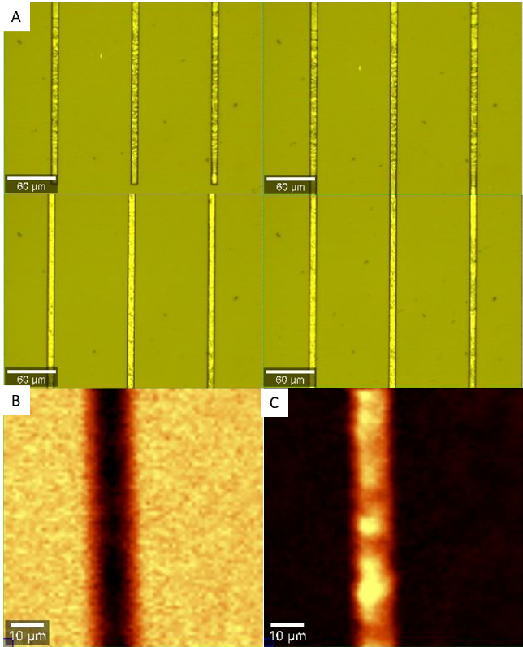SWCNT inks composed of SWCNTs dispersed in a variety of non-surfactant solutions were explored, including COOH-functionalised SWCNTs in water, ethanol, ethylene glycol, as well as pristine SWCNTs in cresol, DMF, NMP, and others. SWCNT ink effectively and precisely fills stamp microchannels if ink contact angle, viscosity, surface tension, printing speed, etc. are controlled. Deposition of SWNCTs along microchannels is uniform if SWCNTs well dispersed and large aspect ratio droplets are stable in microchannel (Fig. 2).

A

**References**

1. Hwang, J. K.; Cho, S.; Dang, J. M.; Kwak, E. B.; Song, K.; Moon, J.; Sung, M. M. (2010). Direct nanoprinting by liquid-bridge-mediated nanotransfer moulding. Nat Nanotechnol, 5(10), 742-748.

**Fig. 2** A) Optical image of SWCNTs patterned in microchannels. Scale bar 60 μm. B) Raman map of PDMS stamp microchannel C) Raman map of same area showing CNT G-band, indicating presence of SWCNTs in channels. Scale bar 10 μm.

1. Corletto, A.; Yu, L.; Shearer, C. J.; Gibson, C. T.; Shapter, J. G. (2018). Direct-Patterning SWCNTs Using Dip Pen Nanolithography for SWCNT/Silicon Solar Cells. Small, 14(16), 1800247.

Corresponding author, Alexander Corletto: a.corletto@uq.net.au