Self-Assembled Hybrid Nanocrystals as Advanced Optoelectronic Materials
Anum Nisarª,Laurent Lermusiauxª, Alison M. Funstonª
ªARC Centre of Excellence in Exciton Science, Melbourne, Australia and School of Chemistry, Monash University, Clayton, Australia

Introduction. The surface plasmon resonance (LSPR) of a metal nanoparticle has a significant impact on the emission of a fluorophore when the metal is in close proximity to the emitter.¹ Understanding the fluorescence modification in a coupled plasmon-exciton system will facilitate the emergence of photonic technologies. However, a key challenge is the development of high-yielding fabrication protocols with control over interparticle separation.¹ DNA based self-assembly of nanoparticles is an attractive choice for the design of superstructures due to the ability of DNA to undergo base-pair recognition and high binding specificity.

Aims. We outline a method to achieve the self-assembly of nanocrystals of different materials in one superstructure. The method is able to form hybrid structures, with unique optical properties, in high purity.

Methods. DNA-based self-assembly combined with gel electrophoresis was employed for the synthesis of core-satellite nanoparticle superstructures composed of a metallic core and semiconductor nanoparticle satellites. The DNA strands are bound to the nanoparticles via a thiol. Separation of semiconductor nanoparticles with one DNA strand per particle is achieved using electrophoresis. These are incubated with metal nanoparticles containing complementary DNA strands (with high coverage) to form the assemblies.
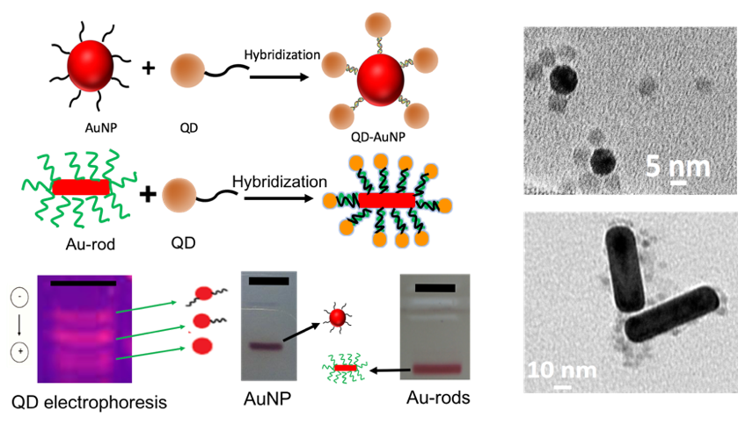
Results and Discussion. Hybrid assemblies are formed from DNA-bound nanoparticle building blocks. The high-purity of the assemblies relies on the ability to control the number of DNA strands per particle,^{2,3} avoiding formation of high yields of higher-order aggregates with uncontrolled geometries. The assembly scheme utilizes a metallic nanoparticle core with a very high DNA coverage. In order to form discrete core-satellite structures, semiconductor nanoparticles functionalized with one DNA strand per particle were used. We have optimized the conditions for the binding of semiconductor particles to a central metal particle via DNA linkers with both 100 and 30 base-pairs. The flexibility in the DNA length allows investigation of long and short-range interactions in the coupled nanocrystals. The methodology presented is highly flexible, allowing formation of stable assemblies of nanoparticles of different shapes, sizes and classes. Steady-state and time-resolved optical experiments show significant change in the emission behavior of the quantum dots in the assembly relative to untethered quantum dots.³

Conclusion. Core-satellite structures of different material properties have been developed with defined interparticle distances guided by the DNA self-assembly and their optical characteristics measured. The assembly approach is widely applicable and may be used to design efficient energy funnels and complex plasmonic architectures for optoelectronic, photonic, chemical and biological sensing applications.
References
1. Nepal, Dhriti, et al. (2013). Large scale solution assembly of quantum dot–gold nanorod architectures with plasmon enhanced fluorescence. ACS Nano 7, 9064-9074
2. Lermusiaux, L. &Funston, A. M. (2018). Plasmonic isomers via DNA-based self-assembly of gold nanoparticles. Nanoscale, 10, 19557-19567
3. Lermusiaux, L., Nisar, A. and Funston, A. M. (2019) Manuscript in preparation
4. Nisar, A. & Funston, A. M. (2019) Manuscript in preparation.

