Nanostructured materials in biomimetic systems

Dorna Esrafilzadeh
Graduate School of Biomedical Engineering, University of New South Wales, Sydney, Australia

Introduction:
Soft, biocompatible, flexible, durable, battery-less; these are just a few key requirements for implantable bionic devices and wearable bioelectronics that need to be minimally invasive to our body. Several strategies, mostly involving smaller implants, softer and more flexible device architectures, can reduce the foreign-body reaction making better tissue/device interfaces and trigger weaker immune responses compare to the traditional metal electrodes with high chance of scarring.
Unsurprisingly, it is difficult to design and fabricate electrodes that fit all the general requirements of an ideal bioelectronic device for body implantation. Yet, as with most engineering problems, feasibility often lies in determining the right balance of requirements and constraints. Recently, advances in atomically thin two-dimensional (2D) materials addressed some of the challenges to improve device efficiency and cell-materials interface. To this end, atomically thin 2D materials including metal oxides can have various applications in electronics and bionic. However, many metal oxides cannot be synthesized as 2D materials with high yield and high concentration through the conventional methods. Herein, we have developed a scalable technique to extract a wide range of 2D metal oxides employing nontoxic eutectic gallium-based alloys as a reaction solvent and co-alloyed with desired metals. The materials have been furthermore fabricated via 3D printer to generate wearables in 3D architecture.
Results and discussions:
Room temperature Gallium-based liquid metal has been alloyed with metals such as Ce and Fe.¹ The alloys were added to water before being shacked vigorously using vortex mixer. After a few second the liquid metal transformed to many microparticles where the skin consisted of atomically thin metal oxide, which can be exfoliated from the liquid metal droplets over a few second centrifugation. This process was repeated several times until very high concentration of up to 100 mg/ml of 2D metal oxide in water was obtained. This process is schematically represented in figure 1. Finally, the supernatant was collected and utilised for further characterisations. 3D printing was performed using HD Hyrel system on the surface of polyurethane (PU) coated glass slide. Raman, X-ray photoelectron spectroscopy (XPS) and atomic force microscopy (AFM) were performed on the metal oxide 2D sheets. Furthermore, cellular studies were performed on the fabricated structures.

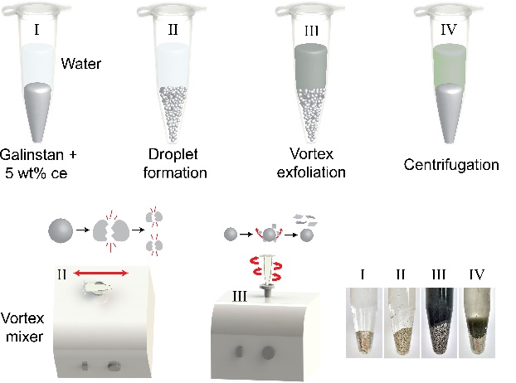
Figure 1. Schematic illustration of the method developed here to exfoliate large quantities of exfoliated metal oxide out of room temperature liquid metal.

References

1. Esrafilzadeh D, Zavabeti A, Jalili R, Atkin P, Choi J, Carey BJ, et al. Room temperature CO2 reduction to solid carbon species on liquid metals featuring atomically thin ceria interfaces. Nature Communications 2019, 10(1): 865.

