NIR nanoscopy for imaging through deep tissue

Fan Wang^{A}
^{A}Institute for Biomedical Materials and Devices (IBMD), Faculty of Science, University of Technology Sydney, Australia.

Introduction.
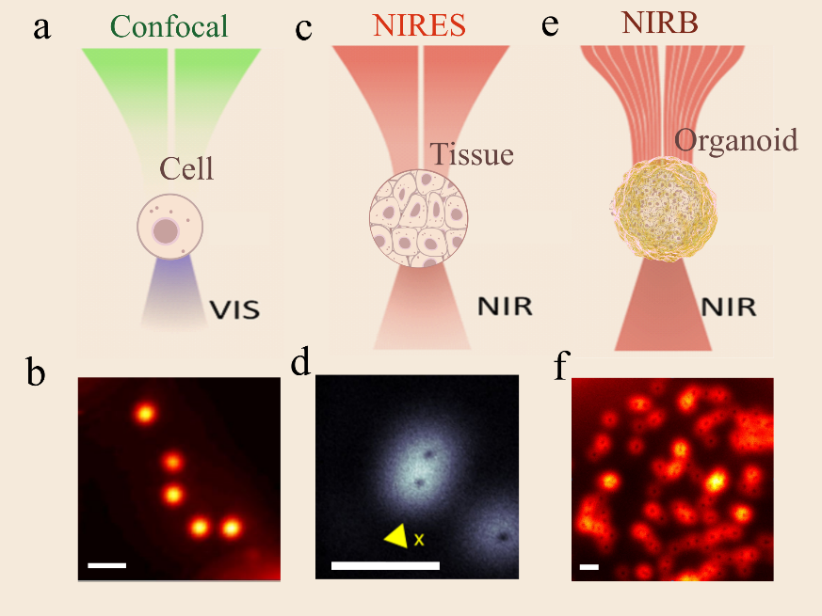
Biological tissue and organoid are in vitro model to study cell behaviours in a living organism, hold great potential for human cellular biology study, especially in disease pathology, drug delivery, and drug efficacy trials. However, it is challenging to achieve in-depth imaging with sub-100nm resolution inside tissue and organoids, as deep tissues have high scattering and absorption for both excitation and emission light. The scattering and absorption will provide aberration which degrades imaging resolution and decreases the signal to noise ratio. Near-infrared multiphoton excitation is the way to mitigate tissue absorption, but it requires high-power to achieve super-resolution. Upconversion nanoparticles (UCNPs), consisted with sensitizer ions (e.g. ytterbium Yb3+) and emitter ions (e.g. thulium Tm3+), could convert near-infrared excitation (NIR) photons to visible and NIR photons under relatively low excitation power. Its unique optical response enables it to achieve low power super-resolution imaging [1]. In this talk, I will introduce a strategy for deep tissue super resolution imaging. The strategy has NIR for both excitation and emission by applying UCNPs as super-resolution imaging probes.
Figure 1. The diagram of normal confocal imaging (a) and its imaging result for UCNPs (b), near-infrared emission saturation nanoscopy (c) and its result (d) [2], near-infrared Bessel beam nanoscopy (e) and its result (f). All size bar in the figure is 1μm.

Results.
We have developed a new mode of near-infrared emission saturation nanoscopy for deep tissue imaging, where both the 980 nm excitation beam and 800 nm emission beam locate at the transparent biological window, achieving a resolution of 50nm, 1/20th of excitation wavelength, in imaging of single UCNP through 93μm thick liver tissue (figure 1 c and d). Using a single Bessel-doughnut beam excitation from a 980 nm diode laser and detecting at 800 nm, we achieved a near-infrared, “non-diffractive” nanoscopy that has a resolution of 98nm inside spheroids, as deep as 55.9 µm (figure 1 e and f). We further demonstrated a NIR-nonlinear SIM nanoscopy that enables faster super-resolution imaging inside deep tissue.

Conclusion.
These methods hold great potential to monitor the nanoscale cargo transportation in biological tissue and organoid. This technology holds great potential for the investigation of the behaviours such as the movement, inter-and intra-cellular trafficking and drug release of single nanoparticles in biological systems.

References
[1] Y Liu et al. Amplified Stimulated Emission in Upconversion Nanoparticles for Super-Resolution Nanoscopy. Nature 2017, 543, 229.
[2] C. Chen et al., “Multi-photon near-infrared emission saturation nanoscopy using upconversion nanoparticles,” Nat. Commun., vol. 9, no. 1, pp. 4–9, 2018.

