Analysing the growth modes of vdW/graphene heterostructures as a function of the substrate

N. Motta^{A*}, J. Bradford^{A}, N.Zebardastan^{A}, A. Wolff^{A}, B Gupta^{A}, J. Lipton-Duffin^{A}, J. MacLeod^{A}, K. Hu^{B}, Y. Ito^{B},C. Mariani^{C}, M.G. Betti^{C}

^{A} School of Chemistry, Physics and Mechanical Engineering and Institute for Future Environments, Queensland University of Technology, Brisbane 4001, QLD, Australia.
^{B} Institute of Applied Physics, Graduate School of Pure and Applied Sciences, University of Tsukuba, Tsukuba 305-8573, Japan
^{C} Department of Physics, Sapienza University, 00185 Rome, Italy

Van der Waals heterostructures of layered materials such as graphene, hexagonal boron nitride and transition metal dichalcogenides (TMDs) have attracted attention recently due to the ability to create synthetic materials with properties different to their constituent layers. Direct growth of 2D layers on epitaxial graphene/SiC offers controlled growth of van der Waals materials with a pristine interface on a device-ready substrate.

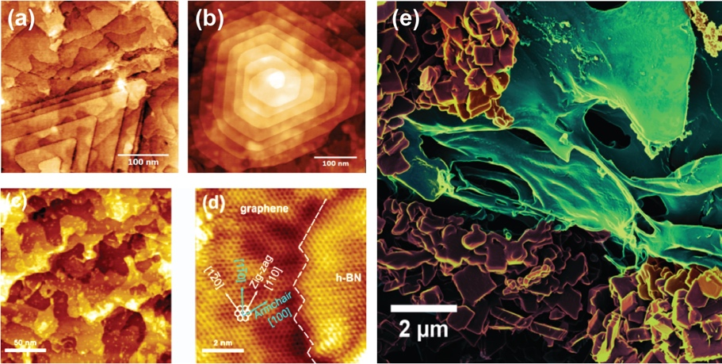
Fig. 1 | MoS₂ heterostructures on epitaxial graphene (a-b). h-BN/graphene in-plane heterostructures (c-d). MoS₂ on Nano Porous Graphene (e).

In this work we analyze the differences of the growth of h-BN and MoS₂ on epitaxial graphene/SiC and of MoS₂ on Nano Porous Graphene (NPG). A systematic investigation of the resulting heterostructures has been conducted by microscopy and spectroscopy. While h-BN grows in-plane by replacing C atoms in graphene (Bradford et al. 2019), the morphology of MoS₂ layers has a very different evolution on different substrates depending on the morphology: from substrates with no steps on NPG to substrates with different distance between steps on epitaxial graphene. We analyze the results as a function of the competing processes of mass flux of the metal precursor and the growth rate.

References
J Bradford, M Shafiei, J MacLeod, N Motta - Advanced Materials Interfaces, 1900419, (2019) https://doi.org/10.1002/admi.201900419

