Porphyrin 2D and 3D Graphene Assemblies as Electrocatalysts for CO₂ reduction

Jaecheol Choi^{A}, Pawel Wagner^{A}, Sanjeev Gambhir^{A}, Sepidar Sayyar^{A}, Rouhollah Jalili^{A,B}, Jeonghun Kim^{C}, Seoungwoo Byun^{D}, Yong Min Lee^{D}, Douglas R. MacFarlane^{E}, Gordon G. Wallace^{A} and David L. Officer^{A,F}
^{A}ARC Centre of Excellence for Electromaterials Science and the Intelligent Polymer Research Institute, University of Wollongong, Wollongong, Australia; ^{B}School of Science, RMIT University, Melbourne, Australia; ^{C}School of Chemical Engineering and the AIBN, The University of Queensland, Brisbane, Australia; ^{D}Department of Energy Science and Engineering, Daegu Gyeongbuk Institute of Science and Technology (DGIST), Daegu, Republic of Korea; ^{E}ARC Centre of Excellence for Electromaterials Science, Monash University, Clayton, Australia; ^{F}Corresponding author.

Introduction.
Electrochemical CO₂ conversion is in the global spotlight as one of the most promising ‘clean’ approach for the conversion of atmospheric and marine CO₂ into clean and renewable liquid fuels as well as offering a potential approach to the amelioration of a major greenhouse gas. In particular, carbon monoxide (CO) produced by electrochemical CO₂ reduction is a principal industrial feedstock for the production of hydrocarbons and bulk oxygenated products. Consequently, the development of a highly energy efficient and selective heterogeneous catalyst for the conversion of CO₂ to CO is of major interest.
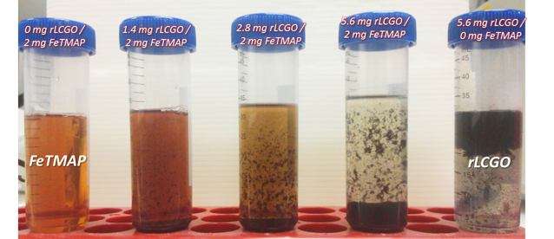
Metal complexes such as metalloporphyrins are promising candidates for the development of heterogeneous catalysts since they have been widely studied as homogeneous catalysts for electrochemical CO₂ reduction due to their high selectivity, low cost, and ease of preparation on a large scale.
Figure. Porphyrin solutions containing increasing amounts of graphene showing catalyst self assembly.
Aim.
The aim of this research was to develop highly energy efficient and selective heterogeneous catalysts for the electrochemical conversion of CO₂ to CO in water using metalloporphyrins and metallophthalocyanine composites with graphene.
Methods.
Simple and facile self-assembly methods (Figure) for the fabrication of heterogeneous composite electrocatalysts using π-π stacking and electrostatic interactions of a water-soluble metalloporphyrin or metallophthalocyanine with reduced liquid crystalline graphene oxide (rLCGO) were developed. The 2D catalyst, a porphyrin/graphene framework (FePGF) was composed of Fe(III)-tetraphenyltrimethylammonium porphyrin (FeTMAP) and rLCGO while the 3D catalyst, FePGH, comprised a FeTMAP/rLCGO hydrogel.[1,2]
Results and Discussion.
The 2D FePGF has an outstandingly robust catalytic performance for the production of CO with an enhanced current density of 1.68 mA cm⁻² and 98.7 % CO faradaic efficiency (FE) at an overpotential of 430 mV for 10 h, corresponding to a TOF of 2.9 s⁻¹ and 104,400 TON. Furthermore, FePGF/CFP has one of the highest cathodic energy efficiencies (60.9 %) reported for immobilized metal complex catalysts. The 3D FePGH which has a highly porous and conductive 3D graphene structure, resulted in high catalytic activity for consistent CO production with 96.4 % faradaic efficiency over 20 h electrolysis at a very low overpotential of 280 mV, corresponding to the highest cathodic energy efficiency yet observed of 79.7 % compared to other state-of-the-art immobilised metal complex electrocatalysts.
Conclusion.
The resulting electrocatalysts possess advantages including (1) facile and rapid electron transfer, (2) easy electrolyte and CO₂ accessibility, (3) structural robustness, (4) excellent FEs (>96%) at overpotentials as low as 280 mV, and (5) superior long-term stability (up to 50 h) under the electrochemical reduction conditions.
References
- Choi, J.; Wagner, P.; Jalili, R.; Kim, J.; MacFarlane, D. R.; Wallace, G. G.; Officer, D. L. Adv. Ener. Mater. 2018, 8, 1801280, DOI: doi.org/10.1002/aenm.201801280.
- Choi, J.; Kim, J.; Wagner, P.; Gambhir, S.; Jalili, R.; Byun, S.; Sayyar, S.; Lee, Y. M.; MacFarlane, D. R.; Wallace, G. G.; Officer, D. L. Ener. Environ. Sci., 2019, 12, 747-755, DOI: 10.1039/c8ee03403f.

