Nanostructured Metasurfaces for vortex generation, multiplexing and lasing

Cheng-Wei Qiu

Department of Electrical and Computer Engineering, Singapore, Singapore 117583.

Introduction

Interfacial engineering via the artificially constructed structures of ultrathin thickness compared to the wavelength has enabled a plethora of advanced manipulations of light-matter interactions. I will report some of the most recent developments in my group as well as in the field of the interfacial engineering of manipulation of light-matter interactions, via the artificially nanostructured metasurfaces.

Aims & Results
Amongst various applications of metasurfaces, I will focus on how to design vortex metasurfaces¹ to generate and multiplex orbital angular momentums (OAMs), with other degrees of freedom of light such as polarization and frequency. Furthermore, we will show some more recent and exciting results about high-purity orbital angular momentum lasing by synergize the metasurfaces and cavities.

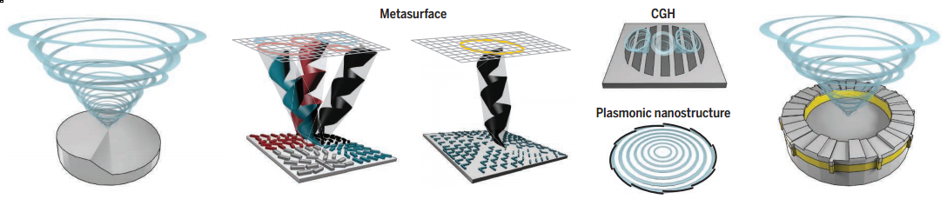

Conclusion
The study provides an alternative paradigm toward an extremely compact and multifunctional nanodevices resorting to the OAM states of the light. The multiplexing and hybridization of OAM states with other properties of light open up new opportunities for the advanced flat-profile optics.

References
- C.-W. Qiu* and Y. Yang, (2017). Vortex generation reaches a new plateau. Science, 357, 645.

