**Interface engineering strategies for low-dimensional semiconductor materials towards enhanced photo and photoelectrochemical water oxidation**

*Huayang ZhangA, Shaobin WangA*

ASchool of Chemical Engineering, The University of Adelaide, North Terrace, Adelaide, SA 5005, Australia.

**Introduction**

Water splitting can realize direct solar-to-fuel conversion and deliver H2 as a renewable source. Efficient photo or photoelectrochemical (PEC) water oxidation is essential for overall water splitting. However, it is kinetically sluggish, due to the multi-step, four-electron and multi-proton transfer processes. Rational design of efficient photocatalytic or PEC water oxidation catalysts (WOCs) is important for advancing the technologies toward efficient water-splitting into hydrogen. Here we propose a series of scalable interface-induced strategies to construct two-dimensional (2D) WO3@CoWO4 bilayer hybrids (Fig. 1 a-b)1, zero/two-dimensional (0D/2D) Co3O4 quantum dots/C3N4 nanosheet (Fig. 1 d-e).2 Benefited from the in situ formed special morphologies, narrowed band gap, rapid charge transfer across the interface, lower charge recombination rates, and active sites created by the interface, enhanced photocatalytic and PEC water oxidation activities are observed on these composites (Fig. 1c,f).

**Results**

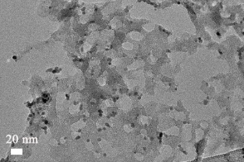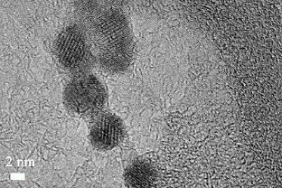

c)

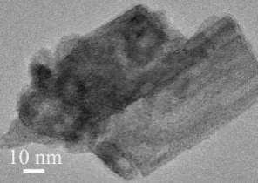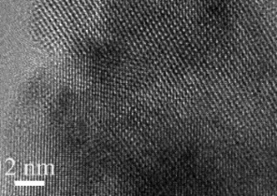

b)

a)

d)

e)

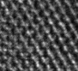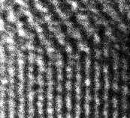

WO3 (001)

CoWO4 (200)

0.24 nm

f)



**Fig. 1** a, b) TEM images and c) corresponding current-voltage curves under illumination (PEC test) of WO3@CoWO4 hybrid. d, e) TEM image and f) corresponding visible-light photocatalytic water oxidation of Co3O4-C3N4

Compared to WO3, photocurrent density at 1.3 V was enlarged by a factor of 2 in the WO3@CoWO4 composites (Fig.1 c). In this configuration, WO3 serves as the photoabsorber (especially for visible light), while CoWO4 functions in three aspects: (i) constructing with WO3 to form p–n heterojunctions; (ii) preventing WO3 from photocorrosion; (iii) acting as an active electrocatalyst to improve the water oxidation kinetics of WO3. Co3O4 quantum dots were dispersedly loaded onto porous g-C3N4 nanosheets as a cocatalyst for enhanced visible-light-driven water oxidation. Numerous pores are in-situ produced on g-C3N4 and tight heterojunction is created due to the strong interaction between Co3O4 and g-C3N4. The produced O2 amount by Co3O4-C3N4-300 were elevated approximately 4 times compared to pristine g-C3N4 (Fig.1 f).

**Conclusion**

The paradigm we introduced in this work could provide a refreshing perspective for pursuing and designing more efficient low-dimensional photo-related water oxidation catalysts.

**References**

1. O H. Zhang, W. Tian, Y. Li, H. Sun, M. O. Tadé and S. Wang, J. Mater. Chem. A, 2018, 6, 6111–6690.
2. H. Zhang, W. Tian, L. Zhou, H. Sun, M. O. Tadé, S. Wang, Appl. Catal. B Environ. 2018, 223, 2-9.