Insight into the effect of spatial distribution of MoS₂ on CdS Nanorods
Xinxin Lu^{A}, Judy N. Hart^{B}, Jason Scott^{A}, Yun Hau Ng^{C}

^{A}School of Chemical Engineering, Particles and Catalysis Research Group, UNSW, Sydney, Australia.
^{B}School of Materials Science and Rngineering, UNSW, Sydney, Australia.
^{C}School of Energy and Environment, City University of Hong Kong, Hong Kong SAR, P.R. China

Abstract
Photocatalytic H₂ evolution and overall water splitting using CdS-MoS₂ heterojunction have been explored by many researchers owing to its visible light harvest and comparably high efficiency,¹ However, the impact of MoS₂ distribution on CdS NRs on photoactivity has rarely been investigated. In this work, a series of MoS₂-tipped CdS NRs have been prepared to study the difference of photocatalytic activity and charge separation dynamics originating from different distribution of MoS₂ nanosheets on CdS NRs. Single-tipped CdS NRs showed the highest H₂ evolution performance (31.5 mmol h⁻¹ g⁻¹), followed by double-tipped CdS NRs and fully-coated CdS NRs. The electrostatic potential on MoS₂-tipped CdS NRs was measured using Kelvin probe force microscopy (KPFM), ranging from 0 to -16 mV across main segment and tip. This indicates the presence of electric field across CdS-MoS₂ interface, which could facilitate photogenerated electron-hole separation. The separation and recombination of photogenerated charge was further investigated by time-resolved photoluminescence delay (TRPL) measured with different band filters under excitation of laser. When a band pass filter (512 nm with 30 nm bandwidth) was used, similar lifetime of photogenerated charge across all the samples was found. On the other hand, longer lifetime of photogenerated charge fitted from the TRPL decay curve of single-tipped CdS NRs was obtained when long pass filters (500 nm and 550 nm) were used, demonstrating a more efficient electron separation and transfer on single-tipped CdS NRs. Meanwhile, Pt particles were photodeposited on MoS₂ nanosheets located at the tips of CdS NRs, indicating that photogenerated electrons are preferentially transferred to and trapped in MoS₂ for Pt reduction, while decreasing lifetime of photogenerated charge and dispersive Pt particles were observed from the wholly MoS₂-coated CdS NRs. Therefore, this systematic study revealed the relationship between the localized MoS₂ distribution and photogenerated charge dynamics, which gives more insight into the CdS-MoS₂ composites during the photocatalytic H₂ evolution reaction.
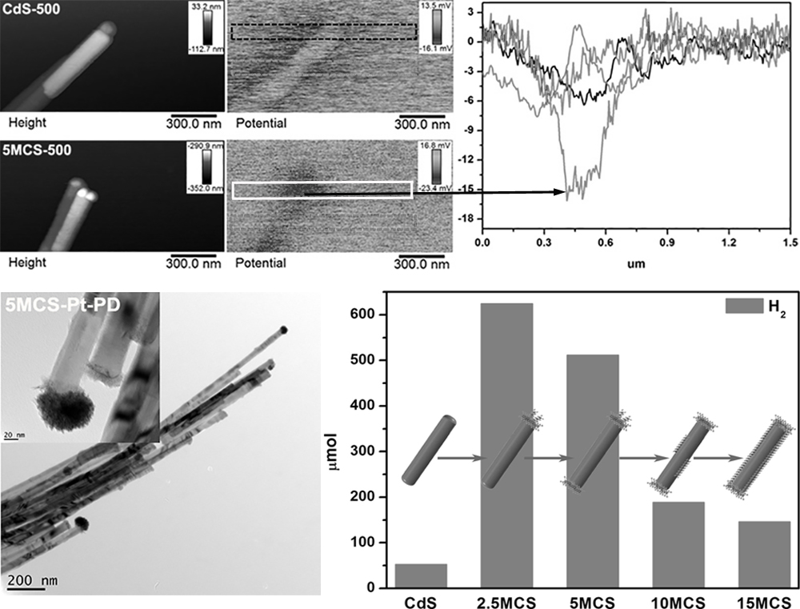
References
- Cheng, L. & Xiang, Q. & Liao, Y. & Zhang, H. (2018). CdS-based photocatalysts. Energy Environ. Sci., 11, 1362-1391.

