Regaining a Lost Dimension – From InAs Nanowires to InAs Nanofin Hall Bars
by Templated Epitaxy

J. Seidl,^{A} J. Gluschke,^{A} X. Yuan,^{B} S. Naureen,^{B} N. Shahid,^{B}
H.H. Tan,^{B} C. Jagadish,^{B} P. Caroff^{B,C} and A.P. Micolich^{A}
^{A} School of Physics, University of New South Wales, Sydney, Australia; ^{B} Department of Electronic Materials Engineering, Research School of Physics and Engineering, The Australian National University, Canberra ACT 2601, Australia; ^{C} Microsoft Station Q, Delft University of Technology, 2600 GA Delft, The Netherlands.

III-V nanowires were originally and are still commonly grown from a nanoparticle metal catalyst with low eutectic point using a vapor-liquid-solid (VLS) approach [1]. However, the VLS growth method is limiting in the quest to extend beyond 1D structures. Selective-area epitaxy using an amorphous oxide template offers a more promising path to functional ‘bottom-up’ 2D structures for electronic devices [2]. It affords precise and reliable deterministic control over shape, thickness and crystal structure without the baggage of catalyst particles and nanowire stems.

Here we report the growth and electrical characterisation of tall, long and thin 2D nanofin structures, like those shown in Fig. 1a-c, directly from an underlying III-V substrate using oxide-templated selective-area epitaxy [3].

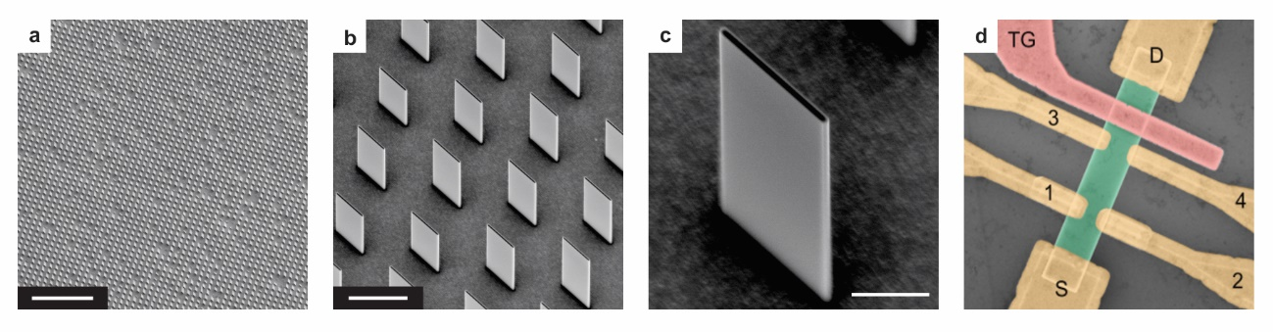
Fig.1. a-c. Scanning electron micrographs of our InAs nanofin structures. The scale bars correspond to 20 μm, 1.5 μm and 500 nm respectively. d. False-colour scanning electron micrograph of a completed nanofin Hall bar sample with nanofin (green), six contacts (yellow) and a top-gate structure (pink).

Our method produces rectangular InAs nanofins with exquisite control over all three geometric dimensions. These nanofins can be mechanically transferred to a separate substrate for fabrication into devices featuring multiple contacts and electrostatic gate structures (see Fig. 1d). The geometry readily enables characterisation via Hall effect or van der Pauw measurements, as well as devices with four-terminal contact arrangements for contact resistance corrected measurements. Our nanofins have high electrical quality with electron transport mobility regularly exceeding 2000 cm²/Vs at a typical 3D electron density ~2.5 × 10¹⁷ cm⁻³, corresponding to an approximate surface accumulation layer density ~1 × 10¹² cm⁻² at temperature T = 300 mK, tunable electron density via electrostatic gating and clear quantum interference structure at temperatures as high as T = 20 K. Our devices show excellent prospects for fabrication into more complicated devices featuring multiple ohmic contacts, local gates and possibly other functional elements, e.g., patterned superconductor contacts, that may make them attractive options for future quantum information applications.

References
[1] K. Hiruma, M. Yazawa, T. Katsuyama, K. Ogawa, K. Haraguchi, M. Koguchi and H. Kakiyabashi, J. Appl. Phys. 77, 447 (1995).
[2] J. Motohisa, J. Noborisaka, J. Takeda, M. Inari and T. Fukui, J. Cryst. Growth 272, 180 (2004).
[3] J. Seidl, J. Gluschke, X. Yuan, S. Naureen, N. Shahid, H.H. Tan, C. Jagadish, A.P. Micolich and P. Caroff, Nano Letters 19, 4666 (2019).

