Nanostructuring Dynamics of Deep-UV Laser Etched Diamond Surfaces

Amanuel M. Berhane^{A}, Christopher G. Baldwin^{A}, Mojtaba Moshkani^{A}, James E. Downes^{A},
Richard P. Mildren^{A}
^{A} MQ Photonics Research Centre, Department of Physics and Astronomy, Macquarie University,
North Ryde, New South Wales 2109, Australia.

Polarization dependent nanopatterning of the (100) and (110) surfaces of CVD grown single crystal diamond samples has been reported recently^{1, 2}. In this work, the generation and propagation of the nanopatterns as well as other nanostructures is investigated on the three major surfaces of diamond including the (111) plane. The results are obtained by etching the three different surfaces under focused linearly and circularly polarized beams to depth ranges of more than 3 µ$m$. The effect of laser pulse durations on the etching dynamics is also investigated by etching the samples under nano- and picosecond lasers. Figure 1 shows SEM images of the nanopattern generation and development on the three major diamond surfaces when etched under the circularly polarized ns-laser with varying exposure times. Figure 1(a-c) shows that a feature starts from noise at 50 nm and propagate to grid nanopattern at depths of 220 nm and 400 nm. When etching the (110) surface under similar conditions, a fine-grained array of spots emerges with increasing grain size as the etch propagates to a depth of 400 nm as shown in Figure 1(d-f). In contrast, etching the (111) shows no sign of nanopattern with the only significant feature being morphological defect related trigonal pits as shown in Figure 1(g-i). The sum of all results indicates the formation of nanopatterns from high spatial frequency noise of the polished starting surface and evolve into a well-defined pattern of progressively decreasing frequency. The nanopatterns and nanostructures also reveal the symmetries of the underlying crystal surface according to the incident beam polarization.

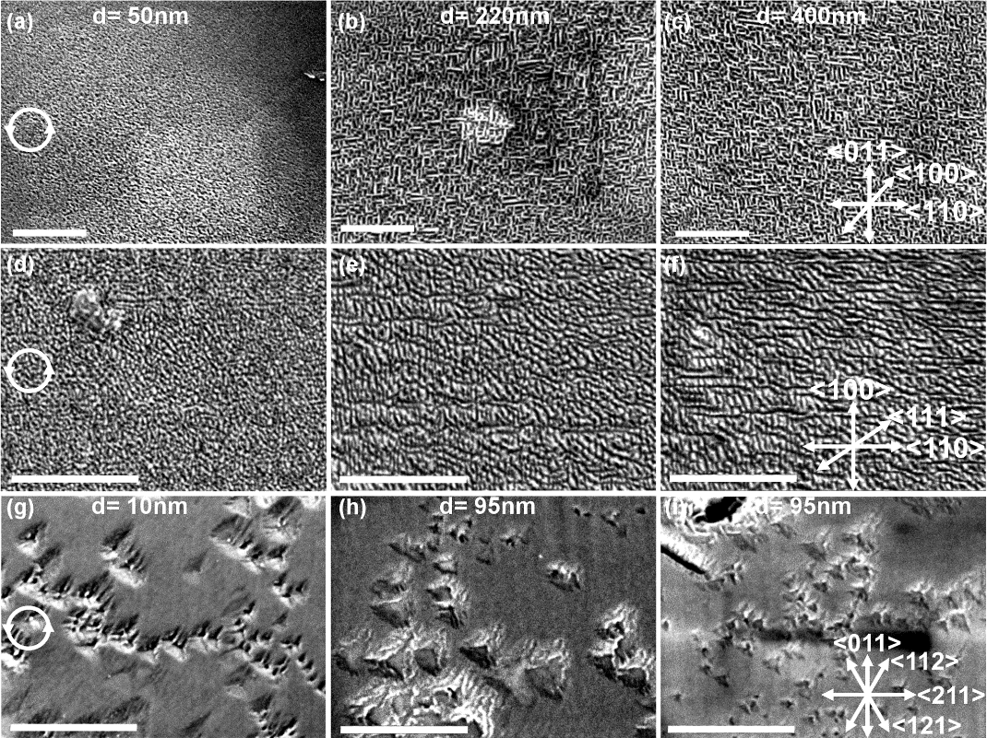

Figure 1. Diverse nanopattern and nanostructure generation and propagation obtained by etching the (100) (a-c), (110) (d-f) and (111) (g-i) diamond surfaces using circularly polarized ns-laser. The depth (d) of each nanopattern is labelled on top of each images and the crystallographic directions are shown at the bottom-right of each raw. The scale bar is 1µm.
References
1. A. Lehmann, C. Bradac and R. Mildren, Nature Communications 5, 3341 (2014).
2. C. Baldwin, J. Downes, C. McMahon, C. Bradac and R. Mildren, Physical Review B 89 (19), 195422 (2014).

