Crystal phase effect on the catalytic activity of gold through intrinsic strain

Lixiang Zhong, Shuzhou Li
School of Materials Science and Engineering, Nanyang Technological University, Singapore.

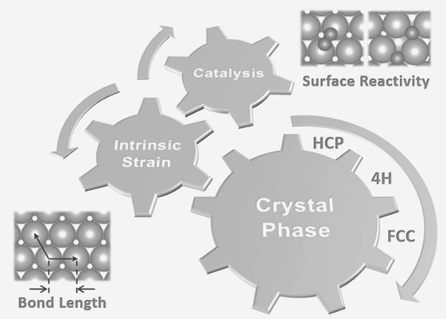
Introduction
Crystal phase engineering is a promising strategy to tune the catalytic performance of metal nanomaterials. (Fan and Zhang 2016) Generally, the crystal phase effect on catalysis is ascribed to distinct surface atomic arrangements of catalysts with different crystal phases. (Li et al. 2017) Here we show that even for similar surfaces, such as the close-packed surfaces, different crystal phases have considerably different surface reactivity due to their distinct intrinsic surface strains. (Zhong and Li 2019)

Methods
Spin-unrestricted calculations were performed using density functional theory (DFT) as implemented in the Vienna ab initio simulation package (VASP). The slab model was adopted to mimic the metal surfaces and the separation between two slabs was larger than 15 Å to eliminate spurious interactions. The climbing image nudged elastic band method was used to find the transition states and calculate the corresponding energy barriers.

Results
Using DFT calculations, we find that hexagonal close-packed (HCP) and double HCP (4H) phases of bulk gold have remarkably smaller in-plane Au-Au lengths than face centered cubic (FCC) gold, while they have similar in-plane bond lengths in free-standing few-layer nanosheets. As in-plane Au-Au length on a bulk surface is epitaxial determined by inner bulk gold phases, the near-surface atom layers of different crystal phases experience distinct intrinsic in-plane strains compared to free-standing nanosheets and have different surface reactivities. The dissociation barriers of O₂ on various crystal phases and surfaces are calculated and conform to the Brønsted-Evans-Polanyi relationship. Effect of thickness on the structural parameters of gold nanosheets is also investigated. In-plane bond lengths of gold nanosheets increase rapidly when the layer number is less than 20 (< 5 nm in thickness), and then tend to be stable at distinct intrinsic strains for different crystal phases.

Conclusion
In summary, we demonstrate that the close-packed surfaces of HCP and 4H gold have significantly smaller intrinsic strains (~1.3%) than that of FCC gold (~2.3%). These distinct intrinsic surface strains result in various oxygen adsorption energies and O₂ dissociation barriers on these close-packed gold surfaces, and the dissociations of O₂ on different crystal phases and surfaces follow the Brønsted-Evans-Polanyi principle. The understanding between crystal phase, nanosheet thickness, intrinsic strain, and surface reactivity provides new opportunities in phase-controlled synthesis of metal nanostructures and their applications in catalysis.

References
- Fan, Z. & Zhang, H. (2016). Crystal phase-controlled synthesis, properties and applications of noble metal nanomaterials. Chem. Soc. Rev., 45, 63-82.
- Li, W.-Z. Liu, J.-X. Gu, J. Zhou, W. Yao, S.-Y. Si, R. Guo, Y. Su, H.-Y. Yan, C.-H. Li, W.-X. Zhang, Y.-W. & Ma, D. (2017). Chemical insights into the design and development of face-centered cubic ruthenium catalysts for Fischer–Tropsch synthesis. J. Am. Chem. Soc., 139, 2267-2276.
- Zhong, L. & Li, S. (2019). Crystal phase effect upon O₂ activation on gold surfaces through intrinsic strain. Nanoscale, 11, 14587-14591.

*E-mail: lzhong003@e.ntu.edu.sg

