Mesoporous heteropoly acid as an electrode for lithium anion battery application
Hamid Ilbeygi ^{A}, In Young Kim ^{B}, Ajayan Vinu ^{B}
^{A} Future Industries Institute (FII), University of South Australia, Mawson Lakes, SA, 5095 Australia;
^{B} Global Innovative Center for Advanced Nanomaterials (GICAN), The University of Newcastle, Callaghan, NSW, 2308 Australia.
Introduction
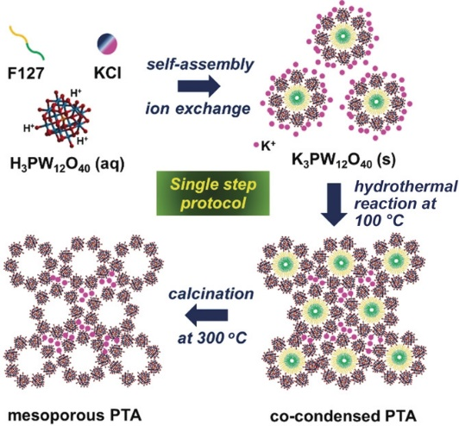
Rechargeable LIBs have attracted huge attention as energy‐storage devices because of their high energy and power densities. For large‐scale applications, such as electric and hybrid electric vehicles, advanced research is needed to fabricate the high‐performance electrode materials required for high power and energy densities and high rate performance. Heteropoly acids (HPAs) are unique materials with interesting properties, including high acidity and proton conductivity. However, their low specific surface area and high solubility in polar solvents make them unattractive for catalytic or energy applications. This obstacle can be overcome by creating nanoporosity within the HPA. We synthesized mesoporous phosphotungstic acid (mPTA) with a spherical morphology through the self‐assembly of phosphotungstic acid (PTA) with a polymeric surfactant as stabilized by KCl and hydrothermal treatment. Their high thermal stability (ca. 450 °C) and lack of solubility in ethylene carbonate/diethyl carbonate (EC/DEC) electrolyte are beneficial for lithium‐ion batteries (LIBs).
Scheme 1 Synthesis of mPTA through a single‐step procedure.

Results and discussion
The crystal structure of mPTA were investigated by X‐ray diffraction (XRD) analysis. The textural parameters of the mPTA materials were further investigated with their nitrogen adsorption–desorption isotherms. As-snthesised materials displayed a type IV sorption isotherm with an H2‐type hysteresis loop, thus suggesting the existence of cage‐type mesopores, which are formed through the self‐assembly of PTA and the co‐condensation process [1]. The mPTA nanostructures had a highest surface area of 93 m² g⁻¹ and a pore size of 4 nm. The structural integrity and oxidation state of the tungsten ion of mPTA materials were examined using Fourier‐transform infrared spectroscopy (FTIR) and W 4f X‐ray photoelectron spectroscopy (XPS), respectively. The mPTA materials showed similar characteristic FTIR peaks to those of bulk PTA, thus suggesting that the as‐synthesized mPTA materials retained the Keggin structure after the calcination process. The discharge/charge specific capacities and Coulombic efficiency of 2.5‐mPTA are compared with those of the bulk PTA. Whereas bulk PTA exhibited discharge capacities of 263, 107, 91, and 87 mAh g⁻¹ at the 1st, 2nd, 10th, and 50th cycles, respectively, those of 2.5‐mPTA were 1975, 1212, 1085, 941, and 872 mAh g⁻¹ at 1st, 2nd, 10th, 50th, and 100th cycles, respectively. The significantly superior specific capacity of 2.5‐mPTA can be first attributed to its low water content, which prevents a reaction between water and the electrolyte of LiPF6, followed by the generation of HF. The detailed lithiation mechanism for 2.5‐mPTA was investigated through in situ X‐ray absorption spectroscopic (XAS) analysis. It was observed during the first discharge step, the absorption edge of W LIII‐edge X‐ray absorption near‐edge structure (XANES) spectra was monotonically shifted to lower energy, as ascribed to a continuous reduction of the W⁶⁺ to W⁴⁺ in LixPW₁₂O₄₀ for lithiation. The change in valence state of W was less pronounced in the 2nd cycle, and no variation was observed in the 4+ valence state of W in the 10th and 20th cycles [2]. All the characterization and application results will be presented in the conference.
References
1. Jiao, F. and P.G. Bruce, Mesoporous Crystalline β-MnO2—a Reversible Positive Electrode for Rechargeable Lithium Batteries. Advanced Materials, 2007. 19(5): p. 657-660.
2. Ilbeygi, H., et al., Highly Crystalline Mesoporous Phosphotungstic Acid: A High-Performance Electrode Material for Energy-Storage Applications. 2019. 58(32): p. 10849-10854.
hamid.ilbeygi@unisa.edu.au

