Polymer-Assisted Metal Deposition for Soft Electronics
Zijian Zheng

Laboratory for Advanced Interfacial Materials and Devices and Research Centre for Smart Wearable Technology, Institute of Textiles and Clothing, The Hong Kong Polytechnic University,
Hung Hom, Kowloon, Hong Kong SAR, China
Metal conductors are indispensable element for most future soft electronic devices. One critical challenge in this field is how to fabricate highly conductive, adhesive, smooth, and soft metal conductors at low temperature under ambient conditions, and preferably in a roll-to-roll manner. Conventional metal nanoparticle inks fall short to satisfy these requirements because of their relatively high processing temperature, rough surface, and poor adhesion, especially for easily oxidized metals such as Cu. Our laboratory recently develops Polymer-Assisted Metal Deposition (PAMD) to address this issue. PAMD allows ambient fabrication of flexible, foldable, stretchable, compressible, and wearable metal (especially Cu) conductors with very high conductivity. This talk will briefly discuss the fundamental chemistry of PAMD, the printing with PAMD, and their applications in several soft electronic devices.

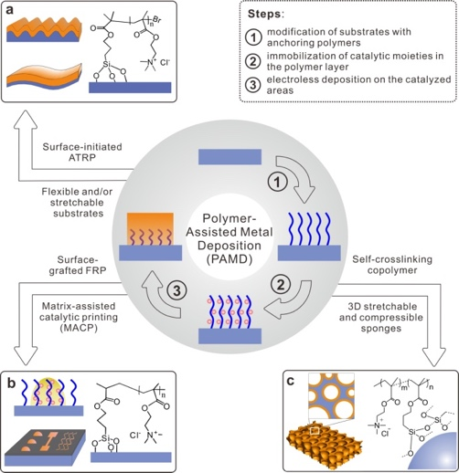

- Y. Yu, C. Yan, Z. J. Zheng*, Adv. Mater. 2014, 26, 5508-5516.
- X. Liu, H. Chang, Y. Li, W. T. S. Huck, Z. J. Zheng*, ACS Appl. Mater. Interfaces, 2010, 2, 529-535.
- K. Li, H. Zhen*, L. Niu, X. Fang, Y. Zhang, R. Guo, Y. Yu, F. Yan, H. Li, Z. J. Zheng*, Adv. Mater. 2014, 26, 7271-7278.
- R. Guo, Y. Yu, Z. Xie, X.,Y. Yang, Z. J. Zheng*, Adv. Mater. 2013, 25, 3343-3350.
- L. Liu, Y. Yu, C. Yan, K. Li, Z. J. Zheng*, Nat. Commun. 2015, 6, 7260.
- Y. Yu, X. Xiao, Y. Zhang, K. Li, C. Yan, X. Wei, L. Chen, H. Zhen, H. Zhou, S. Zhang, Z. J. Zheng*, Adv. Mater. 2016, 28, 4926-4934.
- Y. Yang, Q. Huang, L. Niu, D. Wang, C. Yan, Y. She, Z. J. Zheng*, Adv. Mater. 2017, 29, 1606679.
- J. Chang, J. Shang, Y. Sun, L. K Ono, D. Wang, Z. Ma, Q. Huang, D. Chen, G. Liu, Y. Cui, Y. Qi, Z. J. Zheng*, Nat. Commun. 2018, 9, 4480.

