Photon emission enhancement of praseodymium ions implanted with GaN nanopillars

Shin-ichiro Sato^{A,B}, Manato Deki^{C}, Shuo Li^{B}, Andrew D. Greentree^{B},
Brant C. Gibson^{B}, Tomoaki Nishimura^{D}, Takeshi Ohshima^{A}
^{A}Quantum Beam Science Research Directorate, National Institutes for Quantum and Radiological Science and Technology, Takasaki, Japan; ^{B}Australian Research Council Centre of Excellence for Nanoscale BioPhotonics, RMIT University, Melbourne, Australia; ^{C}Center for Integrated Research of Future Electronics, Nagoya University, Nagoya, Japan; ^{D}Research Center of Ion Beam Technology, Hosei University, Koganei, Japan

Lanthanoid (Ln)-doped Gallium Nitride (GaN) have attracted attentions because of their high intensity luminescence and sharp room-temperature (RT) optical linewidth [1]. These superior luminescent properties are quite attractive for the application of single photon source (SPS) which is a key technology for quantum computing, quantum sensing, and quantum key distribution. However, one of the challenges to realize Ln-doped GaN SPS is the long luminescent transition lifetime, resulting in the low photon counts insufficient to optically detect isolated single Ln ions. Confinement of luminescent centers into nanometersized regions is an effective method to enhance their photon emission and we here we show that confinement into GaN nanopillars enhances photon emission from implanted praseodymium (Pr) ions at RT.
Pr ions with the energy of 100 keV were implanted into a GaN epilayer at the fluence of 1.3×10¹⁴ cm⁻² at RT and thermal annealing at 1250 ºC for 2 min was subsequently performed. The circular and square pillars with the sizes ranging from 100 nm to 2 µm were fabricated on the Pr-doped GaN using electron beam lithography, metal deposition, and dry etching techniques. The peak implanted region was estimated to be 24 nm from the top of pillars and the pillar length was measured to be 510 nm by SEM. Optical properties of Pr-doped GaN nanopillars were investigated by a home-build confocal microscopy (CFM). The excitation wavelength was 525 nm and only the photon emission from Pr ions was collected by using a 650 nm band pass filter with 13 nm band. PL spectra were also measured by an imaging spectrometer equipped in the CFM.
Figure 1 (a) shows a CFM image of Pr-doped GaN nanopillars. Circular pillars with the diameter of 200 nm and square pillars with the side of 200 nm were successfully fabricated and were optically detected at RT. Figure 1 (b) is a PL spectrum of the 200 nm circular pillar. Two sharp peaks appeared at 650.3 nm and 651.8 nm which were attributed to the ³P₀→³F₂ transitions of Pr³⁺. Figure 1 (c) shows the relative PL intensity as a function of nanopillar size. Comparing to the PL intensities from square implanted regions without pillar structures (open triangles), the enhancement due to pillar structures appeared at the sizes less than 1000 nm. The maximum enhancement was obtained at the 500 nm square pillar in this case.
In summary, we fabricated Pr-doped GaN nanopillars and demonstrated the enhancement of photon emission from Pr³⁺ at RT. In the presentation, mechanism of the photon emission enhancement will be discussed based on luminescent transition lifetime, excitation power dependence on PL intensity, and finite element method simulation of the eigenfrequenties in nanopillar structures.
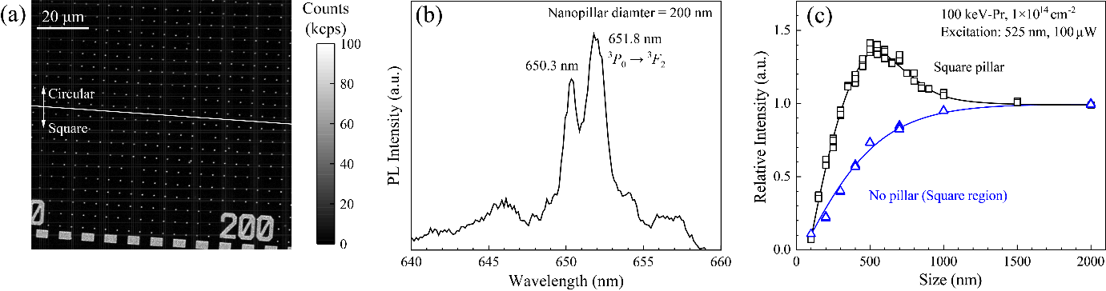
Figure 1. (a) CFM image of Pr-doped GaN nanopillar at RT. Top and bottom of the image are circular (200 nm diameter) and square (200 nm side) pillars at intervals of 5 µm, respectively. (b) PL spectrum of a 200 nm circular pillar. (c) Relative PL intensity as a function of square pillar side, normalized by the intensity at a large implanted region. The PL intensity from the square implanted regions is also shown for comparison.
Reference
- K. P. O'Donnell and V. Dierolf, “Rare-earth doped III-nitrides for optoelectronic and spintronic applications”, Springer, Netherlands (2010).

