Acoustic enhancement of intracellular delivery for ex vivo therapeutics

Shwathy Ramesan ^{A}, Amgad Rezk ^{A}, Christina Cortez-Jugo^{B}, Leslie Yeo^{A}
^{A}Micro/Nanophysics Research Laboratory, School of Engineering, RMIT University, Melbourne, VIC 3001, Australia.
^{B}ARC Centre of Excellence in Convergent Bio-Nano Science and Technology & Department of Chemical and Biomolecular Engineering, University of Melbourne, Parkville, VIC 3010, Australia.

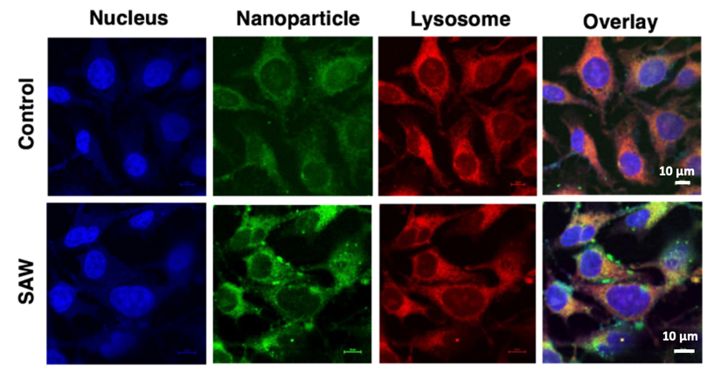
Fig. 1. Confocal images showing distribution of internalized FITC-labelled gold nanoparticles in HEK293-T cells under with and without (control) surface acoustic wave (SAW) excitation.
Recent advances in gene editing and therapy have highlighted the potential of ex vivo cell-based techniques to treat many diseases, wherein a patient’s cells are harvested, engineered to insert various therapeutic agents such as nucleic acids or proteins, and re-infused. Considerable challenges however remain in the ability not just to insert these agents into cells whilst retaining high levels of cellular viability, but also to ensure that they are not lysed within the cell.

Physical methods (e.g., electroporation, sonoporation, etc.), for example, allow efficient translocation of therapeutic cargo into the cell through the formation of pores in the cell membrane. This, however, afflicts some damage to the cells, leading to apoptosis of a considerable proportion of the cells. Biochemical methods, in contrast, rely on carriers such as nanoparticles, vesicles or viruses to facilitate greater endocytotic take-up. The endocytosis pathway nevertheless results in the concentration of the internalised cargo within the endosomal regions of the cell, almost all of which ends up in the lysosome where they are degraded. Strategies that allow them to escape the endosomal recycling path in order to enter the cytoplasm are therefore required if the cargo is to target the nucleus.

We show that exposure of the cells to high frequency (>10 MHz) order sound waves are able to enhance the uptake of nanoparticles, molecules and nucleic acids by several-fold, whilst retaining very high levels (>97%) of cellular viability (Ramesan et al. 2018). This is because the high frequency excitation, unlike sonoporation, does not result in the formation of physical pores in the cell membrane. Instead, the high frequency excitation sufficiently temporarily disrupts the structure of the lipids that make up the cell membrane, thus increasing the membrane permeability sufficiently to allow the therapeutic agent to diffuse through it. The effect, is however, transient such that the organisation of the lipid structure immediately returns to its original state upon relaxation of the acoustic excitation. Such immediate recovery of the cell is the reason for the high cell viability. As this internalisation mechanism does not involve endocytosis, we observe the therapeutic cargo to be distributed throughout the cell instead of being localised within the endosomes or lysosomes (Fig. 1), thus facilitating a greater possibility for nuclear targeting and hence transfection. Indeed, with siRNA delivery into HEK293-T cells, we observe a two-fold knockdown in the gene expression.

References
- Ramesan, S., Rezk, A. R., Dekiwadia, C., Cortez-Jugo, C. & Yeo, L. Y. (2018). Acoustically-mediated intracellular delivery. Nanoscale, 10, 13165-13178.

leslie.yeo@rmit.edu.au

