A 10-minute universal cancer test based on interfacial biosensing

Abu Ali Ibn Sina,^{A} Laura G. Carrascosa,^{A} Matt Trau^{A}
^{A}Center for Personalized Nanomedicine, Australian Institute for Bioengineering and Nanotechnology (AIBN), Corner College and Cooper Roads (Bldg 75), The University of Queensland, Brisbane QLD 4072, Australia
Tel: +61-7-33464178; Fax: +61-7-33463973
Email: a.sina@uq.edu.au

DNA methylation (Fig. 1) is a key epigenetic modification, which involves the addition of a methyl group to the 5 position of cytosine nucleotides.¹⁻³ Eukaryotic cell’s DNA maintains a distinct methylation landscape to regulate gene expression pathways and maintain genomic stability. However, in cancer, this methylation landscape experiences a significant reprogramming with a net loss of global DNA methylation at the intergenic regions of the genome together with a concomitant increase in methylcytosine levels at clustered CpG sites involved in regulatory roles (e.g., selective hyper-methylation at promoter regions).³ We discovered a consequence of genome-wide epigenetic reprogramming induced by cancer, which has been overlooked to date: that the key physicochemical properties of purified genomic DNA are fundamentally different between normal and cancer genomes.⁴ We found that the purified genomic DNA from normal cells had a greater tendency towards aggregation in aqueous solutions than genomic DNA from cancer cells. This appears to be caused by the hydrophobic properties of methylcytosines,⁵ leading to different self-assembly of DNA polymer in solution, depending on the levels and patterning of methylcytosines across the genome. We also found that the solution properties of cancer and normal epigenomes influenced their affinity towards bare gold surfaces. In addition to the solvation properties, gold-DNA interaction was also modulated by the higher affinity of methylcytosines towards gold in comparison to the regular cytosines, and as a function of their clustered or dispersed patterning across the genome (see Fig. 1), which in turn, could determine the pathological state of the DNA. Thus, we hypothesized that the unique methylation landscape (i.e. selective clustered methylation with global hypo-methylation) displayed by most cancerous epigenomes which we referred to as “Methylscape” may potentially serve as a universal cancer biomarker. In consequence, with the significant different physicochemical behaviour of clustered and dispersedly methylated DNA (Fig1: cancer vs normal), we developed a one-step pan-cancer detection technology based on interfacial bio-sensing without the need for sequencing, chemical/enzymatic treatment of samples and PCR amplification procedure. This interfacial biosensing, which is developed in our lab, harnesses the differential adsorption interactions of biological species (e.g. DNA, RNA, proteins) with bare metal surfaces for direct biomolecule detection and analysis.⁶ We believe that the simplicity of this method, along with the high level of accuracy for identifying the cancer Methylscape could find broad application in biology and diagnostics.

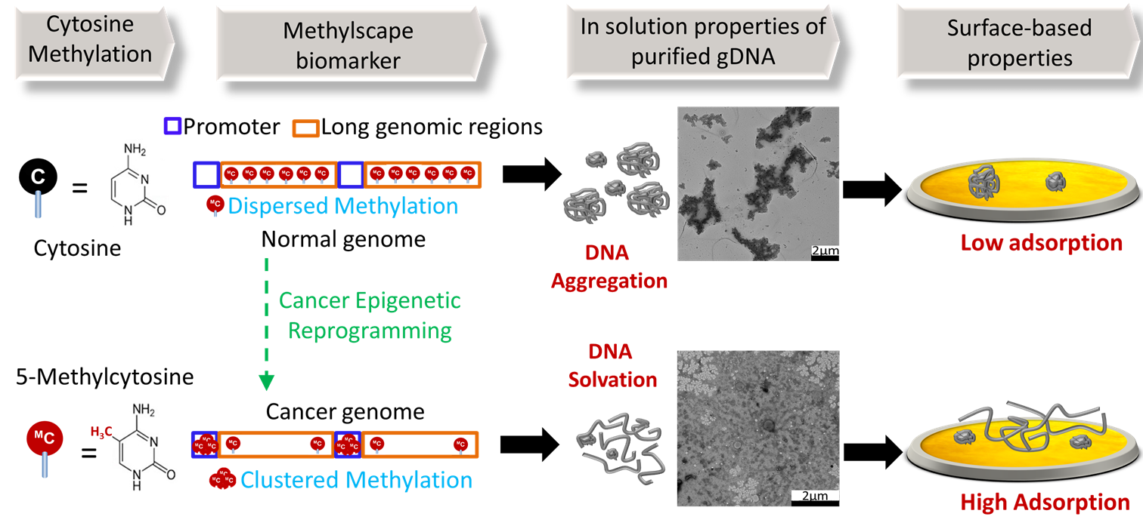
References
Figure1: Reprogramming of the DNA methylation landscape in cancer modulates the solution and surface-based properties of genomic DNA. Inset: TEM image showing the different solvation of DNA purified from the prostate tissue of a cancer patient and a healthy individual.
- Smith, Z. D. & Meissner, A. (2013). DNA methylation: roles in mammalian development. Nature Reviews Genetics 14, 204-220.
- Schubeler, D. (2015). Function and information content of DNA methylation. Nature 517, 321-326.
- Suzuki, M. M. & Bird, A. (2008). DNA methylation landscapes: provocative insights from epigenomics. Nature Reviews Genetics 9, 465-476.
- Sina, A. A. I. et al. (2018). Epigenetically reprogrammed methylation landscape drives the DNA self-assembly and serves as a universal cancer biomarker. Nature Communications 9, 4915.
- Kaur, P. et al. (2012). Hydrophobicity of methylated DNA as a possible mechanism for gene silencing. Physical biology 9, 065001.
- Sina, A. A. I., Koo, K., Ahmed, M., Carrascosa, L. & Trau, M. (2018). Interfacial Biosensing: Direct Biosensing of Biomolecules at the Bare Metal Interface. In: Wandelt, K., (Ed.) Encyclopedia of Interfacial Chemistry: Surface Science and Electrochemistry, Elsevier vol. 7, pp 269–277.

