Computation of the Performance of Dye-Sensitized Solar Cells by a Mathematical Model

Benjamin J Maldon^{A}, Natalie Thamwattana^{A}

^{A}School of Mathematical and Physical Sciences, University of Newcastle, Newcastle NSW, Australia;

Introduction
Dye-Sensitized Solar Cells (DSSCs) have been under intensive study since their academic introduction in 1991¹. Several research directions have consequently emerged to find which materials would produce the highest efficiency at the lowest cost. Modelling the conduction band electron density in the TiO₂ semiconductor by diffusion began with Södergren et al.² and led to a nonlinear diffusion equation given by Anta et al. in their 2006 paper³.

Methods
Using a mathematical model originating in Anta et al.³, we compute important performance benchmarks in DSSCs. In this model, an ordinary differential equation is used to calculate the electron density within an operating DSSC. Given the electron density, we use analytical expressions found in the literature to find vital performance parameters such as the short-circuit current density, the open-circuit voltage and ultimately the efficiency. Under this model, we evaluate the efficiency of a DSSC under commonly used parameter values and suggest improvements.

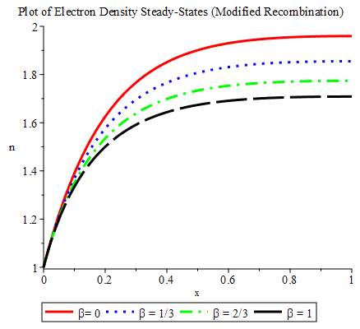
Results
Using the analytical solution of a modified nonlinear diffusion equation (with a method similar to Maldon and Thamwattana⁴), we assess the performance of typical DSSCs. Additionally we find both the electron density and DSSC performance parameters calculated with this model are in good agreement with known results in the literature. We also suggest values for the nondimensional parameters which enhance DSSC performance. From the inset figure, we find that higher values for the trap density parameter β lead to a lower overall electron density, a consequence of stronger traps in the TiO₂ semiconductor⁵.

References

(1) O`Regan, B. and Grätzel, M. A low-cost, high-efficiency solar cell based on dye-sensitized colloidal TiO₂ films. Nature 1991, 353 (6346), 737.
(2) Södergren, S., Hagfeldt, A., Olsson, J. and Lindquist, S. Theoretical Models for the Action Spectrum and the Current-Voltage Characteristics of Microporous Semiconductor Films in Photoelectrochemical Cells. Journal of Physical Chemistry 1994, 98, 5552.
(3) Anta, J. A., Casanueva, F. and Oskam, G. A numerical model for charge transport and recombination in dye-sensitized solar cells. J Phys Chem B 2006, 110 (11), 5372.
(4) Maldon, B. and Thamwattana, N. An Analytical Solution for Charge Carrier Densities in Dye-Sensitized Solar Cells. Journal of Photochemistry and Photobiology A: Chemistry 2019, 370, 31.
(5) Nelson, J. Continuous-Time Random-Walk Model of Electron Transport in Nanocrystalline TiO₂ Electrodes. Physical Review B 1999, 59 (23), 15374.

