Developing High Performance Lead-Free Cs₂AgBiBr₆ Double Perovskite solar cells in a Low Cost Planar Structure
Mehri Ghasemi^{1*}, Miaoqiang Lyu¹, Lianzhou Wang¹
¹ School of Chemical Engineering and Australian Institute for Bioengineering and Nanotechnology, The University of Queensland, Brisbane, QLD, 4072, Australia

Introduction:
Regardless of the high performance reported for hybrid lead halide perovskites, toxicity issue imposes significant circumscriptions toward their market acceptance. In this way, developing low toxic environmentally benign perovskites has become vital important. Recently all-inorganic double perovskite materials have been suggested as a promising alternative due to some of their comparable properties to their lead-based counterparts¹. Among the so far reported double perovskite materials, Cs₂AgBiBr₆ has been widely investigated recently; however, attaining high quality thin film for this material using solution process to conduct high efficiency solar cell is still an utmost challenge.

Results and discussion:
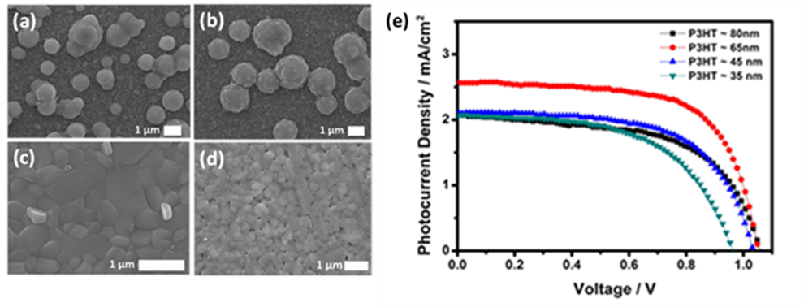
In this work, we developed a simple and facile solution method to produce high quality smooth Cs₂AgBiBr₆ thin film with low root-mean-square of 8 nm and grain size in the range of 300-700 nm (Fig. 1. a-d). The next focus of this work was developing a cost-effective structure to fabricate high efficiency solar cell based on this lead-free material. As matter of fact, in the most common hole transport layers to fabricate highly efficient and reproducible perovskite solar cells such as spiro-OMeTAD, low hole mobility enforces them to be doped by some dopants such as tert-butylpyridine (tBP) and lithium salts². However hydrophilic nature of such dopants compromise stability of the total structure in humidity². Thiophene-based polymers conjugated polymers can be an alternative due to their easy processability, solubility and stability, in which, P3HT has the highest hole mobility of 0.1 cm²V⁻¹S⁻¹. Given these, employing high quality Cs₂AgBiBr₆ thin film in device with planar structure contains low cost dopant-free HTL of P3HT and non-noble metal contact of Cu, optimizing P3HT thickness high power conversion efficiency (PCE) of around 2% achieved (Fig. 1. e). To make a better comparison, functionality of spiro-OMeTAD also was examined, where the best working device showed inferior power conversion efficiency of 1.38%. This observation confirms ability of P3HT to work as an appropriate HTL with good charge transport.
Fig. 1. Scanning electron microscope images of Cs₂AgBiBr₆ on FTO at different spin coating rate (a) 2000, (b) 3000, (c) 4000, (d) 5000 rpm. (e) J-V curve of devices based on planar structure with different P3HT thickness.
References

1. F. Giustino and H. J. Snaith, ACS Energy Lett., 2016, 1, 1233-1240.
2. Y. Guo, C. Liu, K. Inoue, K. Harano, H. Tanaka and E. Nakamura, J. Mater. Chem. A, 2014, 2, 13827-13830.
* m.ghasemi@uq.edu.au

