Fluorescent nanodiamonds for correlative nanoscale cellular imaging

Amanda N. Abraham^{A}, Amy Gelmi^{B}, Chaitali Dekiwadia^{C}, Hiroshi Abe^{D}, Takeshi Ohshima^{D}, Arpita Poddar^{E}, Javier Conesa^{F}, Eva Pereiro^{F}, Ravi Shukla^{E}, Gary Bryant^{G}, Brant C. Gibson^{A}, Philipp Reineck^{A}

^{A}ARC Centre of Excellence for Nanoscale Biophotonics, School of Science, RMIT University, Melbourne, VIC 3001, Australia;
^{B} School of Science, College of Science, Engineering and Health, RMIT University, Melbourne, VIC 3001, Australia;
^{C} RMIT Microscopy and Microanalysis Facility, GPO Box 2476, Melbourne, Victoria 3001 Australia;
^{D} National Institutes for Quantum and Radiological Science and Technology, Takasaki, Gunma 370-1292, Japan;
^{E} Ian Potter NanoBiosensing Facility, NanoBiotechnology Research Laboratory (NBRL),School of Science, RMIT University, Melbourne, VIC 3001, Australia
^{F} ALBA Synchrotron Light Source MISTRAL Beamline – Experiments division. Cerdanyola del Vallès Barcelona 08290, Spain
^{G} Centre for Molecular and Nanoscale Physics, School of Science, RMIT University, Melbourne, VIC 3001, Australia

Understanding the fate of nanomaterials inside cells is vital for many areas of science and technology. Many imaging techniques can provide information about the location and environment of nanoparticles in cells with nanoscale spatial resolution. However, every imaging technique on its own can only provide partial information about the interaction of nanoparticles with cells. Fluorescence microscopy is an excellent tool for live cell imaging, but its spatial resolution is often above 100 nm in the X-Y plane and significantly worse in Z. Electron microscopy on the other hand can provide excellent spatial resolution in at the nanoscale in 3D, but generally doesn’t allow the study of live cells in a natural environment. Hence, correlating the information provided by different imaging techniques is critical to advance our understanding of cell-nanomaterial interactions.
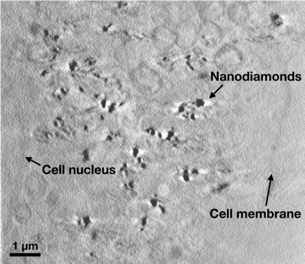
Here we investigate the uptake of fluorescent nanodiamonds by PC3 cancer cells by directly correlating airyscan fluorescence microscopy, atomic-force-microscopy (AFM) and scanning electron microscopy (SEM) images. Fluorescent nanodiamonds are uniquely suited for super-resolution and correlative imaging due to their exceptional photostability,¹ chemical inertness and high biocompatibility.² For the first time, fluorescent nanodiamonds are also imaged using soft X-ray tomography (Figure 1) as an emerging tool for the imaging of nanoparticles inside cells with nanoscale spatial resolution in all three dimensions. Findings from these imaging experiments are complemented by traditional cell viability, stress and nanoparticle uptake assays.
Figure 1. X-ray tomography image of fluorescent nanodiamonds in PC3 cancer cells.

References
(1) P. Reineck, A. Francis, A. Orth, D.W.M. Lau, R.D.V. Nixon-Luke, I. Das Rastogi, W.A.W. Razali, N.M. Cordina, L.M. Parker, V.K.A. Sreenivasan, et al. Brightness and Photostability of Emerging Red and Near-IR Fluorescent Nanomaterials for Bioimaging. Advanced Optical Materials, 2016, 4, 1549.
(2) M. Chipaux, K.J. van der Laan, S.R. Hemelaar, M. Hasani, T. Zheng, R. Schirhagl. Nanodiamonds and Their Applications in Cells. Small, 2018, 14, 1704263.

philipp.reineck@rmit.edu.au

