Ligand effects on the colloidal stability of apolar nanoparticles

Debora Monego and Asaph Widmer-Cooper ^{A}
^{A} ARC Centre of Excellence in Exciton Science, School of Chemistry, The University of Sydney, Sydney, NSW 2006, Australia

Introduction
Being able to predict and tune the colloidal stability of nanoparticles is of vital importance for applications, yet we still lack a clear understanding of how the nanoparticles interact with one another in solution (Batista et al. 2015). Recently, it has become apparent that the organic molecules which typically coat inorganic particles need further attention. This ligand shell is essential for keeping the particles from randomly aggregating in solution, but can affect their stability in subtle and surprising ways. In particular, the ligands can undergo an ordering transition (Fig. 1) that switches the particle-particle interaction from repulsive to attractive (Widmer-Cooper and Geissler 2014, 2016; Kister et al. 2018). The temperature of this transition is sensitive to a range of factors, including the particle dimensions, density of ligand coverage, and ligand length, often leading to non-linear trends that cannot be explained using classical colloid theory (Widmer-Cooper and Geissler 2016; Kister et al. 2018; Monego et al. 2018).

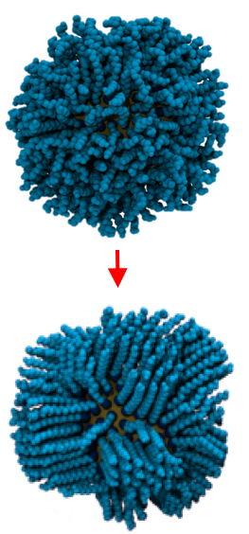

Fig. 1. The ligands can undergo an ordering transition that strongly affects the colloidal stability.

Methods
In this work, we use near-atomistic molecular dynamics (MD) simulations to study the conformational state and energetics of the ligands as a function of temperature, core diameter, and the structure of the ligand and solvent molecules. In addition, we use constrained MD and Hamaker-Lifshitz theory to calculate and decompose the potential of mean force acting between the particles in solution. Our results are compared with small-angle x-ray scattering studies of Au and CdSe nanoparticles.

Results and discussion
We show that the ability of the ligand shell to order (or not) can make sense of a diverse range of surprising phenomena, including an inversion of the effect of ligand length on particle stability, solvent effects that run opposite to the rule of like-dissolves-like, and stabilities that increase by orders of magnitude upon the addition of a single methyl group to the tail of the ligands (Yang et al. 2016). Our results provide a microscopic description of the forces that determine the colloidal stability of apolar nanoparticles and explain why conventional colloid theories fail.

References
1. Batista, C.A.S.; Larson, R.G.; Kotov, N.A. (2015) Science 350, 1242477.
2. Kister, T.; Monego, D.; Mulvaney, P.; Widmer-Cooper, A.; Kraus, T. (2018) ACS Nano 12, 5969.
3. Monego, D.; Kister, T; Kirkwood, N; Mulvaney, P; Widmer-Cooper, A.; Kraus, T. (2018) Langmuir 34, 12982.
4. Widmer-Cooper, A.; Geissler, P.L. (2014) Nano Lett. 14, 57.
5. Widmer-Cooper, A.; Geissler, P.L. (2016) ACS Nano 10, 1877.
6. Yang, Y.; Qin, H.; Jiang, M.; Lin, L.; Fu, T. et al. (2016) Nano Lett. 16, 2133.

asaph.widmer-cooper@sydney.edu.au

