Intrinsically Fluorescent PAMAM Dendrimer as Drug carrier and Nanoprobe: Bioimaging and Neuron Protection Study
Guoying Wang^{A}, Afshin Babazadeh^{A}, Bingyang Shi^{A}, Marco Morsch^{A}

^{A} Department of Biomedical Sciences, Faculty of Medicine & Health Sciences, Macquarie University, Sydney, NSW 2109, Australia

Introduction
PAMAM dendrimers have been described as one of the most tunable and therefore potentially applicable nanoparticles both for diagnostics and therapy ^{[1]}. In recent years, intrinsically fluorescent PAMAM dendrimers have attracted extensive attention in the fields of biological imaging and drug/gene delivery due to their excellent intrinsic fluorescence properties, functional surfaces and highly biocompatibility ^{[2]}. Thus, our group have developed a new green intrinsic fluorescent PAMAM through simply modification with acetaldehyde ^{[3]}. We found that the maximum fluorescence emission intensity of the prepared PAMAM can be increased by 45% after oxidation (heating or long time storage), surprisingly, the fluorescence spectrum becomes much narrower, which is beneficial to its fluorescence performance. The novel intrinsically fluorescence PAMAM (FP) showed excellent biocompatibility with NSC 34 (Motor neuron like) cells, demonstrating great potential for motor neuron based biological imaging and drug delivery. In this study, we fabricated Edaravone (EDA) loaded F-PAMAM nano-complexes (FP/EDA) and surface functionalized with transferrin (Tf), the resulting Tf functionalized drug/nanocomplexs (FP-Tf/EDA) showed enhanced blood brain barrier (BBB) transportation and elevated neuron protection function. The biological imaging performance of FP and FP-Tf was evaluated by zebrafish model to provide guidance for the in-vivo application of intrinsically fluorescent PAMAM system. To our knowledge, it's the first time to report the in vivo application of intrinsically fluorescent PAMAM dendrimer, which provides a theoretical basis for the future clinical application of these intrinsically fluorescent materials.

Aims
- Developing an intrinsically green fluorescent PAMAM dendrimers (FP) as nano-vehicle for neuron protection drug (Edaravone) delivery and study its protection effect in motor neuron cell model.
- Evaluating the biological imaging performance of FP and FP-Tf by a gene-edited zebrafish model to provide guidance for its in vivo application.
Methods
A new green intrinsic fluorescent PAMAM was prepared through simply modification with acetaldehyde. The neuron protection drug Edaravone was encapsulated in the F-PAMAM hydrophobic cavity. The neuron protection effect was evaluated by an H₂O₂ induced oxidation stress cell model. The in vivo bio-imaging property was evaluated by a zebrafish model. Live imaging and tissue cryostat section analysis were applied to evaluate its in vivo biological applications.

Results
The new green intrinsic fluorescent PAMAM showed excellent optical property for intracellular tracking and in vivo bio-imaging. The FP-Tf/EDV complex showed enhanced blood brain barrier (BBB) transportation and elevated neuron protection function. The in vivo bio-imaging result showed that after transferrin functionalization the circulation time of nanocarrier was extremely enhanced from 30 mins to 8h (Fig 1). Interestingly, the transferrin functionalized F-PAMAM (FP-Tf) showed the potential of crossing blood spinal cord barrier and targeting motor neuron cells, which can be applied for motor neuron disease therapy. We also evaluated the bio distribution of FGP and FGP-Tf by directly injection of nanocarrier in the spinal cord and brain tissue, the results showed that the nanocarriers can be quickly dispersed throughout the tissue especially in spinal cord, however, there was no big difference between FP and FP-Tf, which was more likely because the large amount of nanomaterials accumulated around the cell blocked the specific uptake of the material by cells.

Conclusion
The intrinsic green fluorescent PAMAM presented great optical property and excellent biocompatibility to motor neuron like cells. Enhanced blood brain barrier (BBB) transportation and elevated neuron protection function were achieved by FGP-Tf/EDV drug delivery system, suggesting that further investigation into their development as carriers is warranted not just for EDV, but also for other clinically important drugs. The zebrafish model was used to assess the bioimaging properties of F-PAMAM and showed that the transferrin functionalization of F-PAMAM extremely enhanced its circulation time and presented potential application for motor neuron disease therapy. Furthermore, our result of directly injection of nanocarriers in disease region provided a potential approach of applying nanomaterials in brain or spinal cord disease therapy.

Reference
- Li J, Liang H, Liu J, et al. International journal of pharmaceutics, 2018, 546(1-2): 215-225.
- Tomalia D A, Klajnert-Maculewicz B, Johnson K A M, et al. Progress in Polymer Science, 2019, 90, 35-117.
- Wang G, Fu L, Walker A, et al. Biomacromolecules 2019, 20, 5, 2148-2158.
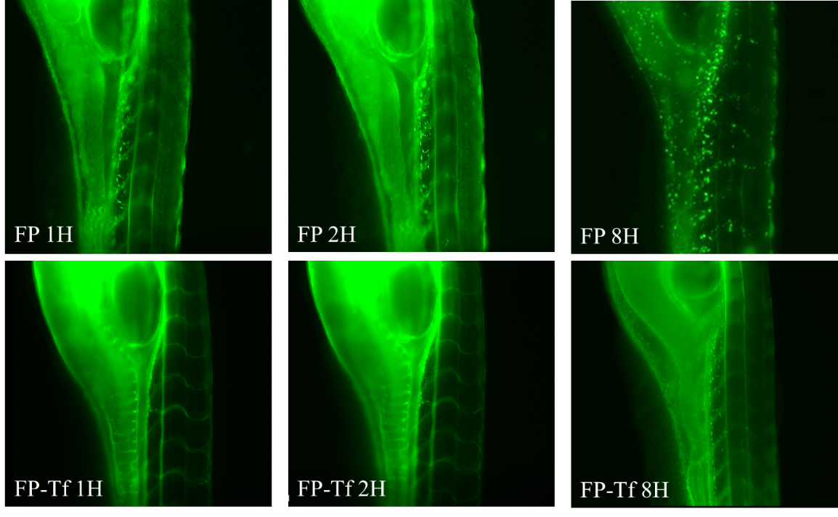
Fig 1, The real time circulating state images of the nanoprobe in zebrafish by fluorescence microscope.

