**Defect-free β-Ga2O3 nanowires grown by the vapour-liquid-solid process**

Curtis P. IrvineA, Thanh T. Huynh, Matthew R. Phillips and Cuong Ton-That

School of Mathematical and Physical Sciences, University of Technology Sydney, NSW 2007, Australia

A Presenting author. Email: Curtis.Irvine@uts.edu.au

**Abstract Summary**

Ga2O3 nanowires were grown using the vapour liquid solid (VLS) process. Nanowire diameters ranged from a few nanometers to 60 nm, and length of several μm. XRD analysis indicated nanowires were monocrystalline β-phase. Cathodoluminescence (CL) and photoluminescence (PL) studies demonstrated the defect-free nature of the nanowires with a strong diameter dependency, which lead to variations in optical properties.

**Introduction**

Ga2O3 has gained attention as an ultrawide band-gap semiconductor (4.8 eV) for use in high power electronics with a high breakdown field of ~8 MV/cm and as the active material in solar blind photodetectors and optoelectronic devices [Higashiwaki et al. 2016]. Reducing dimensionality of Ga2O3 to one dimension can lead to new functionalities. In this work, Ga2O3 nanowires were grown and defects investigated by CL and PL, and plasma annealing.

**Experimental details**

Ga2O3 nanowires were grown on 5nm Au coated silicon and sapphire substrates. A boat half-filled with 490 mg of 3:2 mass ratio of graphite and Ga2O3 powders with substrate in other half was positioned at the centre of a gas-controlled furnace in a quartz tube. Source material was heated at 1000oC under constant flow of 200 sccm argon and 5 sccm oxygen for 5 hours. Nanowires were imaged using Zeiss Supra SEM, while CL and PL analysis was conducted using FEI Quanta 200 SEM.

**Results and Discussion**

Ga2O3 nanowires with diameters from a few nanometres to ~60 nm and micrometre lengths were grown (Fig. 1). X-ray diffraction reveals superior crystalline quality of the nanowires. CL (Fig. 2) and PL analysis shows characteristic self-trapped excitonic emission at 3.4 eV, consistent with β-Ga2O3 [Varley et al. 2012]. Defect-related blue luminescence in Ga2O3 is suppressed in nanowires as vacancy defects can diffuse to the nanowire surface and be eliminated during growth, enabling exploration of surface and quantum confinement effects in nanowires. Plasma annealing can cause significant changes to defect structure.



**Fig 1**. SEM image of Ga2O3 nanowires grown at 1000oC.

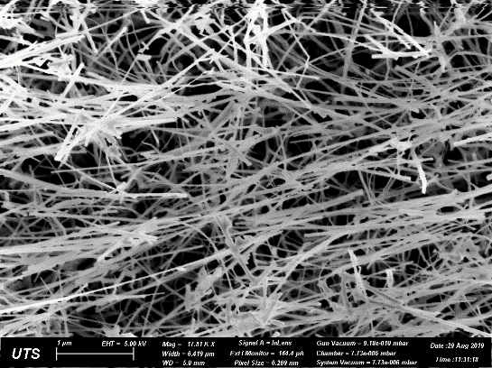

1μm

**Fig 2**. Depth-resolved CL spectra of Ga2O3 nanowires.

**References**

1. Higashiwaki, M., Sasaki, K., Kuramata, A. Masui, T. & Yamakoshi, S. (2016). Recent progress in Ga2O3 power devices. Semicond. Sci. Technol., 31, 034001
2. Varley, J.B., Janotti, A., Franchini, C. & Van de Walle, C.G. (2012). Role of self-trapping in luminescence and p-type conductivity of wide band-gap oxides. Phys. Rev. B., 85, 081109

Email: Curtis.Irvine@uts.edu.au