Machine learning-enabled stiffness detecting by low refractive nanoparticle

Xuchen Shan^{A}, Peng Nie^{A}, Chaohao Chen^{A}, Shihui Wen^{A}, Yongtao Liu^{A}, Baolei Liu^{A} Fan Wang^{A}
^{A}Institute for Biomedical Materials and Devices (IBMD), University of Technology Sydney, Australia.

Introduction.
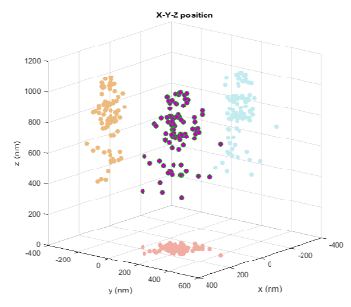
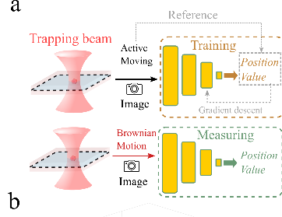
Optical trapping of functional nano-sensor can actively map of interactive information e.g. temperature and viscosity in the nanoscale region in aqueous environment¹. The design of nano-sensor often relays on nanoparticle with a low refractive index. However, the low refractive index from functional nanoparticle results in the reduced magnitude of the scattering field, which complicates its optical force measurement, hindering the application of optical trapping on these particles.

Aims.
To detect the 3D trap stiffness for small particles with low refractive index (RI).

Methods.
Here, applying machine learning involved video tracking analysis on optically trapped nanoparticle², we achieved the 3D optical trapping force measurement for nanoparticles with the low refractive index.

Results.
Applying optical astigmatism modification, we achieved nanoscale 3D localizing of optical trapped nanoparticles with a refractive index of 1.46 and size of 20nm, and thus the construction of 3D force.

Discussion.
Trapping of functional nanoparticle and biological sample, including nanomedicine, nano-sensor and cell organelle, are particularly attractive owing to their opportunity on high-resolution multimodality sensing. These nanoparticles allow for sensing on environment change in viscosity, temperature, PH and force. To avoid invasive scattering and heating, and these particles are often of low refractive index, including UCNP, polymer dot and AIE. This detection method gives a chance to detection by the no heating probe with low RI.
Figure 1. a) The trapped particles in different z-axis position are used to training the system. With the machine learning method, the position of the particle can be known. b) The distribution of the trapped particle.

Conclusion.
This work offers a solution to investigate the optical manipulation of low refractive index nanoparticles, also enables high resolution sensing for a range of environment variations.

References
1. Wang, F. et al. (2018). Microscopic inspection and tracking of single upconversion nanoparticles in living cells. Light Sci. Appl. 7.
2. Deschout, H. et al. (2014). Precisely and accurately localizing single emitters in fluorescence microscopy. Nat. Methods 11, 253–266.

