Molecular imprinting by precipitation polymerisation

Clovia I Holdsworth, K. Fremielle Lim, Phonlakrit Muang-Non

Discipline of Chemistry, School of Environmental and Life Sciences, The University of Newcastle, Callaghan, NSW, Australia 2308

Molecular imprinting is a simple and effective method of imparting highly specific and selective recognition sites in synthetic polymers by immobilising a template molecule (usually also the target molecule) within a rigid polymer matrix. (Wulff, et al 1973; Arshady and Mosbach 1981) At its simplest, the template (T) molecules and functional monomers (FM) are allowed to self-assemble and interact in solution in the presence of an excess amount of crosslinker prior to radical polymerisation. The template-moulded cavities within the polymer matrix are capable of selectively re-binding the template/target molecules (Fig. 1). Conventionally, molecularly imprinted polymers (MIPs) are prepared with minimal amounts of porogen (i.e. bulk imprinting) resulting in monoliths that require grinding and sieving. However, MIPs can be prepared more conveniently using higher volumes of porogen, allowing nano- to micro-particulate MIPs (Fig. 2) to be produced (i.e. precipitation imprinting).
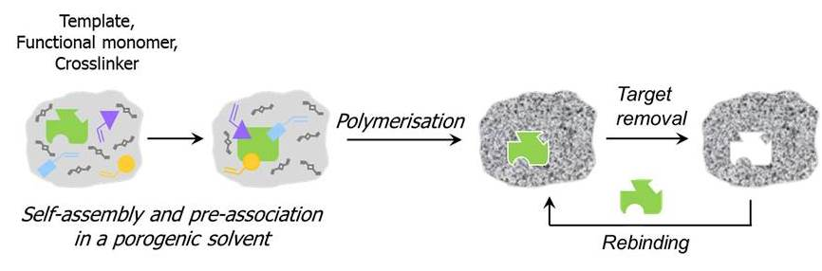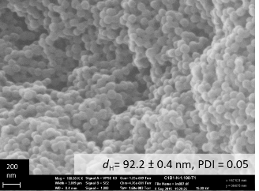

Fig. 1. Overview of the self-assembly molecular imprinting process. Fig. 2. SEM image of a nano-particulate MIP.

Literature has indicated that precipitation imprinting is susceptible to changes in polymerisation conditions. Our study employing a number of templates, e.g xanthine derivatives caffeine and theophylline (Lim and Holdsworth 2018) and phenolic targets 3,5-dimethylphenol, 5-methylbenzene-1,3-diol and 1,3,5-benzenetriol (3OH), demonstrates that the nature of the template, the formulation and initiator concentration affect the binding performance, selectivity and particle size of precipitation MIPs prepared by conventional radical polymerization of EGDMA and methacrylic acid as FM in acetonitrile. We have also observed that imprinting at high dilution affected the T:FM stoichiometry and binding performance of functional monomer 2,6-bis(acryl)amido pyridine, capable of forming a 1:1 complex with an imide-containing template such as 2’,3’,5’-tri-O-acetyl uridine, via an array of H-bond interactions. (Lim, et al 2018) Template rebinding was observed to be < 10% of the incorporated template for most of the precipitation MIP systems under study. We are currently investigating other precipitation MIP systems (e.g. RAFT). Preliminary results will also be presented.

References
Arshady, R. and Mosbach, K. (1981) Synthesis of substrate-selective polymers by host-guest polymerization. Die Makromolekulare Chemie, 182, 687-692.
Lim, K.F. and Holdsworth,C.I. (2018) Effect of Formulation on the Binding Efficiency and Selectivity of Precipitation Molecularly Imprinted Polymers. Molecules, 23. DOI 10.3390/molecules23112996.
Lim, K. F, Hall, A. J., Lettieri, S. and Holdsworth, C.I. (2018). Assessment of the imprinting efficiency of an imide with a "stoichiometric" pyridine-based functional monomer in precipitation polymerization. Journal of Molecular Recognition, 31. doi: 10.1002/jmr.2655.
Wulff, G., Sarhan, A. and Zabrocki, K. (1973) Enzyme-analogue built polymers and their use for the resolution of racemates. Tetrahedron Letters, 14, 4329-4332.

