Re-programming bacterial nanocompartments into photosensitizing nanoparticles
Dennis Diaz^{A}, Febrina Sandra^{A}, Xavier Vidal Asensio^{B}, Anwar Sunna^{A,B}, Andrew Care^{A,*}
^{A}Department of Molecular Sciences, Macquarie University, Sydney, Australia.

Photodynamic therapy (PDT) is a selective and minimally invasive cancer treatment. To destroy tumour cells, PDT relies on photosensitizers that can be activated by light to convert the oxygen within tumour cells into highly toxic reactive oxygen species (ROS) that induce cell death. The green fluorescent flavoprotein mini-Singlet Oxygen Generator (mSOG) is a unique protein photosensitizer that produces ROS when irradiated with blue light and has been used to mediate in vitro PDT [1]. However, due to its potential instability in vivo, its protective encapsulation within nanoparticle-based delivery systems (NDDS) is highly favourable.
Encapsulin nanocages are a new class of protein-based nanocompartments found in 1-4% of known prokaryotes, which have a set of distinct physical and functional features that make them attractive as NDDS [2]. They self-assemble from identical protein subunits into hollow spherical protein-based nanoparticles that are 18-44 nm in diameter and exhibit good colloidal properties, robust stability, excellent biocompatibility and no toxicity. During self-assembly, encapsulins selectively package and protect cargo proteins (native or foreign) tagged with a unique peptide, or ‘encapsulation signal, EncSig’, offering an interchangeable system for the programmed encapsulation of protein-based therapeutics [3]. In addition, surface pore openings allow small molecules, like cellular oxygen, to enter the internal cavities of encapsulins, facilitating their interaction with the protein cargo. The outer surfaces of encapsulins are also highly adaptable and can be genetically and/or chemically modified to further enhance their functionalities (e.g. tumour-targeting). Thus, encapsulins represent an exciting NDDS for the encapsulation and delivery of protein photosensitizers, like mSOG, in the PDT of cancers (Fig. 1).
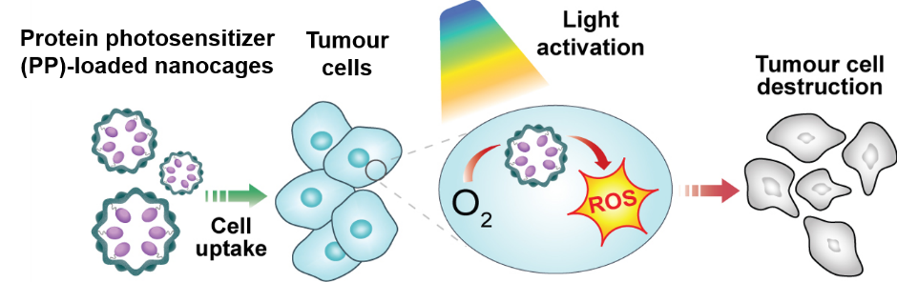
In this work, we reprogrammed the encapsulin (ENC) from the bacterium Thermotoga maritima to encapsulate EncSig-tagged mSOG variants, mSOG-1 or mSOG-2, previously engineered for enhanced ¹O₂ generation. All miniSOG-loaded ENCs were recombinantly produced in Escherichia coli, purified by chromatographic methods and were found to be 25-30 nm in size, monodisperse and fluorescent. mSOG is a Type II photosensitizer that produces singlet oxygen (¹O₂) upon blue light irradiation. All mSOG-loaded ENCs produced measurable quantities of ¹O₂ under blue light activation, with the mSOG-1-loaded ENC variant (mSOG-1-ENC) shown to be the most effective. Based on these findings, we evaluated the PDT killing effect of mSOG-1-ENC in an in vitro model of lung cancer. mSOG-1-ENC displayed no cytotoxicity in the dark, however, when activated with blue light, it caused an ~25% reduction in cancer cell viability. These results demonstrate light-activated mSOG-1-ENC’s photosensitizing capacity and its ability to mediate PDT.
Fig. 1. Concept - Protein photosensitizer(PP)-loaded encapsulin nanocages for the PDT of tumour cells.
In summary, this work presents the first time protein-based nanoparticles ave been loaded with functional protein photosensitizers and shown to mediate in vitro PDT. Further development of these novel PDT nanoplatform is anticipated to enhance its therapeutic efficacy, ultimately leading towards testing in pre-clinical animal models of cancer.

References:
1. Souslova, E.A., et al., Applications of genetically encoded photosensitizer miniSOG: from correlative light electron microscopy to immunophotosensitizing. J Biophotonics, 2017. 10(3): p. 338-352.
2. Giessen, T.W., et al., Widespread distribution of encapsulin nanocompartments reveals functional diversity. Nat Microbiol, 2017. 2: p. 17029.
3. Moon, H., et al., Developing Genetically Engineered Encapsulin Protein Cage Nanoparticles as a Targeted Delivery Nanoplatform. Biomacromolecules, 2014. 15(10): p. 3794-3801.

andrew.care@mq.edu.au

