Nanowires, quantum phase slips and electromagnetic duality in quantum circuits
T. C. Bartolo^{A}, J. S. Smith^{A}, M. J. Cyster^{A}, S. A. Wilkinson^{A}, N. Vogt^{B}, Y. Schön^{C}, J. N. Voss^{C},
H. Rotzinger^{C}, and J. H Cole^{A}

^{A} Chemical and Quantum Physics, School of Science, RMIT University, Melbourne, Australia
^{B} HQS Quantum Simulations GmbH, 76187 Karlsruhe, Germany
^{C} Physikalisches Institut, Karlsruhe Institute of Technology, Karlsruhe, Germany

Introduction
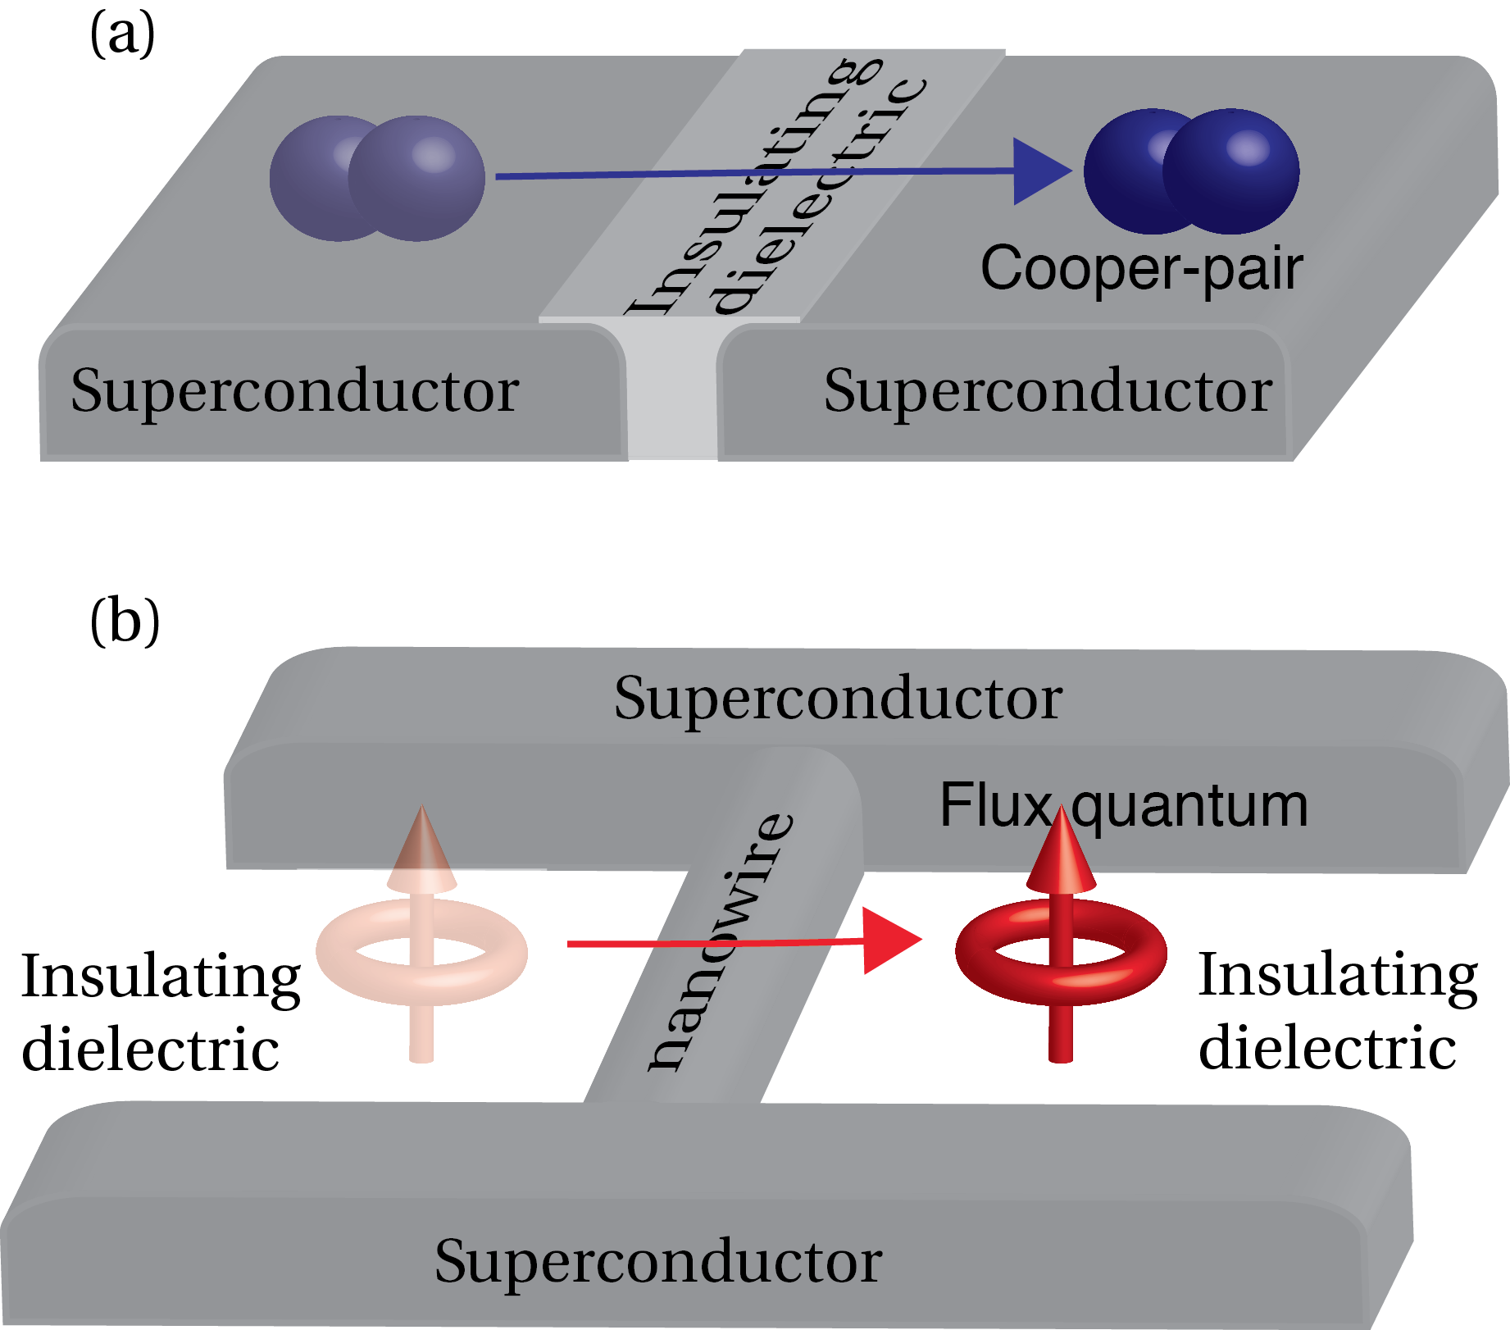
When two pieces of superconducting metal are separated by a ultra-thin region of insulator, their current and voltage characteristics depend on the quantum mechanical phase of the superconducting current on either side. This results in the Josephson effects and has led to a series of new technological developments including magnetic field detectors, quantum computer components, single electron pumps and detectors, and devices for high precision electrical standards. Although the physics of Josephson junctions has become relatively mainstream, there is an electromagnetic duality at the heart of these devices which has broader ramifications. If two regions of superconducting material are linked via a nanoscale constriction (for example a nanowire) then similar relationships between current and voltage hold, however the roles of charge and phase are interchanged (Mooij and Nazarov, 2006). Such a device is termed a quantum phase slip (QPS) element and is the dual of a Josephson junction (see Fig. 1). Realising quantum circuits based on QPS elements has proven challenging due to the disorder inherent in thin superconducting films with sufficiently large kinetic inductance (Astafiev et al. 2012).
Figure 1. (a) A Josephson junction is a thin insulating barrier between two regions of superconductor, through which Cooper-pairs can tunnel. (b) Two regions of superconducting material connected via a nanoscale constriction forms a barrier for magnetic flux quanta. This is a quantum phase slip element.

Methods
Motivated by recent work on anharmonic oscillators based on QPS elements made from granular aluminium oxide films (Schön et al. 2019), we perform numerical simulations to understand the relationship between electrical response and film morphology and structure. We use effective models as well as atomistic approaches to understand the conduction properties of both the metallic and insulating regions of these films. The resulting network models can then be analysed using quasicharge (Wilkinson et al. 2019, 2017) and Green’s function (Cyster et al. 2019) techniques to provide a detailed understanding of how current flows through a typical device.

Conclusions
Constructing detailed computational models of nanowires fabricated from thin film granular superconductors allows us to optimise the fabrication process, resulting in more efficient and reliable circuits for quantum computing and sensing applications.

References
J.E. Mooij and Y.V. Nazarov, Nature Physics, 2, 3, 169–172, (2006).
O.V. Astafiev et al., Nature, 484, 7394, 355–358, (2012).
Y. Schön et al., arXiv:1907.04107 (2019).
S. A. Wilkinson et al., New Journal of Physics, 19, 093023 (2017)
S. A. Wilkinson and J. H. Cole, Physical Review B, 99, 134502 (2019)
M. J. Cyster et al., arXiv:1905.12214

(2019).

